Table of Contents

Review 1

Linear Regression Review 1

Stochastic Gradient Descent (SGD) Regression 3

SGD Scaling 4

Epochs 5

Logistic Regression Review 5

SGDClassifier 8

A Simplified Explanation of the Gradient Descent Algorithm 8

The Loss (Cost) Function 9

Implementing Gradient Descent 11

Calculating the Derivative 12

The Learning Rate 14

Gradient Descent Summary 19

Stochastic Gradient Descent 19

Welcome back ☺

## Review

This term will actually be quite a bit different than the last one but the difference

will not be apparent today. The content in this document will seem excessive at a first glance

but I will strive to keep it manageable. I will put things into context during class so you

can get through it quickly.

A goal of this document is to provide a quick review how to apply regression and classification

routines but perfect recall is not expected. We will also introduce the Stochastic GradientDescent

to perform regression and classification just like we have done with OLS and logistic regression.

You do not need to understand the new routines at a deep level. We will examine these

algorithms in more detail later.

The reason we are spending time on gradient descent algorithms now is because they

are a foundation for other machine learning algorithms which we will introduce in the course

in the near future.

## Linear Regression Review

Example : Linear Regression

Hopefully you remember ordinary least squares, OLS, to create a best fit line. The very first example of multiple regression that we covered in COMP3948 was used to predict wine quality.

Here is the code.

|  |
| --- |
| import pandas as pd  import numpy as np  from sklearn import metrics  from sklearn.model_selection import train_test_split  import statsmodels.api as sm  PATH = "/Users/pm/Desktop/DayDocs/data/"  CSV_DATA = "winequality.csv"  dataset = pd.read_csv(PATH + CSV_DATA,  skiprows=1, # Don't include header row as part of data.  encoding = "ISO-8859-1", sep=',',  names=('fixed acidity', 'volatile acidity', 'citric acid',  'residual sugar', 'chlorides', 'free sulfur dioxide',  'total sulfur dioxide', 'density', 'pH', 'sulphates',  'alcohol', 'quality'))  # Show all columns.  pd.set_option('display.max_columns', None)  # Increase number of columns that display on one line.  pd.set_option('display.width', 1000)  print(dataset.head())  print(dataset.describe())  X = dataset[['fixed acidity', 'volatile acidity', 'citric acid', 'residual sugar',  'chlorides', 'free sulfur dioxide', 'total sulfur dioxide', 'density',  'pH', 'sulphates','alcohol']].values  # Adding an intercept *** This is required ***. Don't forget this step.  # The intercept centers the error residuals around zero  # which helps to avoid over-fitting.  X = sm.add_constant(X)  y = dataset['quality'].values  X_train, X_test, y_train, y_test = train_test_split(X, y, test_size=0.2, random_state=0)  model = sm.OLS(y_train, X_train).fit()  predictions = model.predict(X_test) # make the predictions by the model  print(model.summary())  print('Root Mean Squared Error:',  np.sqrt(metrics.mean_squared_error(y_test, predictions))) |

The result generates a root mean square error (RMSE) of **0.620**. The root mean square error represents the average deviation from the mean. Where y is the actual value and $\hat{y}$ is the predicted value:

RMSE = $\sqrt{{(y- \hat{y})}^{2}}$

Here is the model summary which shows that $R^{2}$, the coefficient of determination is **0.365**.

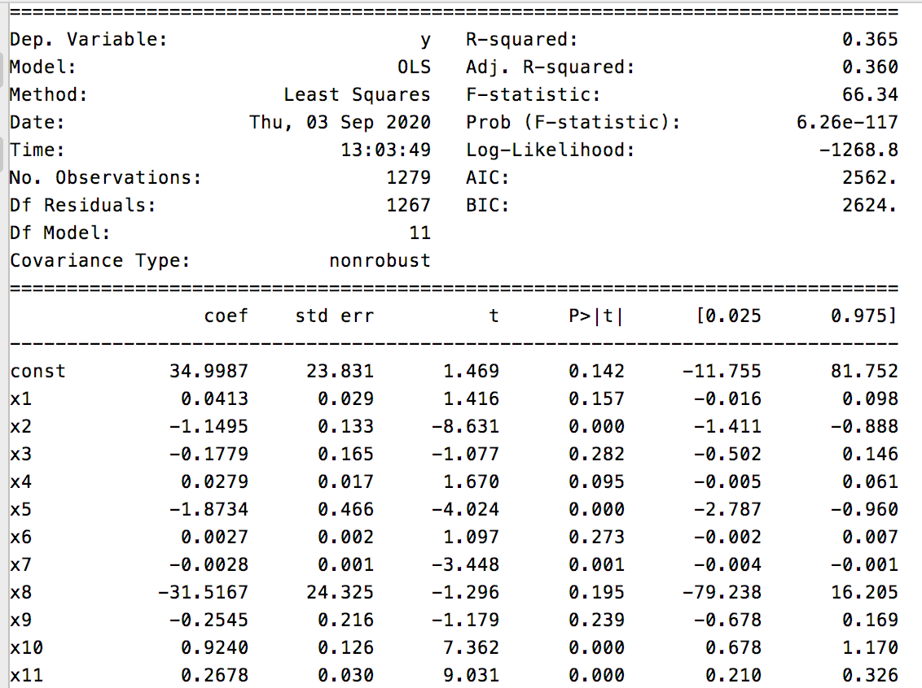

Exercise (2 marks)

Modify the code so only the statistically significant predictor variables are included. Show your code here:

|  |
| --- |
| import pandas as pd import numpy as np from sklearn import metrics from sklearn.model_selection import train_test_split import statsmodels.api as sm from pathlib import Path  PATH = Path("C:\datasets\winequality.csv")   dataset = pd.read_csv(PATH,  skiprows=1, # Don't include header row as part of data.  encoding = "ISO-8859-1", sep=',',  names=('fixed acidity', 'volatile acidity', 'citric acid',  'residual sugar', 'chlorides', 'free sulfur dioxide',  'total sulfur dioxide', 'density', 'pH', 'sulphates',  'alcohol', 'quality')) # Show all columns. pd.set_option('display.max_columns', None)  # Increase number of columns that display on one line. pd.set_option('display.width', 1000) print(dataset.head()) print(dataset.describe()) X = dataset[[ 'volatile acidity',  'chlorides', 'total sulfur dioxide', 'sulphates','alcohol']].values  # Adding an intercept *** This is required ***. Don't forget this step. # The intercept centers the error residuals around zero # which helps to avoid over-fitting. X = sm.add_constant(X) y = dataset['quality'].values  X_train, X_test, y_train, y_test = train_test_split(X, y, test_size=0.2, random_state=0)  model = sm.OLS(y_train, X_train).fit() predictions = model.predict(X_test) # make the predictions by the model print(model.summary()) print('Root Mean Squared Error:',  np.sqrt(metrics.mean_squared_error(y_test, predictions))) |

What is the root mean squared error after making the changes?

|  |
| --- |
| Root Mean Squared Error: 0.6259157889490543 |

## Stochastic Gradient Descent (SGD) Regression

Stochastic gradient descent is one of the most fundamental machine learning algorithms. We need to cover it early because it will form the basis for many other more advanced machine learning algorithms. We will not discuss it in much detail for this class but we will cover it more detail during the lab.

### SGD Scaling

Stochastic Gradient Descent is sensitive to feature scaling so it is highly recommended to scale your data. For example, scale each attribute on the input vector X to [0,1] or [-1,+1], or standardize it to have mean 0 and variance 1. Note that the same scaling must be applied to the test vector to obtain meaningful results. This task is often performed using StandardScaler.

**Note:** Remember to use the training set to fit the scaler. Also remember that only the x-values are scaled.

|  |
| --- |
| # Stochastic gradient descent models are sensitive to differences  # in scale so a StandardScaler is usually used.  from sklearn.preprocessing import StandardScaler  scaler = StandardScaler()  scaler.fit(X_train) # Don't cheat - fit only on training data  X_trainScaled = scaler.transform(X_train)  X_testScaled = scaler.transform(X_test) |

Example : Stochastic Gradient Descent

This code generates a regression model to predict the wine quality using stochastic gradient descent with the **SGDRegressor** class. The root mean square error from this process is varies between roughly **0.619** and **0.622** each time the program is run. The RMSE is actually very similar to the linear regression. Notice how scaling is used to tame the magnitude of the predictor variables.

To build this example, add this code onto the end of Example 1.

|  |
| --- |
| ###########################################################  print("\nStochastic Gradient Descent")  from sklearn.linear_model import SGDRegressor  from sklearn.metrics import mean_squared_error  # Stochastic gradient descent models are sensitive to differences  # in scale so a StandardScaler is usually used.  from sklearn.preprocessing import StandardScaler  scaler = StandardScaler()  scaler.fit(X_train) # Don't cheat - fit only on training data  X_trainScaled = scaler.transform(X_train)  X_testScaled = scaler.transform(X_test)  # SkLearn SGD classifier  sgd = SGDRegressor(verbose=1)  sgd.fit(X_trainScaled, y_train)  predictions = sgd.predict(X_testScaled)  print('Root Mean Squared Error:',  np.sqrt(mean_squared_error(y_test, predictions))) |

### Epochs

You will notice some differences when examining the output when building a regression model with stochastic gradient descent. SGD regressors output loss values for each epoch. **An epoch is an iteration of a machine learning algorithm which works towards minimizing a cost / loss function.**

|  |
| --- |
| -- Epoch 6  Norm: 0.41, NNZs: 11, Bias: 5.650050, T: 7674, Avg. loss: 0.215492  Total training time: 0.00 seconds.  -- Epoch 7  Norm: 0.42, NNZs: 11, Bias: 5.646630, T: 8953, Avg. loss: 0.215903  Total training time: 0.00 seconds.  -- Epoch 8  Norm: 0.42, NNZs: 11, Bias: 5.652358, T: 10232, Avg. loss: 0.215620  Total training time: 0.00 seconds.  Convergence after 8 epochs took 0.00 seconds  Root Mean Squared Error: 0.6223729015084277 |

## Logistic Regression Review

In COMP3948 we used logistic regression for classification. Remember, logistic regression uses a sigmoid function to clamp ‘y’ between 0 and 1 for all values of X.

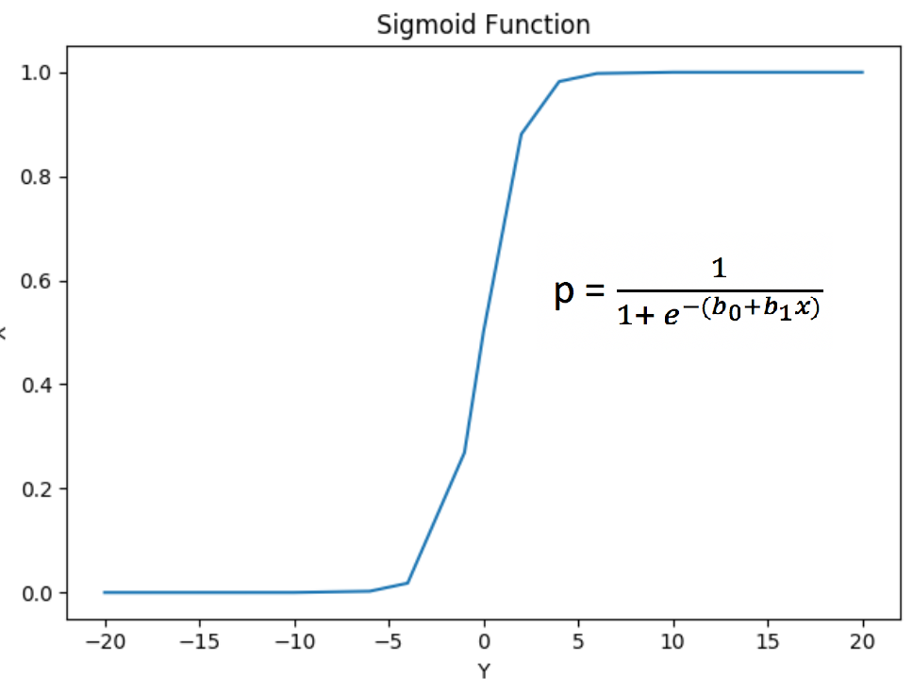

Example : Logistic Regression

This is actually the first logistic regression example that we covered in COMP3948. GMAT and GPA scores and work experience were used to determine if a student applicant would be admitted. A chi-square test found GMT and work experience to be statistically significant.

# GMT # GPA #Work

﻿Predictor Chi-Square Scores: [123.062 3.307 21.457]

To avoid overfitting, we dropped the GPA column. The revised model uses GMT scores and work experience to make the prediction.

Intercept:

[0.176]

[[1.546 1.711]]

The logistic regression model succeeded with 100% accuracy. Note that the results without scaling only offered 80%accuracy*.*

Accuracy: 1.0

Confusion Matrix

Predicted 0 1

Actual

0 5 0

1 0 5

Here is the code:

|  |
| --- |
| import pandas as pd  import numpy as np  from sklearn.model_selection import train_test_split  from sklearn.linear_model import LogisticRegression  from sklearn import metrics  # Setup data.  candidates = {'gmat': [780,750,690,710,680,730,690,720,  740,690,610,690,710,680,770,610,580,650,540,590,620,  600,550,550,570,670,660,580,650,660,640,620,660,660,  680,650,670,580,590,690],  'gpa': [4,3.9,3.3,3.7,3.9,3.7,2.3,3.3,  3.3,1.7,2.7,3.7,3.7,3.3,3.3,3,2.7,3.7,2.7,2.3,  3.3,2,2.3,2.7,3,3.3,3.7,2.3,3.7,3.3,3,2.7,4,  3.3,3.3,2.3,2.7,3.3,1.7,3.7],  'work_experience': [3,4,3,5,4,6,1,4,5,  1,3,5,6,4,3,1,4,6,2,3,2,1,4,1,2,6,4,2,6,5,1,2,4,6,  5,1,2,1,4,5],  'admitted': [1,1,1,1,1,1,0,1,1,0,0,1,  1,1,1,0,0,1,0,0,0,0,0,0,0,1,1,0,1,1,0,0,1,1,1,0,0,  0,0,1]}  df = pd.DataFrame(candidates,columns= ['gmat', 'gpa',  'work_experience','admitted'])  print(df)  # Separate into x and y values.  X = df[['gmat', 'gpa','work_experience']]  y = df['admitted']  # Import the necessary libraries first  from sklearn.feature_selection import SelectKBest  from sklearn.feature_selection import chi2  # Show chi-square scores for each feature.  # There is 1-degree freedom since 1 predictor during feature evaluation.  # Generally, >=3.8 is good)  test = SelectKBest(score_func=chi2, k=3)  chiScores = test.fit(X, y) # Summarize scores  np.set_printoptions(precision=3)  print("\nPredictor Chi-Square Scores: " + str(chiScores.scores_))  # Re-assign X with significant columns only after chi-square test.  X = df[['gmat', 'work_experience']]  # Split data.  X_train,X_test,y_train,y_test = train_test_split(  X, y, test_size=0.25,random_state=0)  # Perform logistic regression.  logisticModel = LogisticRegression(fit_intercept=True, random_state = 0,  solver='liblinear')  # Stochastic gradient descent models are sensitive to differences  # in scale so a StandardScaler is usually used.  from sklearn.preprocessing import StandardScaler  scaler = StandardScaler()  scaler.fit(X_train)  X_trainScaled = scaler.transform(X_train)  X_testScaled = scaler.transform(X_test)  logisticModel.fit(X_trainScaled,y_train)  y_pred=logisticModel.predict(X_testScaled)  # Show model coefficients and intercept.  print("\nModel Coefficients: ")  print("\nIntercept: ")  print(logisticModel.intercept_)  print(logisticModel.coef_)  # Show confusion matrix and accuracy scores.  confusion_matrix = pd.crosstab(y_test, y_pred,  rownames=['Actual'],  colnames=['Predicted'])  print('\nAccuracy: ',metrics.accuracy_score(y_test, y_pred))  print("\nConfusion Matrix")  print(confusion_matrix) |

## SGDClassifier

The SGDClassifier class is an altered version of the SGDRegressor class. However, SGDClassifier is designed to make binary and multi-class predictions.

Example : Stochastic Gradient Descent

For your reference this code shows how you can implement the SGDClassifier class to perform the same classification as logistic regression did in Example 3. The results are not dramatic since the SGDClassifier score is also perfect just like with logistic regression. To build this example, add this code to the end of Example 3.

|  |
| --- |
| print("\nStochastic Gradient Descent")  from sklearn.linear_model import SGDClassifier  clf = SGDClassifier()  clf.fit(X_trainScaled, y_train)  y_pred = clf.predict(X_testScaled)  # Show confusion matrix and accuracy scores.  confusion_matrix = pd.crosstab(y_test, y_pred,  rownames=['Actual'],  colnames=['Predicted'])  print('\nAccuracy: ',metrics.accuracy_score(y_test, y_pred))  print("\nConfusion Matrix")  print(confusion_matrix) |

### A Simplified Explanation of the Gradient Descent Algorithm

Example : Gradient Descent Explained in Simple Terms

This example is based on the video by Josh Stormer at <https://youtu.be/sDv4f4s2SB8>. For this case gradient descent is used to find a best-fit linear equation to predict height based on weight.

**Height = intercept + $β∙$ weight**

To keep this explanation simple, assume the slope $β$ is known to be 0.64. To further simplify the demonstration, we will only discuss how to optimize the intercept. The equation then becomes:

**Height = intercept + $0.64∙$ weight**

To begin, the algorithm starts with a random value for the intercept of 0. Figure 1 shows a scatter plot with three samples. For this case we are trying to find the intercept of a best fit line between them.

Figure : Scatter of Samples

|  |  |  |
| --- | --- | --- |
|  | Weight | Height |
| 0.5  2.3  2.9 | 1.4  1.9  3.2 |

When a line with a slope of 0.64 and an intercept of 0 is drawn (refer to Figure 2), the equation for predicting weight becomes:

**Height = intercept + $β∙$ weight = 0 + $0.64∙$ weight**

**Height = 0 + $0.64∙$ 0.5 = 0.32**

Figure : Regression Line

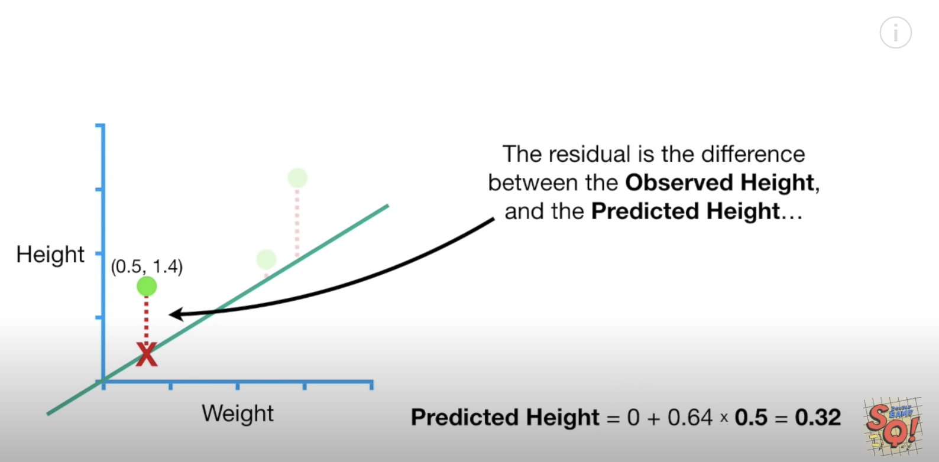

### The Loss (Cost) Function

Loss is used to measure the effectiveness of the model. Loss really is just the sum of the squared residuals. When actual height is 1.4 and our estimated height is 0.32 when the residual value is:

**1.4 – 0.32 $≈$ 1.08**

When summing the squared residuals for all three data points in our example the result is:

${(-1.08)}^{2}+{(-0.428)}^{2}+{1.344}^{2}$ = 3.155

Exercise (2 marks)

Show the calculation by hand that is used to generate the residual value of -0.428 in the sum of squared residual values calculation above. To do this you will have to plug the actual weight value of 1.9 into the model equation.

|  |
| --- |
| Actual height = 2.3  Actual weight = 1.9  Predicted height = 0 + 0.64*height (2.3) = 1.472  Residual = 1.9 – 1.472 = 0.428 |

The red dot in Figure 3 is the sum of the squared residuals when intercept is 0. The sum of the squared residuals is the **cost function**.

Figure : Regression Line Versus Cost Function

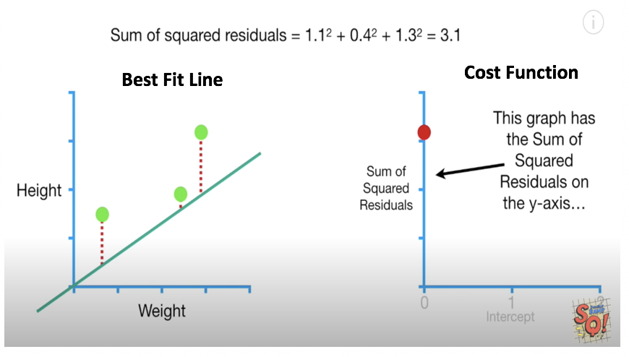

Exercise (1 mark)

I know this question may seem trivial and even obvious but it is important that you understand. What does the value of the red dot in the graph in Figure 3 represent in terms of the horizontal and vertical axis?

|  |
| --- |
| The red dot shows the sum of the squared residuals. It tells you how off the predictions are. |

We can change the intercept to obtain a lower sum squared residuals. Lower squared residuals imply a more accurate regression. The red dots in the right of Figure 4 show how the error is reduced as the intercept value is increased.

Figure : Best Fit Versus Cost

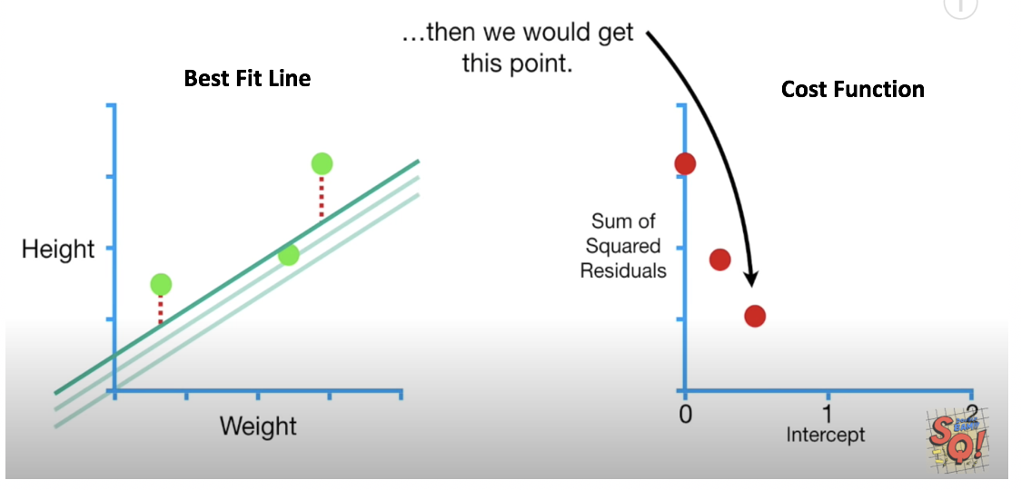

Exercise (1 mark)

Which dot in highlights the most optimized point of the cost function.

1. The green dot at the very left.
2. The red dot on the left.
3. The middle red dot.
4. The red dot on the right.

Exercise (1 mark)

In figure 4 for , each red dot represents the sum of the squared residuals for all samples when using a specific intercept.

T / F

The slope of the cost function approaches 0 as the regression becomes more accurate. See Figure 5.

Figure : Seeking the Minimal Slope of the Cost Function

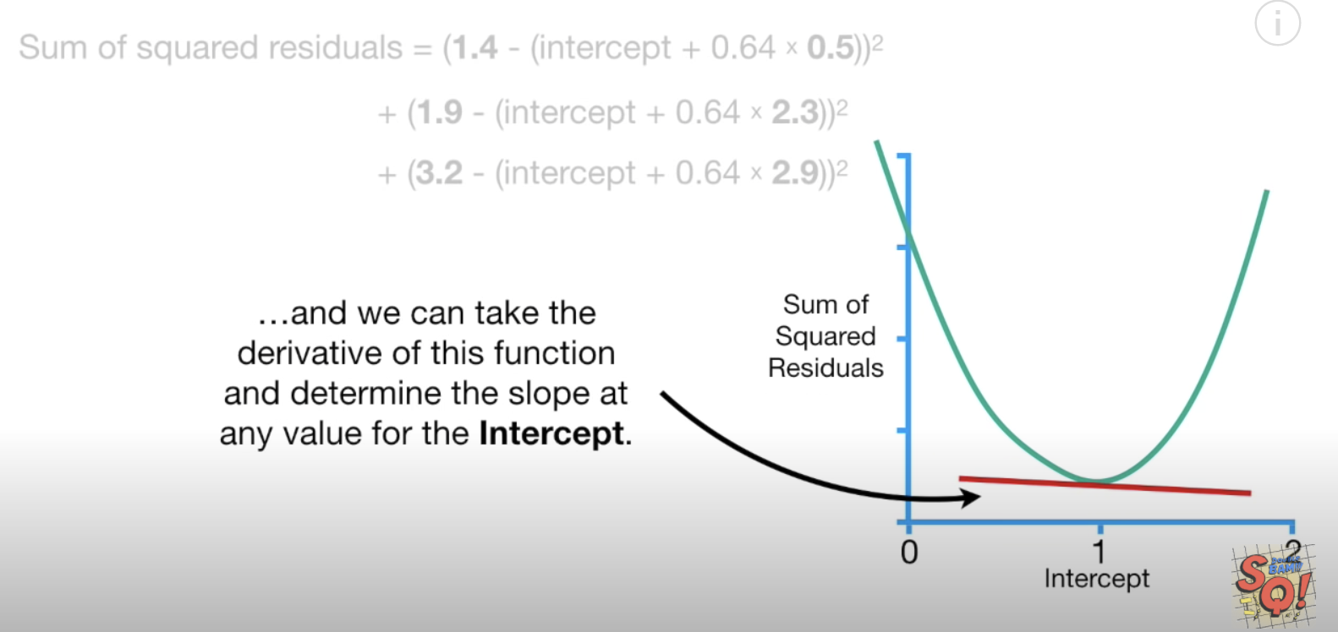

## Implementing Gradient Descent

We place Chad the robot at a random position in our bowl. However, Chad has only one sensor. The sensor detects the loss value at the exact position where he stands. Using this sensor, how could Chad get to the bottom? If you guessed gradient descent you guessed right. (see Figure 6).

Figure : Chad the Robot is. Finding His Way to the Bottom of the Bowl

|  |  |
| --- | --- |
|  |  |

Gradient descent finds the slope of the cost function that is closest to zero. We can calculate the slope using several methods. You could calculate the change in y over the change in x. You can also take the derivative of the cost function to do the same thing. When the intercept is 0 the slope is -5.7.

Figure : Finding the Slope of the Cost (Loss) Function

Where 0.64 is the slope of the best fit line:

|  |  |  |
| --- | --- | --- |
|  | Weight  0.5  2.3  2.9 | Height  1.4  1.9  3.2 |

Exercise (1 mark)

By examining the graph, suggest an intercept value for the example above when the cost / loss function is minimized?

|  |
| --- |
| About 1 |

## Calculating the Derivative

Figure 7 summarizes the calculates the sum of the squared residuals relative to the change in the intercept. In other words, we are calculating the derivative with respect to the intercept.

We will not cover calculus in this course but for curious minds here is how the equation for the derivative of the loss function is derived.

**intercept + $β∙$ ${weight}_{1}$ = 0 + $0.64∙$ ${weight}_{1}$**

= i + $β∙w$

Where i=intercept, h= height and $\hat{h}$ =estimated height:

Residual = $\sum{(}$ ${h-\hat{h})}^{2}$

= $\sum{h^{2}}{-2∙h∙\hat{h}+\hat{h}}^{2}$

= ${\sum{h^{2}}-2∙h∙(i+β∙w)+(i+β∙w)}^{2}$

= ${\sum{h^{2}}-2hi -2hβw+i^{2}+2iβw+β^{2}w}^{2}$

$\frac{d (residual error)}{d(intercept)}$ = 0 – 2h – 0 +2i +2 $βw$ + $0$

= -2(h – i - $βw$)

Since the intercept is a constant, the derivative of the intercept is 0. In the end we can determine that the change in the sum of squared residuals relative to the change in the intercept is -5.7 as shown in Figure 7. Therefore, the slope of the cost function when the intercept is 0 is -5.7. Here is some code to perform the same calculation:

|  |
| --- |
| weights = [0.5, 2.3, 2.9]  heights = [1.4, 1.9, 3.2]  def getSlopeOfLossFunction(weights, heights, intercept):  sum = 0  BETA = 0.64  for i in range(0, len(weights)):  sum += -2 * (heights[i] - intercept - BETA * weights[i])  print("Intercept: " + str(intercept) + " Res: " + str(round(sum, 2)))  intercept = 0  getSlopeOfLossFunction(weights, heights, intercept) |

Exercise (1 mark)

What is the approximate derivative of the sum of the squared residuals when the intercept is 0.95?

1. 0
2. -1
3. 0.213
4. 0.296

Exercise (1 mark)

Show a picture of the slope of the loss function when the intercept is 0.95 for this example. You can use MS Paint, a drawing tool or you can draw it on paper and embed your image in this document. Show your graph below.

|  |
| --- |
|  |

### The Learning Rate

When plotting the gradient descent cost function values in Figure 8, notice how the width between intercept estimates become closer as the slope of the cost function approaches zero.

Figure : Width Between Cost Function Points

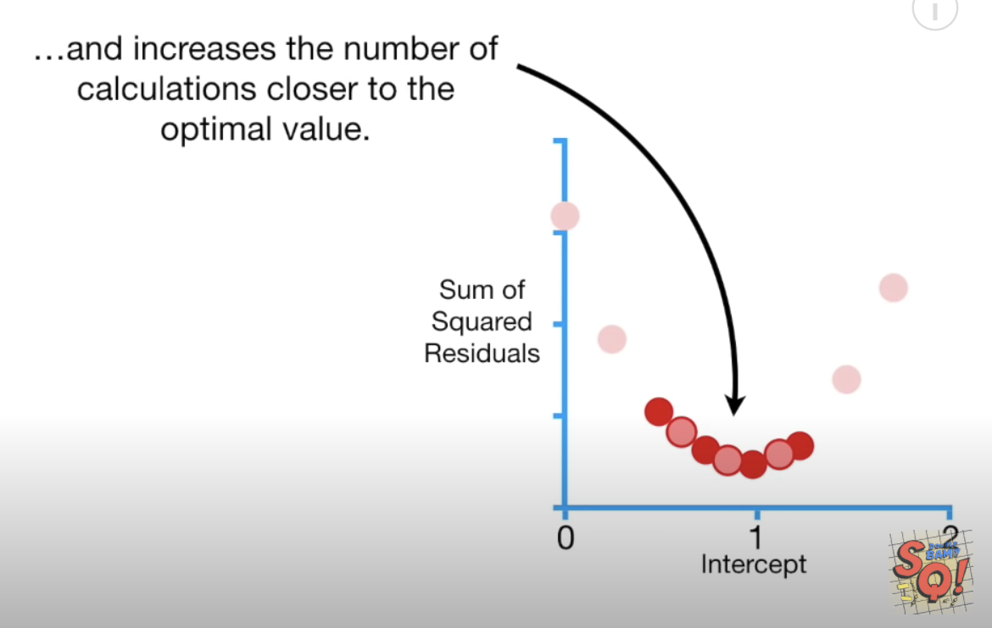

A higher learning rate can be used to speed up the descent to the minimum. However, a learning rate that is too high can cause the algorithm to overshoot the minimum and miss it. A learning rate that is too low can cause the algorithm to take too long to find the minimum. Often, manual adjustments to the learning rate are needed to find an optimal balance between speed and accuracy.

Figure 9 shows various learning rates which are applied over several iterations which are called **epochs**. The yellow and green learning rates are too fast so they missed the minimum.

Figure : Various Learning Rates

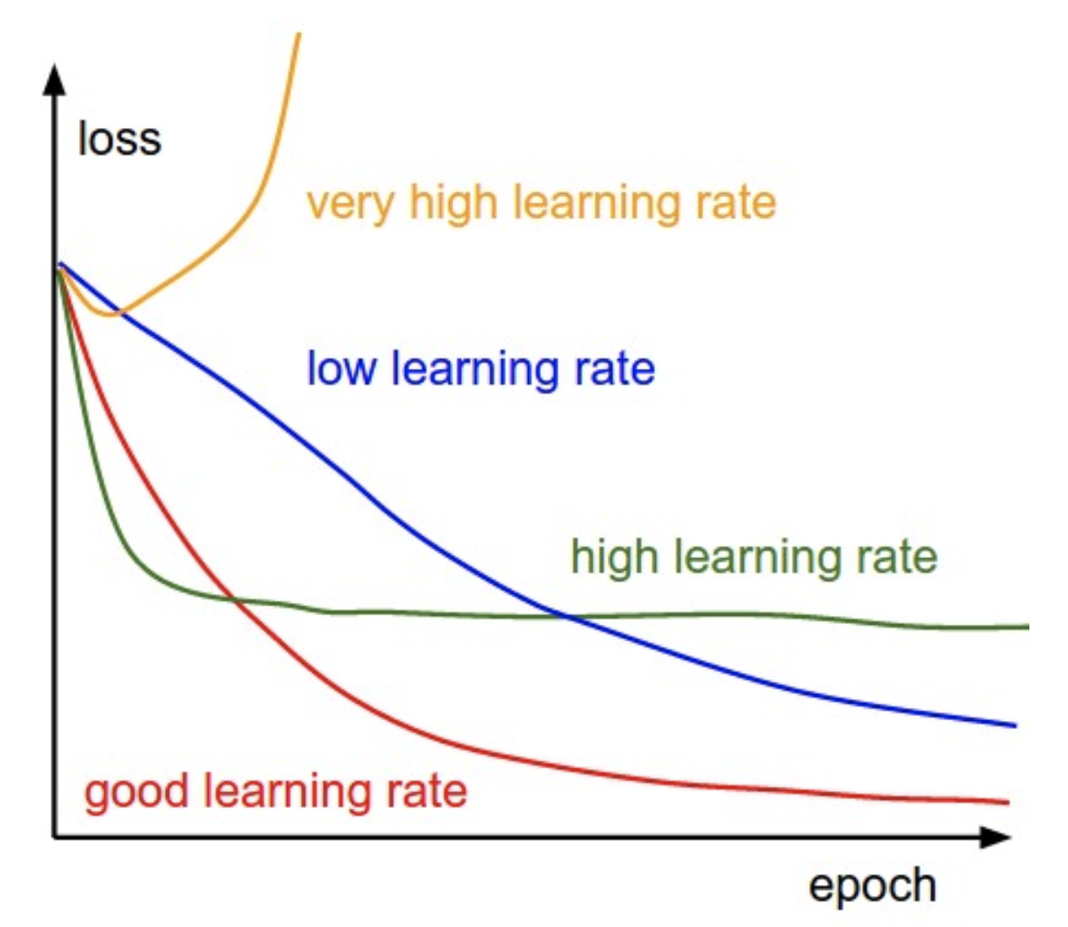

Exercise (1 mark)

Which line in Figure 9 shows a learning rate that is too slow?

|  |
| --- |
| blue |

#### Step Size

Step size in this case refers to the amount of change in the intercept value as we search for the optimum.

To avoid over or under-shooting the minimum we need to find an appropriate step size at a rate that is suitable when far or close to the minimum. Ideally, as the slope of the loss function approaches 0 the step size becomes smaller and smaller (refer to Figure 8).

**Step size = slope $∙$ learning rate**

Remember, we showed that when the intercept is zero, the slope of the cost (loss) function is

-5.7

Figure : Slope of the Cost Function when the Intercept is 0.

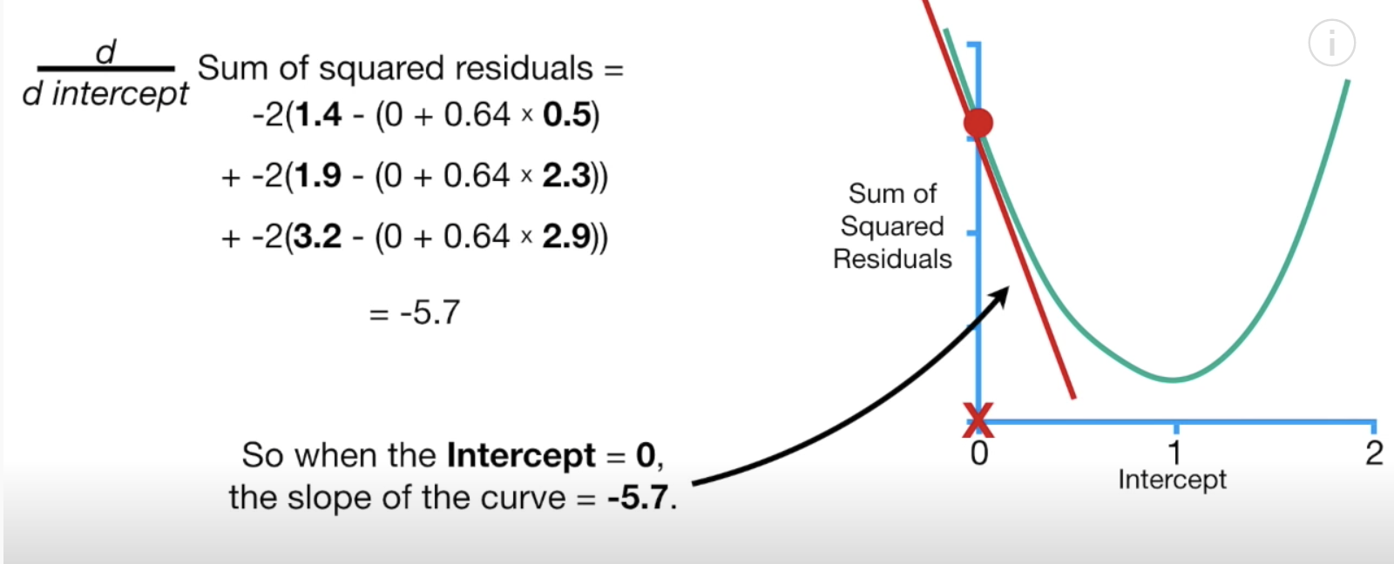

Therefore, if the **learning rate** is 0.1, the step size when the intercept is zero is:

Step size = slope $∙$ learning rate = -5.7 $∙$ 0.1 = -0.57

The new intercept becomes the old intercept - the step size:

New intercept = old intercept – step size = 0 - -0.57 = 0.57

We can represent our new intercept on our graph (see Figure 11).

Figure : Plotting intercepts 0 and 0.57 on the cost function graph

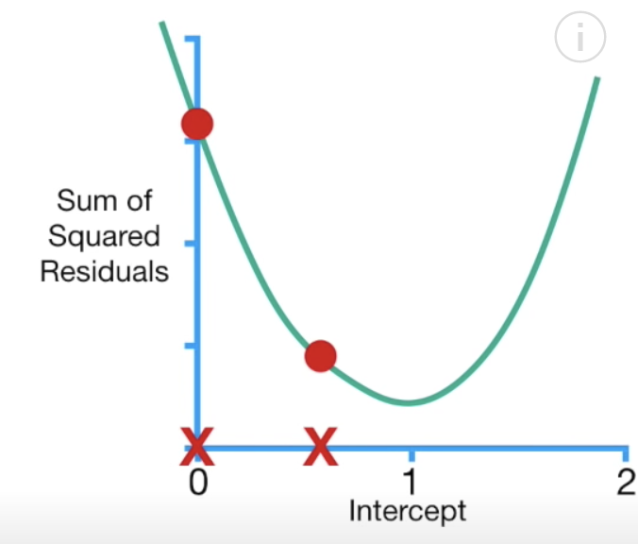

When the intercept is 0.57, notice how the sum of the squared residuals is reduced (see Figure 12).

Figure : Reducing the Sum of the Squared Residuals

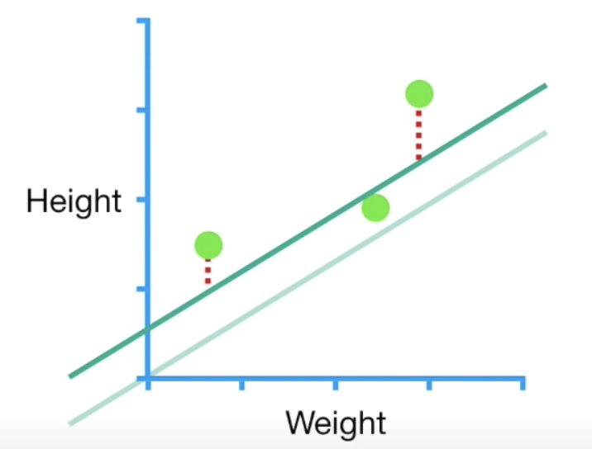

Exercise (3 marks)

What is the slope of the cost function when the intercept is 0.57? Show the setup for your calculation. Refer to Figure 10. Also show the final answer.

|  |
| --- |
| Derivative of the sum of the square residuals =  -2(1.4-(0.57 + 0.64*0.5) + -2(1.9-(0.57 + 0.64*2.3) + -2(3.2-(0.57 + 0.64*2.9)  = -2.3 |

Exercise (3 marks)

If the learning rate is 0.1, what is the next step size when the intercept is 0.57? What intercept is generated with the new step size? Show your calculations.

|  |
| --- |
| Step size = -2.3 * 0.1 = -0.23  New intercept is 0.57- (-0.23) = 0.8 |

Example : Calculating the Minimum Loss When Estimating the Intercept and Slope

In Example 5 we examined how to apply gradient descent to find the best fit line by only adjusting the intercept. This example continues from Example 5. However, in this case we will consider adjustments to both the intercept and the slope of the best fit line.

Just like before we will calculate the sum of the squared residuals to determine the slope of the loss function. This time though, we will adjust both the slope and the intercept. Since we are now calculating loss function values for different slope and intercept values it helps to visualize the cost function in 3D space. To minimize the cost function, we must now find the minimum using three different axes. In other words, we need to find the bottom of the bowl shape shown in Figure 13.

Figure : Cost Function with Changing Slope and Intercept Values

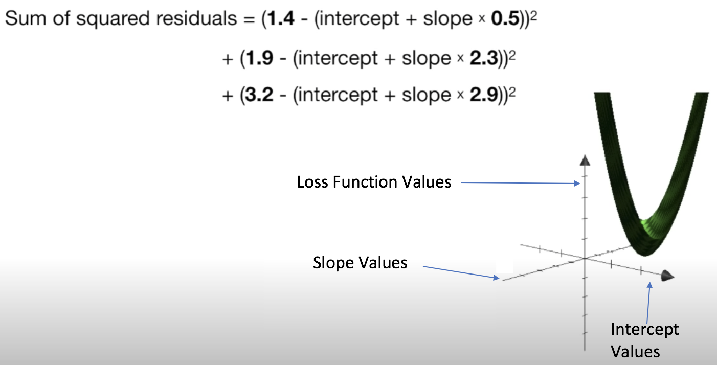

In Example 5, we were only searching for the changes in the intercept so we only took the derivative of the loss function with respect to the intercept. Now, since we are adjusting the intercept and the slope of the best fit line we must take the derivative of the loss function with respect to the intercept and the slope of the best fit line (see Figure 14).

Figure : Calculating the Slope of the Loss Function using Two Variables

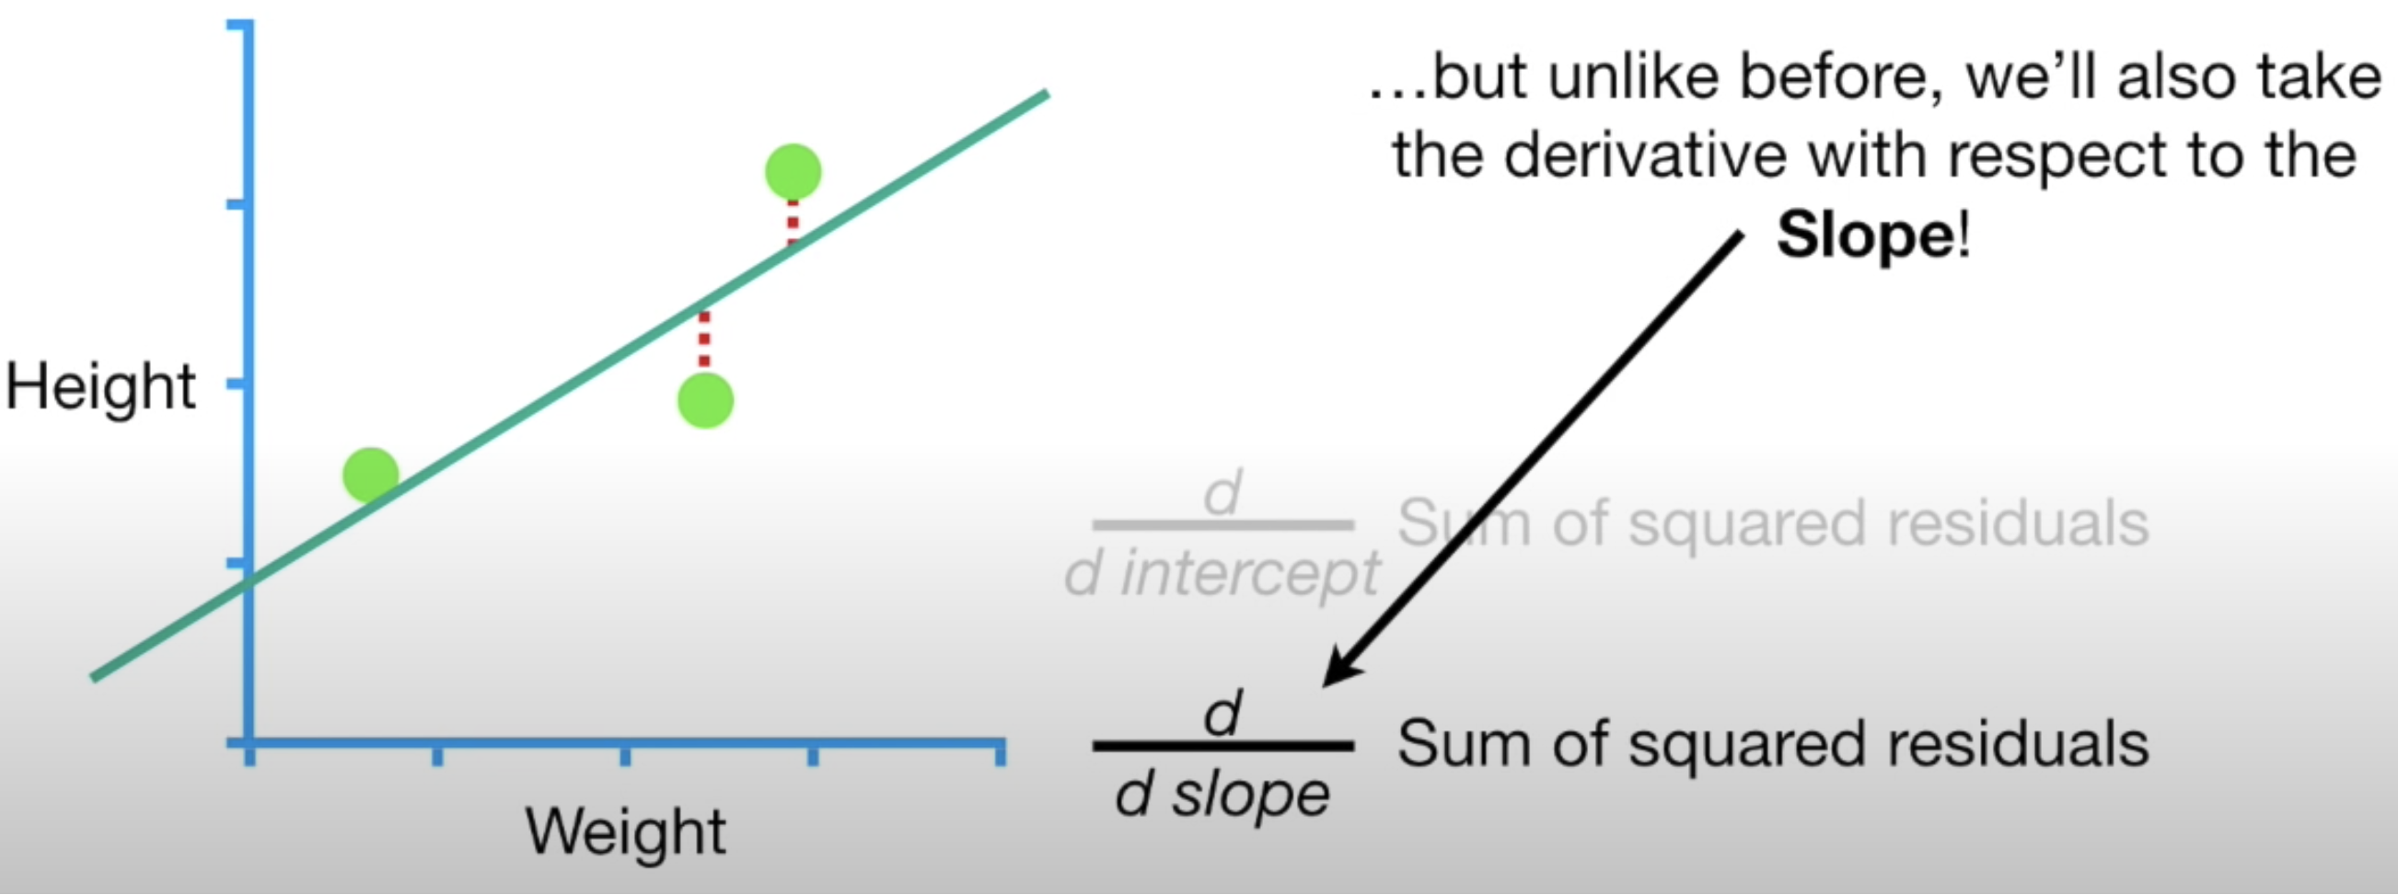

When you have two or more derivatives of the same function this is called a **gradient**. Figure 15 shows the calculations needed for determining both derivatives.

Figure : Derivatives with respect to the intercept and the slope

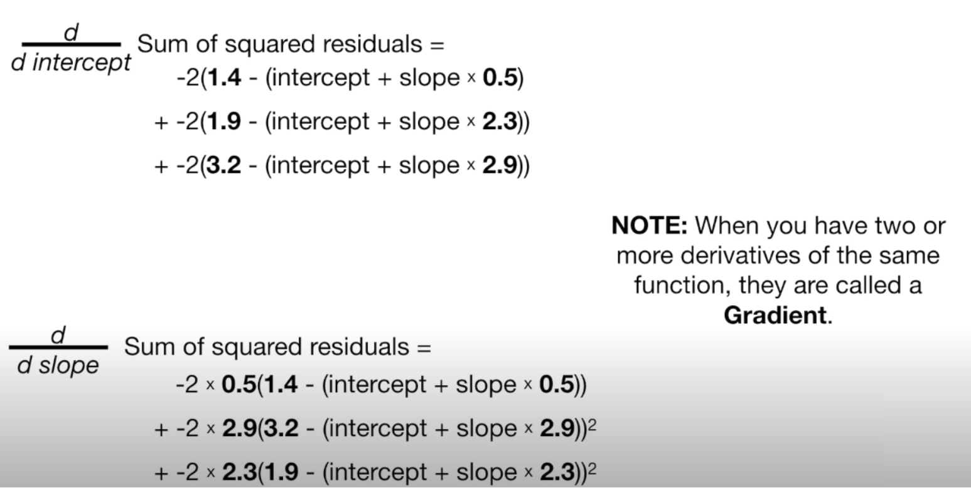

Essentially, we are using two different slopes to find minimums in two different dimensions If we were to calculate both derivatives by starting with an intercept of 0 and a slope of 1, notice how the step sizes are calculated when the learning rate is 0.1 (see Figure 16).

Figure : Calculating Step Size for each Dimension

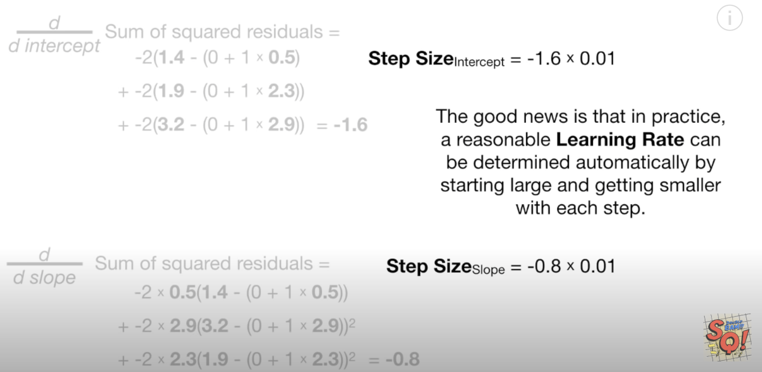

After taking several steps we arrive at the optimal slope and intercept for the best fitting line. This happens to be the same result that is generated by the least squares method (Figure 17).

Figure : The optimal intercept and slope from gradient descent

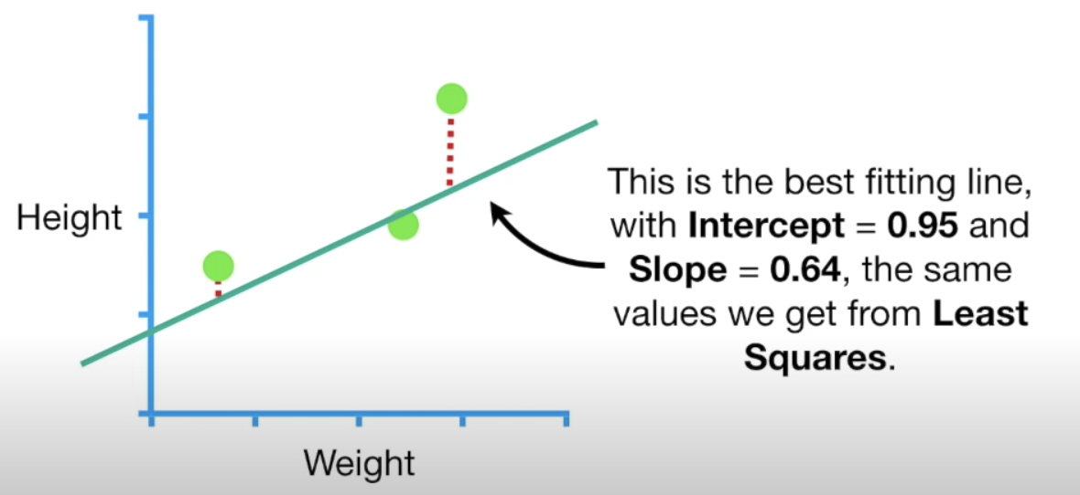

If we had more parameters than height and weight then we take only need to take more derivatives and everything else would stay the same.

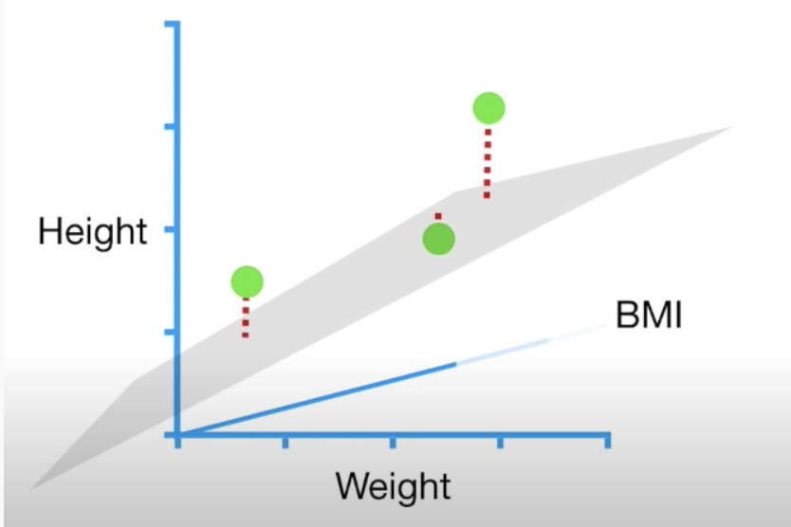

### Gradient Descent Summary

The sum of the squared residuals is just one type of loss function, there are many other types of loss functions but gradient descent works the same way. Specifically, the steps of the gradient descent algorithm are:

1. Take the derivative of the loss function for each parameter in it. In other words, take the gradient of the loss function.
2. Pick random values for the parameters.
3. Plug the parameter values into the derivatives.
4. Calculate the step sizes: (Step size = Slope x learning rate)
5. New parameter = old parameter – step size
6. Go back to step 3 and repeat until finding a minimum of 0.001 or less or until generally 1000 iterations (epochs).

## Stochastic Gradient Descent

For the three data points in Example 5 and Example 6 the calculations did not take very long. However, with millions of data records, the calculations can be very time consuming. Stochastic gradient descent works like the gradient descent algorithm. However, stochastic gradient descent takes a random subset of data to perform the calculations for the cost function.

Exercise (1 mark)

In your own words, explain how stochastic gradient descent is different than gradient descent.

|  |
| --- |
| A gradient descent uses the whole data set to calculate the cost function, while the stochastic gradient descent uses a random subset of the data to calculate the cost function. |

Exercise (1 mark)

A gradient:

1. Is used for grating cheese.
2. Could be used to find the minimum of a single dimension.
3. Is the combination of two or more derivatives of the same equation in different dimensions.
4. Is the mid-point of a curvature.

Contents

Word2Vec 1

Applications 1

Limitations 1

Word2Vec: Model Building and Examples 3

Word2Vec Model Parameters 3

Passive Aggressive Classifiers 5

Term Frequency Inverse Document Frequency (TFIDF) 6

Term Frequency 6

Inverse Document Frequency 6

Fake News Detection 6

Visualizing CNN Output with Trulens 8

Observing How an Image is Processed In Each Layer of the CNN 13

Using MaskVisualizer from TruLens to Observe Where Model Focused 14

Visualizing the Gradient of the Prediction Output Using IntegratedGradients from TruLens 15

Calculating Attributions for Individual Neurons 16

## Word2Vec

Word2vec is a natural language processing technique created in 2013 by a team of researchers at Google. As the name itself suggests, word2vec takes a text input and produces vectors that represent each word. For documentation see <https://www.tensorflow.org/tutorials/text/word2vec>

The algorithm uses a neural network model to learn word associations from the training dataset. The assumption of Word2Vec is that words share similar contexts. For instance: "dog", "puppy" and "pup" are often used in similar situations, with similar surrounding words like "good", "fluffy" or "cute". Word2Vec can be used for text classification or clustering.

### Applications

* Word Clustering
* Spell Checker
* Suggest additional words for a partial sentence

### Limitations

* Model results can be heavily based on the training dataset.
* The result of training can also be sensitive to parametrization.
* The algorithm may be outdated now and transformer models are more commonly used in natural language processing.

Example : Pre-Trained Model

The creators of Word2Vec have published pre-trained vectors trained on part of [Google News dataset](https://drive.google.com/file/d/0B7XkCwpI5KDYNlNUTTlSS21pQmM/edit?resourcekey=0-wjGZdNAUop6WykTtMip30g) (about 100 billion words). The model contains 300-dimensional vectors for 3 million words and phrases. Loading the model may take some time since the training set is large (about 1.6GB).

pip install genism

|  |
| --- |
| import gensim.downloader as api  # Load pre-trained vectors trained on part of Google News dataset (about 100 billion words).  # The model contains 300-dimensional vectors for 3 million words and phrases.  model = api.load('word2vec-google-news-300')  print("\nTop 10 words most similar to dog:")  print(model.most_similar("dog"))  print("\nSimilarity between day and night.")  print(model.similarity("day", "night"))  print ("\nThe imposter among [breakfast, lunch, dinner, chocolate] is:")  print(model.doesnt_match("breakfast lunch dinner chocolate".split())) |

The code outputs the following:

|  |
| --- |
| Top 10 words most similar to dog:  [('dogs', 0.8680489659309387), ('puppy', 0.8106428384780884), ('pit_bull', 0.780396044254303), ('pooch', 0.7627376914024353), ('cat', 0.7609457969665527), ('golden_retriever', 0.7500901818275452), ('German_shepherd', 0.7465174198150635), ('Rottweiler', 0.7437615394592285), ('beagle', 0.7418621778488159), ('pup', 0.740691065788269)]  Similarity between day and night.  0.50700074  The imposter among [breakfast, lunch, dinner, chocolate] is:  chocolate |

Exercise (2 marks)

Run the code but swap in an animal whose first letter starts with the same letter as your first name. Also swap in your first name instead of mine.

|  |
| --- |
| import gensim.downloader as api  # Load pre-trained vectors trained on Google News dataset (about 100 billion words).  # The model contains 300-dimensional vectors for 3 million words and phrases.  model = api.load('word2vec-google-news-300')  print("\nTop 10 words most similar to porcupine:")  print(model.most_similar("porcupine"))  print("\nSimilarity between porcupine and dogs.")  print(model.similarity("porcupine", "dongs"))  print ("\nThe imposter among [breakfast, lunch, dinner, pat] is:")  print(model.doesnt_match("breakfast lunch dinner pat".split())) |

Show a screenshot of the output:

|  |
| --- |
|  |

## Word2Vec: Model Building and Examples

It is possible to train a Word2Vec model on a custom domain. There are two types of Word2Vec models:

1. CBOW

CBOW is a predictive modeling technique used to predict a word given the context of the surrounding words. In this model, the algorithms use the context of the words to predict the target word. For example, if the context words are "the", "cat", and "is", the model will likely predict "sleeping".

1. Skip Gram

Skip-Gram is the opposite of CBOW. This model predicts the context words given the target word. For example, if the target word is "sleeping", the model will predict the context words "the", "cat", and "is".

### Word2Vec Model Parameters

Here are some key parameters for the word2vec model. The complete list can be found at [gensim](https://radimrehurek.com/gensim/models/word2vec.html).

* **sentences** *(iterable of iterables, optional)* – The sentences iterable can be a list of lists of tokens, or an iterable that streams the sentences directly from disk/network.
* **corpus_file** *(str, optional)* – Path to a corpus file in LineSentence format. You may use this argument instead of sentences to get performance boost. Only one of sentences or corpus_file arguments need to be passed
* **vector_size** *(int, optional)* – Dimensionality of the word vectors.
* **window** *(int, optional)* – Maximum distance between the current and predicted word within a sentence.
* **min_count** *(int, optional)* – Ignores all words with total frequency lower than this.
* **workers** *(int, optional)* – Use these many worker threads to train the model (=faster training with multicore machines).
* **sg** *({0, 1}, optional)* – Training algorithm: 1 for skip-gram; otherwise CBOW.
* **epochs** *(int, optional)* – Number of iterations (epochs) over the corpus. (Formerly: iter)

Example : Training Word2Vec Model

This example shows how to train a Word2Vec model on custom text. The text is limited so the model is not very good.

The program uses both CBOW and SKIP Gram models to find similarity scores between tail and fox. It also identifies words closest to fox. Spoiler alert: In case you did not know this, the fox offers to take the gingerbread man across the river on his back but it’s a trick and the fox eats him. The context words found by the model help to reveal this unfortunate turn of events.

|  |
| --- |
| SKIP CBOW Model  Similarity score between 'tail' and 'fox' - CBOW: -0.025201058  Most similar words to fox and tail - CBOW: [('decided', 0.2885017991065979), ('snapped', 0.25704067945480347), ('in', 0.2104814499616623), ('back.', 0.20662857592105865), ('re', 0.19860148429870605), ('out', 0.1933133453130722), ('take', 0.192650705575943), ('nose', 0.18367135524749756), ('when', 0.17450621724128723), ('yard', 0.16885673999786377)]  SKIP GRAM Model  Similarity score between 'tail' and 'fox' - Skip Gram: 0.7708877  Most similar to 'tail' and 'fox' - Skip Gram: [('decided', 0.1650265008211136), ('yard', 0.130541130900383), ('nose', 0.11839824169874191), ('when', 0.10730229318141937), ('halfway', 0.10551087558269501), ('back.', 0.10312772542238235), ('shape', 0.10216770321130753), ('snapped', 0.08792714029550552), ('upon', 0.08604012429714203), ('don', 0.08323509991168976)] |

Here is the code:

|  |
| --- |
| # import nltk for tokenizing sentences and words  import nltk  nltk.download('punkt')  from nltk.tokenize import sent_tokenize, word_tokenize  # import word2vec model  import gensim  from gensim.models import Word2Vec  # Reads ‘alice.txt’ file  data_file = open("./gingerbread_man.txt", encoding="utf8")  text = data_file.read()  # Replaces escape character with space  cleaned_text = text.replace("\n", " ")  data = []  # iterate through each sentence in the file  for sentence in sent_tokenize(cleaned_text):  words = []  # tokenize the sentence into words  for word in word_tokenize(sentence):  words.append(word.lower())  data.append(words)  # Create CBOW model  cbow_model = gensim.models.Word2Vec(data, min_count=1, vector_size=100,  window=5, batch_words=1000)  # Print results  print("\nSKIP CBOW Model")  print("Similarity score between 'tail' " +  "and 'fox' - CBOW : ",  cbow_model.wv.similarity('tail', 'fox'))  # Print results  print("Most similar words to fox and tail - CBOW : ",  cbow_model.wv.most_similar('tail', 'fox'))  # Create Skip Gram model  print("\nSKIP GRAM Model")  skip_gram_model = gensim.models.Word2Vec(data, min_count=1,  vector_size=100, window=5,  batch_words = 1000, sg=1)  # Print results  print("Similarity score between 'tail' " +  "and 'fox' - Skip Gram : ",  skip_gram_model.wv.similarity('tail', 'fox'))  # Print results  print("Most similar to 'tail' and 'fox' - Skip Gram : ",  skip_gram_model.wv.most_similar('tail', 'fox')) |

## Passive Aggressive Classifiers

The passive aggressive classifier algorithm is an online learning algorithm, which means that it can update its weights as new data comes in. The passive aggressive classifier has a parameter, namely, the regularization parameter, C that allows for a trade-off between the size of the margin and the number of misclassifications. In each iteration, the passive aggressive classifier looks at a new instance, assesses whether it has been correctly classified or not, and then updates its weights accordingly. If the instance is correctly classified, there is no change in weight. However, if it is misclassified, the passive aggressive algorithm adjusts its weights in order to better classify future instances based on this misclassified instance. The degree to which the Passive Aggressive algorithm adjusts its weights is dependent on the regularization parameter C and how confident it is in the classification of that particular instance.

As with other supervised learning algorithms, the passive aggressive classifier works by taking a set of training data and dividing it into two groups: a training set and a test set. The passive aggressive classifier then uses the training set to learn how to correctly classify objects into one of two categories.

In each iteration, the passive aggressive classifier looks at a new instance, assesses whether it has been correctly classified or not, and then updates its weights accordingly. If the instance is correctly classified, there is no change in weight. However, if it is misclassified, the passive aggressive algorithm adjusts its weights in order to better classify future instances based on this misclassified instance. The degree to which the Passive Aggressive algorithm adjusts its weights is dependent on the regularization parameter C and how confident it is in the classification of that particular instance.

<https://vitalflux.com/passive-aggressive-classifier-concepts-examples/>

## Term Frequency Inverse Document Frequency (TFIDF)

TFIDF vectors can be used with passive aggressive classifiers for grouping text.

TFIDF works by proportionally increasing the number of times a word appears in the document but is counterbalanced by the number of documents in which it is present. Hence, words like ‘this’, ’are’ etc., that are commonly present in all the documents are not given a very high rank. However, a word that is present too many times in a few of the documents will be given a higher rank as it might be indicative of the context of the document.

### Term Frequency

Term frequency is defined as the number of times a word (i) appears in a document (j) divided by the total number of words in the document.

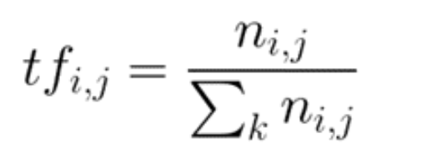

### Inverse Document Frequency

Inverse document frequency refers to the log of the total number of documents divided by the number of documents that contain the word. The logarithm is added to dampen the importance of a very high value of IDF.

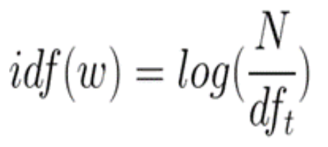

TFIDF is computed by multiplying the term frequency with the inverse document frequency.

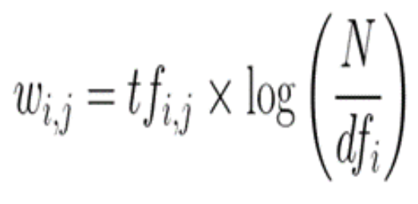

Reference:

<https://www.analyticsvidhya.com/blog/2021/07/bag-of-words-vs-tfidf-vectorization-a-hands-on-tutorial/#:~:text=TFIDF%20works%20by%20proportionally%20increasing,given%20a%20very%20high%20rank>.

### Fake News Detection

Passive aggressive classifiers trained with TFIDF vectors are useful for building models that detect fake news.

The steps for fitting the model are:

# 1. Initialize a TfidfVectorizer to remove stop words. 'a', 'is', 'the'

tfidf_vectorizer = TfidfVectorizer(stop_words='english', max_df=0.7)

# 2. Transform text to numeric TFIDF vectors.

tfidf_train = tfidf_vectorizer.fit_transform(x_train)

tfidf_test = tfidf_vectorizer.transform(x_test)

# 3. Initialize a PassiveAggressiveClassifier with TFIDF vectors.

pac = PassiveAggressiveClassifier()

pac.fit(tfidf_train,y_train)

Example : Fake News Detection

Here is the full code solution which builds the passive aggressive classifier for detecting fake news.

|  |
| --- |
| import numpy as np  import pandas as pd  import itertools  from sklearn.model_selection import train_test_split  from sklearn.feature_extraction.text import TfidfVectorizer  from sklearn.linear_model import PassiveAggressiveClassifier  from sklearn.metrics import accuracy_score, confusion_matrix, classification_report  #Read the data  df = pd.read_csv('/Users/pm/Downloads/FakeNews.csv')  #Get shape and head  print(df.shape)  print(df.head())  pd.set_option('display.max_colwidth', None)  print(df.head(1))  # Fake Articles  print("Number of FAKE articles: " + str(np.sum(df['label'] == 'FAKE')))  # Real Articles  print("Number of REAL articles: " + str(np.sum(df['label'] == 'REAL')))  # Fake Articles  print("Number of FAKE articles: " + str(np.sum(df['label'] == 'FAKE')))  # Real Articles  print("Number of REAL articles: " + str(np.sum(df['label'] == 'REAL')))  # Split the dataset  x_train, x_test, y_train, y_test = train_test_split(df['text'], df['label'], test_size=0.2, random_state=7)  # Initialize a TfidfVectorizer  tfidf_vectorizer = TfidfVectorizer(stop_words='english', max_df=0.7)  # Fit and transform train set, transform test set  tfidf_train = tfidf_vectorizer.fit_transform(x_train)  tfidf_test = tfidf_vectorizer.transform(x_test)  # Initialize a PassiveAggressiveClassifier  pac = PassiveAggressiveClassifier()  pac.fit(tfidf_train,y_train)  #- Predict on the test set and calculate accuracy  y_pred=pac.predict(tfidf_test)  score=accuracy_score(y_test,y_pred)  print(f'Accuracy: {round(score*100,2)}%')  # Build confusion matrix  confusion_matrix(y_test,y_pred, labels=['FAKE','REAL'])  # Creating classification report  print(classification_report(y_test, y_pred)) |

Exercise (3 marks)

Create two news items with your name in it.

data = np.array(['Pat McGee is going to space.', 'Pat McGee works at BCIT.'])

series = pd.Series(data)

Transform the data and make a prediction with the model to determine if the statements are true. Show the extra code needed to transform sentences with your name in it and to make predictions as to whether the statements are fake or not.

|  |
| --- |
| data = np.array(['Victor is going to space.', 'Victor studies at BCIT.'])  series = pd.Series(data)  # Transform the data  tfidf_data = tfidf_vectorizer.transform(series)  # Make a prediction  y_pred_data = pac.predict(tfidf_data)  # Print the predictions  for i in range(len(series)):      if y_pred_data[i] == 'FAKE':          print(f"The statement '{series[i]}' is FAKE.")      else:          print(f"The statement '{series[i]}' is TRUE.") |

Show a screenshot of your output here:

|  |
| --- |
|  |

## Visualizing CNN Output with Trulens

Convolutional Neural Networks (ConvNets or CNNs) have gained massive popularity in recent years, mostly being used to analyze visual imagery. Their applications are wide-ranging, from simple binary classifiers to complex models that are used in hospitals to identify tumors. Despite being so widely used, CNNs are still somewhat of a black box: it is not always clear “why” a model makes the prediction that it does. Without this information, how can researchers and developers be sure their models will work in the real world?

Trulens offers ways to analyze how a CNN image classifier model makes predictions. These analytical tools can help generate attention heatmaps for input images, showing us just where the model is looking when it makes a prediction. TruLens also provides additional insights such as showing the most important feature map in each layer, giving us important information for evaluating our models.

Trulens is compatible with Keras and Pytorch CNN’s. Documentation is available at:

<https://github.com/truera/trulens>

Example : Preparing the CNN for use with Trulens

The different steps in this section explain how to set up the CNN and how to prepare it for a visualization of its outputs.

To setup your system to run a project utilizing these tools, run the following import code in a Jupyter Notebook or Google Colab cell. I used Google Colab.

|  |
| --- |
| # Here are all the imports that we'll need. Please comment out if you have them installed (not neccessary just for peace of mind).  import sys  !{sys.executable} -m pip install trulens  !{sys.executable} -m pip install torchvision  !{sys.executable} -m pip install matplotlib  !{sys.executable} -m pip install pandas  !{sys.executable} -m pip install scipy  !{sys.executable} -m pip install tensorflow  !{sys.executable} -m pip install torchsummary  !{sys.executable} -m pip install torch  !{sys.executable} -m pip install IPython  !{sys.executable} -m pip install numpy --upgrade  !{sys.executable} -m pip install Pillow |

Next run the following import statement to import all of the relevant libraries into your Jupyter Notebook

|  |
| --- |
| # Import all the libraries we'll need  import json  import PIL  import requests  import scipy.misc  import torch  import torch.nn as nn  import torchvision  import matplotlib.pyplot as plt  import matplotlib.cm as cm  import numpy as np  import pandas as pd  import tensorflow as tf  import torchvision.utils as utils  import torchvision.models as models  import torchvision.transforms as transforms  from IPython.display import Image, display  from tensorflow import keras  from torchsummary import summary  from torch.autograd import Variable  from trulens.nn.attribution import InputAttribution  from trulens.nn.attribution import IntegratedGradients  from trulens.visualizations import ChannelMaskVisualizer  from trulens.visualizations import MaskVisualizer  from trulens.visualizations import HeatmapVisualizer  from trulens.nn.models import get_model_wrapper  from trulens.nn.attribution import InternalInfluence  from trulens.nn.distributions import PointDoi  from trulens.nn.quantities import ClassQoI, InternalChannelQoI, MaxClassQoI  from trulens.nn.slices import Cut, InputCut, OutputCut, Slice |

This next step will display the figures inline in your notebook cell.

|  |
| --- |
| # Display matplotlib figures in the cell  %matplotlib inline |

#### Load Pre-Trained PyTorch CNN Model

Now that the environment is setup, we’ll be importing a pre-trained VGG16 model from pyTorch. Just as a quick introduction, VGG16 is a CNN developed by the Visual Geometry Group from Oxford University. This model won the ImageNet Large Scale Visual Recognition Challenge (ILSVRC) in 2014, and is widely considered one of the best image classifier models to currently exist. It is able to classify over 1000 objects with ~93% accuracy. The 16 in VGG16 stands for 16 weighted layers (13 Convolution layers and 3 Dense layers).

This next block of code imports the pre-trained model and creates a wrapped model with TruLens, which we will use later for analysis. It will also print out a quick summary of the model, showing layers and output shapes.

|  |
| --- |
| # Create a Pytorch VGG16 model  pytorch_model = models.vgg16(pretrained=True)  device = 'cpu'    # Produce a wrapped model from the pytorch model for Trulens.  wrapped_model = get_model_wrapper(pytorch_model, input_shape=(3,224,224), device=device)  print(summary(pytorch_model, (3, 224, 224))) |

#### Transform Image to Appropriate Size

In the following block of code, we’ll use the Pillow library to open an image from a URL on your device and then make transformations on that image to an appropriate size in order to pass it to the VGG16 model. In Jupyter, it will also show a Matplotlib diagram of the original image.

You will need to upload an image to a place where your notebook can access it. Name your image accordingly.

|  |
| --- |
| url = "beaglebike.jpg"  with PIL.Image.open(url) as img:  x = np.array(img.resize((224,224), PIL.Image.ANTIALIAS))[np.newaxis]    # Pre-process uploaded image  normalize = transforms.Compose([  transforms.ToTensor(), # convert to [0, 1]    # Means and stddevs of ImageNet (calculated from their image library)  transforms.Normalize(  mean=[0.485, 0.456, 0.406],  std=[0.229, 0.224, 0.225])])  processed_image = np.array(normalize(x[0])).transpose(1, 2, 0)[np.newaxis]    # Transpose to [*, C, H, W] for PyTorch convention.  x = x.transpose(0, 3, 1, 2)  processed_image = processed_image.transpose(0, 3, 1, 2)  plt.imshow(img) |

Now that the model and input image are ready, we can make predictions. Before we pass the image through the model, we use the following code to collect some useful information along the way. This code will collect all the convolution layers.

#### Show Information about the CNN

Total convolution layers: 13

|  |
| --- |
| # we will save the conv layer weights in this list  model_weights =[]    #we will save the 13 conv layers in this list  conv_layers = []    # get all the model children as list  model_children1 = list(pytorch_model.children())  model_children = model_children1[0]    #counter to keep count of the conv layers  counter = 0    #append all the conv layers and their weights to the list  for i in range(len(model_children)):  if type(model_children[i]) == nn.Conv2d:  counter+=1  model_weights.append(model_children[i].weight)  conv_layers.append(model_children[i])  elif type(model_children[i]) == nn.Sequential:  for j in range(len(model_children[i])):  for child in model_children[i][j].children():  if type(child) == nn.Conv2d:  counter+=1  model_weights.append(child.weight)  conv_layers.append(child)  print(f"Total convolution layers: {counter}") |

#### Generator Proper Tensor Format

Then run the model, make transformations on the input image. This will print out the image shape before being passed to our model.

|  |
| --- |
| # run the model with cuda if available, else use cpu  device = torch.device("cuda" if torch.cuda.is_available() else "cpu")  x_model = pytorch_model.to(device)    # show how transformations change image shape  transform = transforms.Compose([  transforms.Resize((224, 224)),  transforms.ToTensor(),  transforms.Normalize(mean=[0.485, 0.456, 0.406],  std=[0.229, 0.224, 0.225])])  image = transform(img)  print(f"Image shape before: {image.shape}")  image = image.unsqueeze(0)  print(f"Image shape after: {image.shape}")  image = image.to(device) |

#### Show the Convolutional Layers

Now, just for a quick double-check, print out the names of all of the convolution layers:

Name: Conv2d(3, 64, kernel_size=(3, 3), stride=(1, 1), padding=(1, 1)); Shape:torch.Size([1, 64, 224, 224])

Name: Conv2d(64, 64, kernel_size=(3, 3), stride=(1, 1), padding=(1, 1)); Shape:torch.Size([1, 64, 224, 224])

Name: Conv2d(64, 128, kernel_size=(3, 3), stride=(1, 1), padding=(1, 1)); Shape:torch.Size([1, 128, 224, 224])

Name: Conv2d(128, 128, kernel_size=(3, 3), stride=(1, 1), padding=(1, 1)); Shape:torch.Size([1, 128, 224, 224])

Name: Conv2d(128, 256, kernel_size=(3, 3), stride=(1, 1), padding=(1, 1)); Shape:torch.Size([1, 256, 224, 224])

Name: Conv2d(256, 256, kernel_size=(3, 3), stride=(1, 1), padding=(1, 1)); Shape:torch.Size([1, 256, 224, 224])

Name: Conv2d(256, 256, kernel_size=(3, 3), stride=(1, 1), padding=(1, 1)); Shape:torch.Size([1, 256, 224, 224])

Name: Conv2d(256, 512, kernel_size=(3, 3), stride=(1, 1), padding=(1, 1)); Shape:torch.Size([1, 512, 224, 224])

Name: Conv2d(512, 512, kernel_size=(3, 3), stride=(1, 1), padding=(1, 1)); Shape:torch.Size([1, 512, 224, 224])

Name: Conv2d(512, 512, kernel_size=(3, 3), stride=(1, 1), padding=(1, 1)); Shape:torch.Size([1, 512, 224, 224])

Name: Conv2d(512, 512, kernel_size=(3, 3), stride=(1, 1), padding=(1, 1)); Shape:torch.Size([1, 512, 224, 224])

Name: Conv2d(512, 512, kernel_size=(3, 3), stride=(1, 1), padding=(1, 1)); Shape:torch.Size([1, 512, 224, 224])

Name: Conv2d(512, 512, kernel_size=(3, 3), stride=(1, 1), padding=(1, 1)); Shape:torch.Size([1, 512, 224, 224])

Here is the code:

|  |
| --- |
| outputs = []  names = []  for layer in conv_layers[0:]:  image = layer(image)  outputs.append(image)  names.append(str(layer))    joined = list(zip(names,outputs))  for i in joined:  print(f"Name: {i[0]}; Shape:{i[1].shape}") |

### Observing How an Image is Processed In Each Layer of the CNN

Example : Observing how an Image is Processed in Each Layer of the CNN

The code below will use the data we set up earlier to show how the image is processed by VGG16 at each convolution layer. You can see how edges are being collected, and how the Gaussian blur is applied. You can see how it gets less and less detail as it goes further.

|  |
| --- |
| processed = []  for feature_map in outputs:  feature_map = feature_map.squeeze(0)  gray_scale = torch.sum(feature_map,0)  gray_scale = gray_scale / feature_map.shape[0]  processed.append(gray_scale.data.cpu().numpy())    fig = plt.figure(figsize=(30, 50))  for i in range(len(processed)):  a = fig.add_subplot(5, 4, i+1)  imgplot = plt.imshow(processed[i])  a.axis("off")  a.set_title(names[i].split('(')[0], fontsize=30)  plt.savefig(str('feature_maps.jpg'), bbox_inches='tight') |

Figure : Output from Each Convolutional Layer



Exercise (1 mark)

Do not overthink this question. I am just aiming for a basic understanding. Please explain why there are 13 images in Figure 1.

|  |
| --- |
| There are 13 convolution layers |

Exercise (1 mark)

What can you say about the amount of detail in each image that is output from one convolutional layer to the next?

|  |
| --- |
| After each layer, the extracted feature become more complex. |

#### Showing the Predictions

Example : Showing the Predictions

Now, use the model to print out prediction scores for all of the labels in the Imagenet classification library. To run this code you will need to download the *.json file and upload it to Google Colab.

<https://github.com/raghakot/keras-vis/blob/master/resources/imagenet_class_index.json>

|  |
| --- |
| # Make predictions using pytorch model and write them to output  with torch.no_grad():  output = pytorch_model(torch.from_numpy(processed_image).to('cpu')).cpu().numpy()  df = pd.DataFrame(output)  df = df.transpose()  df  # Open classifications file  with open('imagenet_class_index.json') as file:  classes_index = json.load(file)    # change indexes to labels  labels_from_index = [classes_index[str(x)][1] for x in range(len(classes_index))]  top_labels = [  (j, labels_from_index[j], output[0][j])  for j in np.argsort(output[0])[::-1][:10]]    # Top 10 predictions of image by pytorch VGG16  df = pd.DataFrame(top_labels, columns=["Index", "Name", "Score"])  df |

The output shows a listing of objects that have been detected.

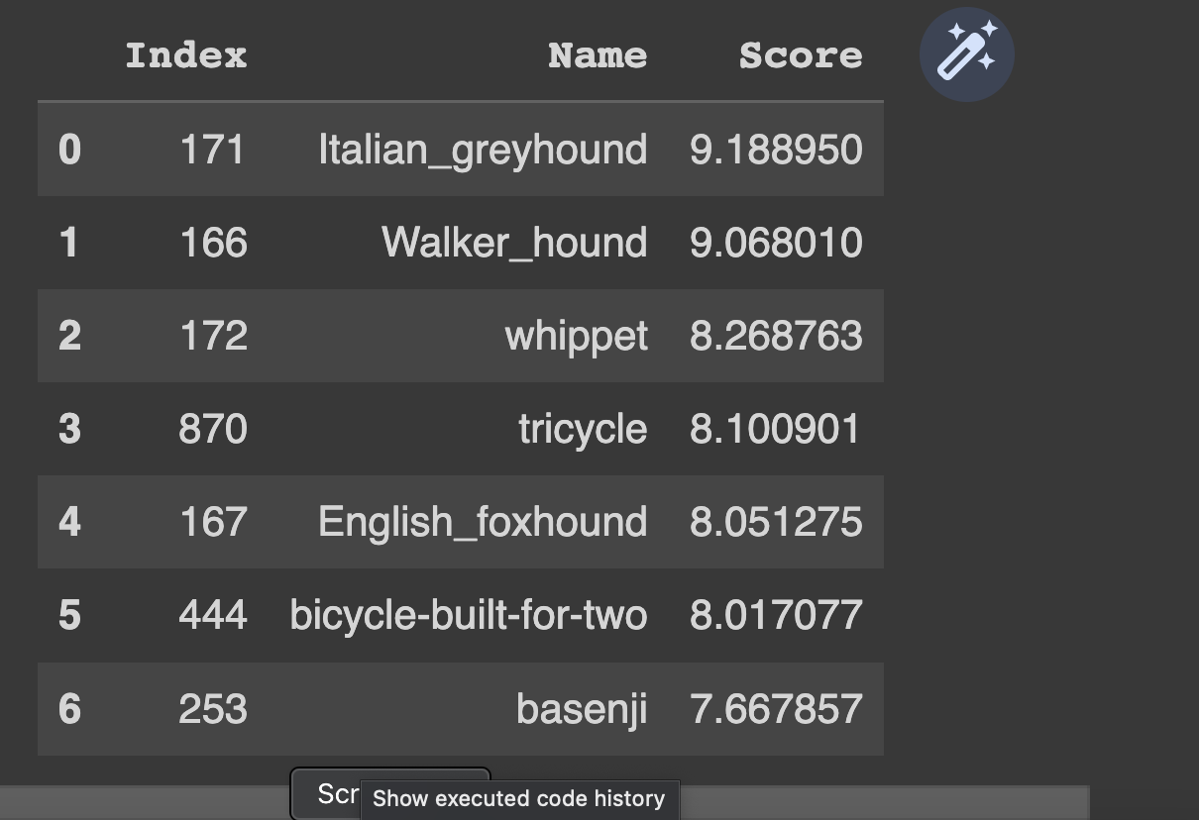

### Using MaskVisualizer from TruLens to Observe Where Model Focused

A MaskVisualizer can be used to highlights pixels where the model focused most when making the predictions. This visualizer receives blur and threshold parameters. **Blur** helps users see a more generalized area of interest. **Threshold** selects the areas of most interest.

Figure : Observing Areas of Model Focus Using MaskVisualizer

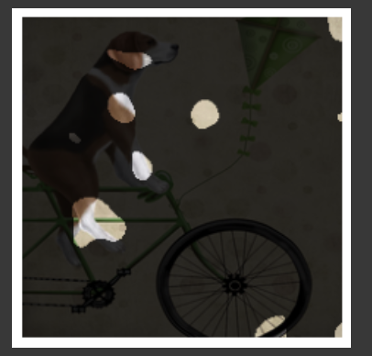

Example : Observing with the CNN Model Focused

This code generates a saliency map to highlight the features that were observed the most by the model for classification.

|  |
| --- |
| from trulens.nn.attribution import InputAttribution  from trulens.nn.attribution import IntegratedGradients  from trulens.visualizations import MaskVisualizer    # A mask is applied to reveal the top threshold % of pixels by attribution.  infl = InputAttribution(wrapped_model)  attrs_input = infl.attributions(processed_image)  masked_image = MaskVisualizer(blur=10, threshold=0.95)(attrs_input, x) |

Exercise (2 marks)

Run the code above again but use blur = 7 and threshold=0.90. Show the output result.

|  |
| --- |
| Original picture: |

Explain how the output is different than the output in Figure 2.

|  |
| --- |
| Using a blur of 7 results in less blur than a blur of 10. There are more details in the result but also more noise. Using a threshold of 0.90 results in a mask highlighting 90% of the pixels through attribution. Similarly using a threshold of 0.95 results in a mask highlighting 95% of the pixels. |

### Visualizing the Gradient of the Prediction Output Using IntegratedGradients from TruLens

IntegratedGradients from TruLens, computes the gradient of the model’s prediction output. The integrated gradients (IG) method is widely used to evaluate the extent to which each feature contributes to the classification.

Figure : Observing Gradient Output with a Saliency Map and a Heatmap

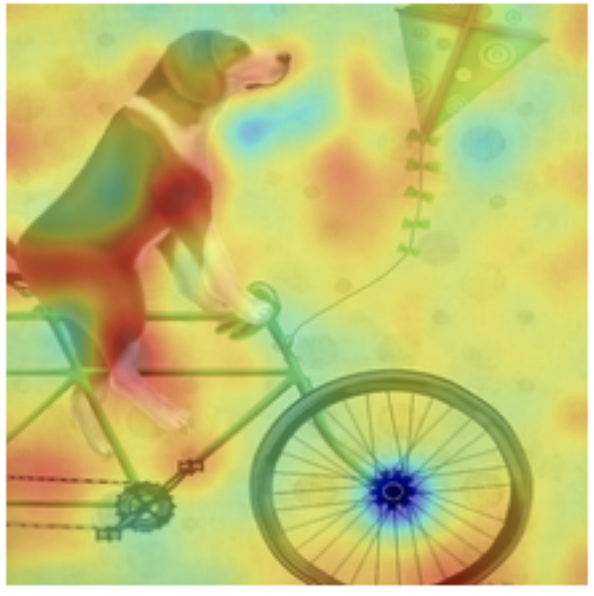

Example : Observing Gradient Output with a Saliency Map and a Heatmap

|  |
| --- |
| infl = IntegratedGradients(wrapped_model, resolution=10)  attrs_input = infl.attributions(processed_image)  masked_image = MaskVisualizer(blur=10, threshold=0.95)(attrs_input, x)  infl = IntegratedGradients(wrapped_model, resolution=10)  attrs_input = infl.attributions(processed_image)  masked_image = HeatmapVisualizer(blur=10)(attrs_input, x) |

Exercise (1 mark)

Explain why the gradient of the prediction is important.

|  |
| --- |
| Calculating the gradient helps identify important input features. With this information we can improve the models performance. |

### Calculating Attributions for Individual Neurons

An attribution measures the contribution of a function’s output in the classification model. The code below shows TruLens’ how to calculate attributions for individual neurons within a model. TruLens can reveal how feature maps in each layer are critical for model decision-making.

Example : Calculating and Showing Attributions for Individual Neurons

|  |
| --- |
| from trulens.nn.attribution import InternalInfluence  from trulens.nn.distributions import PointDoi  from trulens.nn.quantities import ClassQoI, InternalChannelQoI, MaxClassQoI  from trulens.nn.slices import Cut, InputCut, OutputCut, Slice  # Slice defines a layer to use for internal attributions.  # QoI (quantity of interest), defines the model behavior to explain using  # attributions, it is the output of some layer.  # DoI (distribution of interest) specifies points surrounding each record for  # attribution calculations.    # Define the influence measure.  infl = InternalInfluence(  wrapped_model,  Slice(Cut('features_28'), OutputCut()),  MaxClassQoI(),  PointDoi())    attrs_internal = infl.attributions(processed_image).sum(axis=(2,3)) |

This following code will show the top feature map in features_28, model at that layer.

Number of neurons in layer features_28: 512

Top feature map: 3

|  |
| --- |
| # Define the influence measure.  infl = InternalInfluence(wrapped_model, 'features_28', 'max', 'point')    # Get the attributions for the internal neurons at layer 'features_28'. Because  # layer 'features_28' contains 2D feature maps, we take the sum over the width  # and height of the feature maps to obtain a single attribution for each feature  # map.  attrs_internal = infl.attributions(processed_image).sum(axis=(2,3))  print(f"Number of neurons in layer features_28: {len(attrs_internal[0])}")    top_feature_map = int(attrs_internal[0].argmax())    print('Top feature map:', top_feature_map) |

And this code will show the image with an attention mask for that layer:

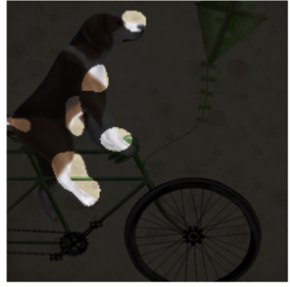

|  |
| --- |
| # Since feature maps represent learned features we can’t easily interepret them  # But Trulens can use a second set of attributions to find input features that are  # most important in defining THIS particular feature map  masked_image = ChannelMaskVisualizer(  wrapped_model,  'features_28',  top_feature_map,  blur=10,  threshold=0.95)(x, processed_image)  plt.axis('off')  plt.imshow(masked_image[0].transpose((1,2,0))) |

Exercise (2 marks)

How many feature maps are there? Explain how you figured this number out?

|  |
| --- |
| There are 512 feature maps in the “features_28” layer.  Length of the first element attrs_internal = infl.attributions(processed_image).sum(axis=(2,3)) |

Exercise (1 mark)

Show the visualization for features_27.

|  |
| --- |
|  |

Table of Contents

Recurrent Neural Networks (RNNs) 1

Sequential Data 1

Learning Sequences 2

Hidden State 2

Long Short-Term Memory Networks 2

LSTM’s for Prediction in Wave Seqeuences 5

Tokenizing and Sequencing Sentences 7

Long Short-Term Memory Terminology 9

Embedding Layer 9

LSTM Layers 9

Further Improvements 12

## Recurrent Neural Networks (RNNs)

This initial discussion about RNNs is based on the video at <https://www.youtube.com/watch?v=LHXXI4-IEns>

### Sequential Data

Recurrent neural networks help to explain sequential data. For example, when trying to predict the direction of a moving ball, it is difficult to know with only the current position. Figure 1 shows a snapshot of the ball at its current position.

Figure : Current Snapshot of a Ball



To improve your accuracy, you need to know where the ball has been. Figure 2 shows several snapshots of the ball’s historical positions in succession.

Figure : Sequence of Ball Positions



Sequence data can be obtained and stored in many different ways. For example, audio files contain wave data which is sequential.



Words also follow a sequence. If you only read the words “the beach” you have no context about why “the beach” is mentioned. A more complete sentence with leading words provides more detail.

Mocha and Cocoa went to the beach.

In all sequential cases if we understand what occurred earlier we can better understand the current context.

### Learning Sequences

Learning sequences can help with understanding. For example, if you were asked to list the letters of the alphabet you could very quickly recall the letters in a typical order. If you were asked to list the letters of the alphabet in reverse order you would probably pause and walk through those steps more slowly. However, an alternate sequence can be learned to make the task easier.

### Hidden State

RNN’s include a hidden state to reference previous inputs. Figure 3 shows 5 steps to understand the meaning behind “What time is it?”. At the first step, the word “what” is read. At the second step, the word “time” is read and “what” is contained in a hidden state. In the third step, “is” is read and the previous two words are stored in the hidden state. By step 5, the representation of the initial states is proportionally weighted less. As the RNN processes more steps it has difficulty retaining information from previous steps. Short term memory and vanishing gradients can often make it challenging for RNN’s to model with sequential data.

Figure : Tracking Hidden States with RNN’s

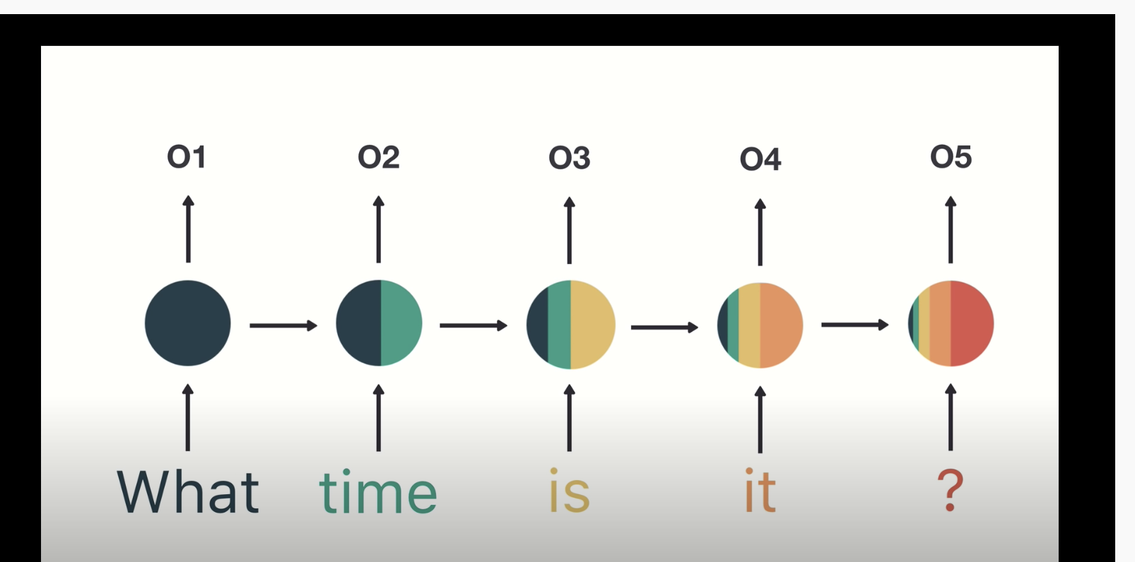

## Long Short-Term Memory Networks

LSTM’s were developed to overcome problems with RNN’s. LSTM’s use gates which perform operations to learn what to store in memory.

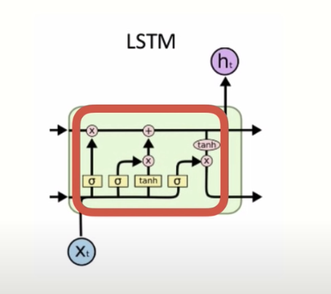

LSTM’s are computationally more expensive than RNN’s but LSTM’s can offer significant improvement to manage context about sequences. The result though is LSTM’s are very slow to train.

Example : Single Layer LSTM

(This example is based on chapter 6 from Long Short-Term Memory Networks by Dr. Jason Brownlee)

As mentioned earlier, LSTM’s use gates to determine what to store in memory. This example trains on samples of five numbers that range between 0 and 9. The numbers are one-hot-encoded so:

[5, 8, 3, 0, 9]

Becomes

# [[0, 0, 0, 0, 0, 1, 0, 0, 0, 0]

# [0, 0, 0, 0, 0, 0, 0, 0, 1, 0]

# [0, 0, 0, 1, 0, 0, 0, 0, 0, 0] # Third element where index = 2

# [1, 0, 0, 0, 0, 0, 0, 0, 0, 0]

# [0, 0, 0, 0, 0, 0, 0, 0, 0, 1]]

The target variable during training is always represented by the third element. In other words, y = 3 for this case. When the model is trained it will almost always pick the second element:

The code that creates the model and updates the weights is highlighted in green.

Here is the full program:

|  |
| --- |
| from random import randint  from numpy import array  from numpy import argmax  from keras.models import Sequential  from keras.layers import LSTM  from keras.layers import Dense  NUM_FEATURES = 10  NUM_SAMPLES = 5  TARGET_INDEX = 2  NUM_WEIGHT_UPDATES = 100  # generate array of 5 numbers like [5, 8, 3, 0, 9].  # each number is >=0 and <10  def generate_sequence():  return [randint(0, NUM_FEATURES-1) for _ in range(NUM_SAMPLES)]  # one hot encode sequence  def oneHotEncode(sequence):  encoding = list()  # Convert [5, 8, 3, 0, 9]  # to  # [[0, 0, 0, 0, 0, 1, 0, 0, 0, 0]  # [0, 0, 0, 0, 0, 0, 0, 0, 1, 0]  # [0, 0, 0, 1, 0, 0, 0, 0, 0, 0]  # [1, 0, 0, 0, 0, 0, 0, 0, 0, 0]  # [0, 0, 0, 0, 0, 0, 0, 0, 0, 1]]  for value in sequence:  # Create vector of zeros.  vector = [0 for _ in range(NUM_FEATURES)]  vector[value] = 1 # Add 1 to vector.  encoding.append(vector)  return array(encoding)  # decode a one hot encoded string  def oneHotDecode(encoded_seq):  # gets index of element with the maximum value.  return [argmax(vector) for vector in encoded_seq]  # generate one example for an lstm  def generateSample(targetIndex):  # generate sequence such as [5, 8, 3, 0, 9]  sequence = generate_sequence()  # one hot encode sequence so [5, 8, 3, 0, 9] becomes  # [[0, 0, 0, 0, 0, 1, 0, 0, 0, 0]  # [0, 0, 0, 0, 0, 0, 0, 0, 1, 0]  # [0, 0, 0, 1, 0, 0, 0, 0, 0, 0]  # [1, 0, 0, 0, 0, 0, 0, 0, 0, 0]  # [0, 0, 0, 0, 0, 0, 0, 0, 0, 1]]  encoded = oneHotEncode(sequence)  # reshape sequence to be 3D  X = encoded.reshape((1, NUM_SAMPLES, NUM_FEATURES))  # y becomes 1-hot encoded version of 3rd element of [5,8,3,0,9]  # [0, 0, 0, 1, 0, 0, 0, 0, 0, 0]  y = encoded[targetIndex].reshape(1, NUM_FEATURES)  return X, y  # define model  model = Sequential()  model.add(LSTM(25, input_shape=(NUM_SAMPLES, NUM_FEATURES)))  model.add(Dense(NUM_FEATURES, activation='softmax'))  # Our output is a one-hot encoded vector so use categorical  # crossentropy.  model.compile(loss='categorical_crossentropy',  optimizer='adam', metrics=['accuracy'])  model.summary()  for i in range(10000):  trainX, trainy = generateSample(TARGET_INDEX)  # Update model - weights are updated and are not reset.  model.fit(trainX, trainy, epochs=1, verbose=2)  # evaluate model  correct = 0  NUM_EVALUATIONS = 100  for i in range(NUM_EVALUATIONS):  X, y = generateSample(TARGET_INDEX)  yhat = model.predict(X)  if oneHotDecode(yhat) == oneHotDecode(y):  correct += 1  print('Accuracy: %f' % ((correct / NUM_EVALUATIONS))) |

Exercise (1 mark)

When model.fit() is called, indicate if the weights are updated or reset.

1. Updated b) Reset

## LSTM’s for Prediction in Wave Seqeuences

Multilayer LSTM’s have additional memory cells and each layer helps to boost performance by solving different parts of the problem.

Example : Predicting Wave Sequences

(This example is based on chapter 7 from Long Short Term Memory Networks by Dr. Jason Brownlee)

This example shows how a multi-layer LSTM can help to predict the next step in a sine wave sequence.

Samples used for this example include sets of sine waves that are defined by 55 points each. The first 50 points in the sequence define X. The last five points in the sequence are held back for y.

Figure : Three sequential sine wave samples. The first 50 points are X. The last 5 points are y.

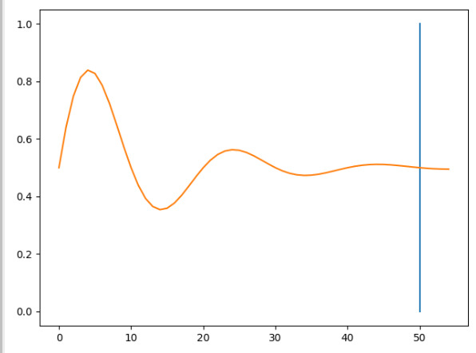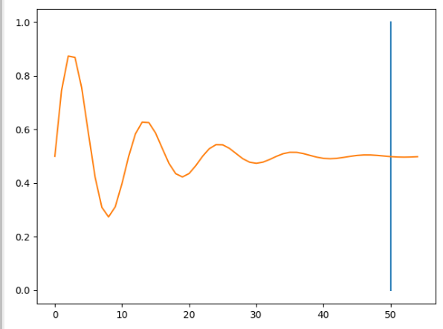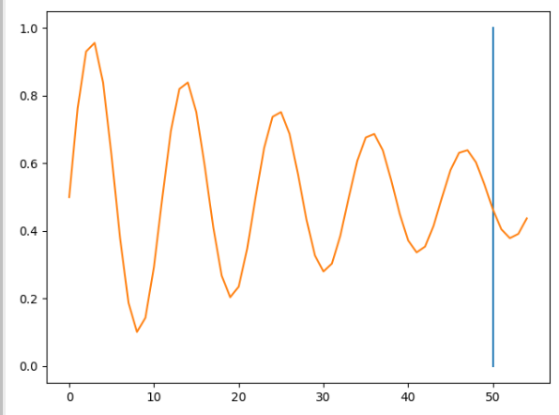

The fitted model tries to predict the next five steps in the sequence.

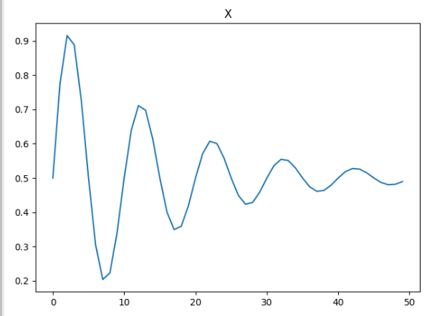 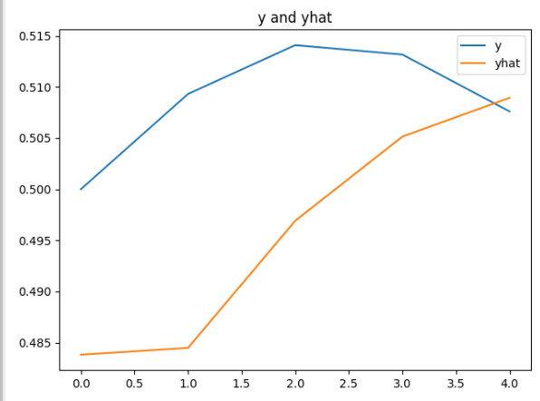

Here is the code:

|  |
| --- |
| from math import sin  from math import pi  from math import exp  from random import randint  from random import uniform  from numpy import array  from matplotlib import pyplot  from keras.models import Sequential  from keras.layers import LSTM  from keras.layers import Dense  # generate damped sine wave in [0,1]  def getWaveSequence(length, period, decay):  return [0.5 + 0.5 * sin(2 * pi * i / period) * exp(-decay * i) \  for i in range(length)]  # generate input and output pairs of damped sine waves  def generateWaveSamples(input_len, n_patterns, output_len):  X, y = list(), list()  for _ in range(n_patterns):  p = randint(10, 20)  d = uniform(0.01, 0.1)  wave_sequence = getWaveSequence(input_len + output_len, p, d)  x_data = wave_sequence[:-output_len]  X.append(x_data)  y_data = wave_sequence[-output_len:]  y.append(y_data) # Assigns next 5 values in sequence.  X = array(X).reshape(n_patterns, input_len, 1)  y = array(y).reshape(n_patterns, output_len)  return X, y  # configure problem  INPUT_LEN = 50  OUTPUT_LEN = 5  # define model  model = Sequential()  model.add(LSTM(20, input_shape=(INPUT_LEN, 1)))  model.add(Dense(OUTPUT_LEN))  model.compile(loss='mae', optimizer='adam')  model.summary()  # fit model  NUM_SAMPLES = 10000  X, y = generateWaveSamples(INPUT_LEN, NUM_SAMPLES, OUTPUT_LEN)  history = model.fit(X, y, batch_size=10, epochs=1)  # evaluate model  NUM_SAMPLES = 1000  X, y = generateWaveSamples(INPUT_LEN, NUM_SAMPLES, OUTPUT_LEN)  loss = model.evaluate(X, y, verbose=0)  print('Mean squared error: %f' % loss)  print("\n*** Make predictions")  for i in range(0, 5):  # prediction on new data  X, y = generateWaveSamples(INPUT_LEN, 1, OUTPUT_LEN)  yhat = model.predict(X, verbose=0)  pyplot.title("Y and Yhat")  pyplot.plot(y[0], label='y')  pyplot.plot(yhat[0], label='yhat')  pyplot.legend()  pyplot.show() |

## Tokenizing and Sequencing Sentences

LSTM’s can be used to predict sentiment so we will take a moment first to discuss tokenization which is the generation of numeric features.

Example : Tokenizing and Sequencing Sentences

This example explains the process of converting text to numeric vectors for modelling.

Starting with the following sentences:

"This is not yellow."

"This is a blue moon."

"Hello all."

texts_to_sequences()converts the sentences sets of integers:

[[1, 2, 3, 4],

[1, 2, 5, 6, 7],

[8, 9]]

The vectors are then padded with zeros so all sentence vectors are the same size. The first sentence vector represents four words. The second sentence vector represents five words. The third sentence vector represents two words.

|  |
| --- |
| array([[0, 1, 2, 3, 4],  [1, 2, 5, 6, 7],  [0, 0, 0, 8, 9]], dtype=int32) |

Here is all of the code which performs the transformation for the sentences. This code converts the code into a vertical array of features. We end up with is a vertical array of numerical features which is ideal input for a neural network.

|  |
| --- |
| from keras.preprocessing.text import Tokenizer  from keras_preprocessing.sequence import pad_sequences  sentence1 = "This is not yellow."  sentence2 = "This is a blue moon."  sentence3 = "Hello all."  sentences = [sentence1, sentence2, sentence3]  # Restrict tokenizer to use top 2500 words.  tokenizer = Tokenizer(num_words=2500, lower=True,split=' ')  tokenizer.fit_on_texts(sentences)  # Convert to sequence of integers.  X = tokenizer.texts_to_sequences(sentences)  print(X)  # Showing padded sentences:  paddedX = pad_sequences(X)  print(paddedX) |

Exercise (2 marks)

Just for fun, tokenize and pad the following sentences with your first and last name in it. Use three or more sentences such as:

YourFirstName Yourlastname is prepared to succeed.

YourFirstName Yourlastname sees opportunity in every challenge.

To get the mark, you must use your first and last name but if you want you can change the sentences. Show your code here:

|  |
| --- |
| from keras.preprocessing.text import Tokenizer import tensorflow as tf  sentence1 = "Victor Li is prepared to succeed." sentence2 = "Victor Li sees opportunity in every challenge." sentences = [sentence1, sentence2]  # Restrict tokenizer to use top 2500 words. tokenizer = Tokenizer(num_words=2500, lower=True, split=' ') tokenizer.fit_on_texts(sentences)  # Convert to sequence of integers. X = tokenizer.texts_to_sequences(sentences) print(X)  # Showing padded sentences: paddedX = tf.keras.utils.pad_sequences(X) print(paddedX) |

Show your final output after tokenizing and padding here. Highlight the numbers which represent your first and last name.

|  |
| --- |
| [[1, 2, 3, 4, 5, 6], [1, 2, 7, 8, 9, 10, 11]]  [[ 0 1 2 3 4 5 6]  [ 1 2 7 8 9 10 11]] |

## Long Short-Term Memory Terminology

We are not going to dive into the math or logic that enables an LSTM network but I will discuss some high-level definitions here before we build an LSTM model in code.

### Embedding Layer

Embedding layers are used in sentiment problems to store weights for words. Related words are geometrically closer such as dinner and kitchen. Words such as glacier and coconut are likely geometrically far apart. During a forward pass words are referenced in this layer to get a particular embedding.

### LSTM Layers

LSTM layers define cells for managing hidden states while iterating through different time steps. You have flexibility to adjust these values. Usually LSTM layers are accompanied with drop out layers.

Example : LSTM for Sentiment Analysis

This example predicts sentiment for yelp reviews. It is based on this example.

<https://towardsdatascience.com/understanding-lstm-and-its-quick-implementation-in-keras-for-sentiment-analysis-af410fd85b47>

I used a smaller file called yelp_mini.csv to save time while tuning the hyperparameters. A larger yelp_review.csv file is in the data sets folder for more rigorous training.

The loss and accuracy functions indicate a favourable situation where training and validation estimates coincide. Based on the graphs though, it may be possible that the model is underfit and that more epochs could improve results.

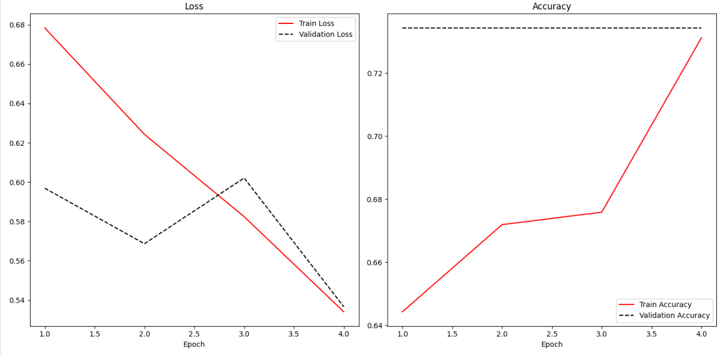

Here is the code:

|  |
| --- |
| import pandas as pd  import re  from keras_preprocessing.sequence import pad_sequences  from sklearn.model_selection import train_test_split  from tensorflow.python.keras import Sequential  from tensorflow.python.keras.layers import Embedding, LSTM, Dense  PATH = "/Users/pm/Desktop/DayDocs/data/"  FILE = "yelp_mini.csv"  data = pd.read_csv(PATH + FILE)  # Show all columns.  pd.set_option('display.max_columns', None)  pd.set_option('display.width', 1000)  # Create a sentiment column.  # Ratings above 3 are positive, otherwise they are negative.  data['sentiment'] = ['pos' if (x>3) else 'neg' for x in data['stars']]  data['text'] = data['text'].apply((lambda x: re.sub('[^a-zA-z0-9\s]','',x)))  from keras.preprocessing.text import Tokenizer  VOCABULARY_SIZE = 2500  tokenizer = Tokenizer(num_words=VOCABULARY_SIZE, lower=True,split=' ')  tokenizer.fit_on_texts(data['text'].values)  X = tokenizer.texts_to_sequences(data['text'].values)  X = pad_sequences(X)  WORDS_PER_SENTENCE = X.shape[0]  NUM_REVIEWS = X.shape[1]  import numpy as np  VOCABULARY_SIZE = np.amax(X) + 1  word_info_sz = 128 # Size of output vector for each word.  # This can be changed.    # Stores info about word sequence -  # "Eat to live" vs. "Live to eat" are very different.  sentence_info_sz = 200 # Vector size for storing info about  # entire sequence.  # This can be changed.  batch_size = 32  model = Sequential()  model.add(Embedding(VOCABULARY_SIZE, word_info_sz))  model.add(LSTM(sentence_info_sz, dropout=0.2))  model.add(Dense(2, activation='softmax')) # Two column one-hot encoded output.  # Target data is one-hot encoded so we must use ‘categorical_crossentropy’ for loss.  # Here we are using one-hot encoding so we must use categorical_crossentropy.  # One-hot encoding is a fancy way to say multi-column binary encoding.  # Y_train  # [[0 1]  # [1 0]  # [0 1]  model.compile(loss = 'categorical_crossentropy',  optimizer='adam',metrics = ['accuracy'])  print(model.summary())  Y = pd.get_dummies(data['sentiment']).values  X_train, X_test, Y_train, y_test = train_test_split(X,Y, test_size = 0.20)  history = model.fit(X_train, Y_train, batch_size =batch_size, epochs =4,  verbose = 1, validation_data=(X_test, y_test))  score, acc = model.evaluate(X_test, y_test, verbose=2, batch_size=batch_size)  print("Score: %.2f" % (score))  print("Validation Accuracy: %.2f" % (acc))  import matplotlib.pyplot as plt  def showLoss(history):  # Get training and test loss histories  training_loss = history.history['loss']  validation_loss = history.history['val_loss']  # Create count of the number of epochs  epoch_count = range(1, len(training_loss) + 1)  plt.subplot(1, 2, 1)  # Visualize loss history for training data.  plt.plot(epoch_count, training_loss, label='Train Loss', color='red')  # View loss on unseen data.  plt.plot(epoch_count, validation_loss, 'r--', label='Validation Loss',  color='black')  plt.xlabel('Epoch')  plt.legend(loc="best")  plt.title("Loss")  def showAccuracy(history):  # Get training and test loss histories  training_loss = history.history['accuracy']  validation_loss = history.history['val_accuracy']  # Create count of the number of epochs  epoch_count = range(1, len(training_loss) + 1)  plt.subplot(1, 2, 2)  # Visualize loss history for training data.  plt.plot(epoch_count, training_loss, label='Train Accuracy', color='red')  # View loss on unseen data.  plt.plot(epoch_count, validation_loss, 'r--',  label='Validation Accuracy', color='black')  plt.xlabel('Epoch')  plt.legend(loc="best")  plt.title('Accuracy')  plt.subplots(nrows=1, ncols=2, figsize=(14,7))  showLoss(history)  showAccuracy(history)  plt.show() |

## Further Improvements

* We can use much larger dataset with more epochs to increase the accuracy. See yelp_review.csv.
* We might use more hidden dense layers can be used to improve the accuracy (or not). We can tune other hyper parameters as well.

Exercise (1 mark)

What kind of loss function option is suitable when the target variable values are stored in a single column and values range between 0 and 1. You may have to refer to notes from earlier in the course to confirm.

|  |
| --- |
| Binary cross-entropy or log loss is good for binary classification problems. |

Exercise (1 mark)

What kind of loss function option is appropriate when the target variable values are stored in multiple columns and values for each column range between 0 and 1.

|  |
| --- |
| Categorical cross-entropy loss can be used. However, it assumes each sample belongs to only one class. For Binary cross-entropy, each sample can be from multiple classes. It will depend on the samples. |

Exercise (1 mark)

What kind of loss function option is appropriate when the target variable values are stored in a single column and the possible values range between 0 and 5?

|  |
| --- |
| Categorical cross-entropy loss is good for multi-class classification problems. |

Exercise (1 mark)

What kind of loss function option is appropriate when the target variable is one hot encoded?

|  |
| --- |
| Categorical cross-entropy loss |

Exercise (5 marks)

Grid search the word vector and sequence vector sizes ideally to improve accuracy. Or, if accuracy cannot be improved, then determine if the word vector and sequence vector sizes be reduced without deteriorating the accuracy.

NOTE: LSTM’s take a notoriously long amount of time to run. Please keep your grid search reasonable. You might choose to use a smaller version of the original data set to avoid a lengthy amount of training time.

Tip: The loss plot shows that likely more epochs would help.  Better results might also involve adjusting the learning rate as well.

You might also increase the word_info_sz. If you had time you could even increase the sentence_info_sz. Probably you will get better results but the training time will be extensive.

Training could take a long time so you may decide to tune these parameters separately rather than in an exhaustive grid search. A cloud-based solution might also help to alleviate some of the processing demand.

Show your accuracy score, word vector and sequence vector sizes here:

|  |
| --- |
|  |

Show the code used to perform the grid search here:

|  |
| --- |
| import pandas as pd import re import tensorflow as tf from sklearn.model_selection import train_test_split from tensorflow.python.keras import Sequential from tensorflow.python.keras.layers import Embedding, LSTM, Dense import numpy as np import matplotlib.pyplot as plt from keras.preprocessing.text import Tokenizer from keras.callbacks import EarlyStopping from keras.callbacks import ModelCheckpoint from keras.models import load_model  PATH = "C:/datasets/" FILE = "yelp_mini.csv" data = pd.read_csv(PATH + FILE) data = data.iloc[:40]  # Show all columns. pd.set_option('display.max_columns', None) pd.set_option('display.width', 1000)  # Create a sentiment column. # Ratings above 3 are positive, otherwise they are negative. data['sentiment'] = ['pos' if (x > 3) else 'neg' for x in data['stars']] data['text'] = data['text'].apply((lambda x: re.sub('[^a-zA-z0-9\s]', '', x)))  VOCABULARY_SIZE = 2500 tokenizer = Tokenizer(num_words=VOCABULARY_SIZE, lower=True, split=' ') tokenizer.fit_on_texts(data['text'].values)  X = tokenizer.texts_to_sequences(data['text'].values) X = tf.keras.utils.pad_sequences(X) WORDS_PER_SENTENCE = X.shape[0] NUM_REVIEWS = X.shape[1]   def showLoss(history):  # Get training and test loss histories  training_loss = history.history['loss']  validation_loss = history.history['val_loss']   # Create count of the number of epochs  epoch_count = range(1, len(training_loss) + 1)  plt.subplot(1, 2, 1)  # Visualize loss history for training data.  plt.plot(epoch_count, training_loss, label='Train Loss', color='red')   # View loss on unseen data.  plt.plot(epoch_count, validation_loss, 'r--', label='Validation Loss',  color='black')   plt.xlabel('Epoch')  plt.legend(loc="best")  plt.title("Loss")   def showAccuracy(history):  # Get training and test loss histories  training_loss = history.history['accuracy']  validation_loss = history.history['val_accuracy']   # Create count of the number of epochs  epoch_count = range(1, len(training_loss) + 1)  plt.subplot(1, 2, 2)  # Visualize loss history for training data.  plt.plot(epoch_count, training_loss, label='Train Accuracy', color='red')   # View loss on unseen data.  plt.plot(epoch_count, validation_loss, 'r--',  label='Validation Accuracy', color='black')  plt.xlabel('Epoch')  plt.legend(loc="best")  plt.title('Accuracy')   VOCABULARY_SIZE = np.amax(X) + 1  # word_info_sz = 128 # Size of output vector for each word. # # This can be changed. # # # Stores info about word sequence - # # "Eat to live" vs. "Live to eat" are very different. # sentence_info_sz = 200 # Vector size for storing info about # # entire sequence. # # This can be changed. batch_size = 32  word_info_sz_list = [50, 100] sentence_info_list = [50, 150]  for word_info_sz in word_info_sz_list:  for sentence_info_sz in sentence_info_list:  model = Sequential()  model.add(Embedding(VOCABULARY_SIZE, word_info_sz))  model.add(LSTM(sentence_info_sz, dropout=0.2))  model.add(Dense(2, activation='softmax')) # Two column one-hot encoded output.   # Target data is one-hot encoded so we must use ‘categorical_crossentropy’ for loss.  # Here we are using one-hot encoding so we must use categorical_crossentropy.  # One-hot encoding is a fancy way to say multi-column binary encoding.  # Y_train  # [[0 1]  # [1 0]  # [0 1]  model.compile(loss='categorical_crossentropy',  optimizer='adam', metrics=['accuracy'])  print(model.summary())   Y = pd.get_dummies(data['sentiment']).values  X_train, X_test, Y_train, y_test = train_test_split(X, Y, test_size=0.20)   # history = model.fit(X_train, Y_train, batch_size=batch_size, epochs=4,  # verbose=1, validation_data=(X_test, y_test))   es = EarlyStopping(monitor='val_loss', mode='min', verbose=1, min_delta=0.000001, patience=200)  mc = ModelCheckpoint('best_model.h5', monitor='val_loss', mode='min', verbose=1,  save_best_only=True)   # fit model  history = model.fit(X_train, Y_train, validation_data=(X_test, y_test), epochs=15, verbose=0,  callbacks=[es, mc])   # load the saved model  model = load_model('best_model.h5')   score, acc = model.evaluate(X_test, y_test, verbose=2, batch_size=batch_size)  print("Score: %.2f" % (score))  print("Validation Accuracy: %.2f" % (acc))   plt.subplots(nrows=1, ncols=2, figsize=(14, 7))  showLoss(history)  showAccuracy(history)  plt.show() |

Exercise (5 marks)

Starting with the solution from Exercise 7, increase the number of epochs. Add a callback to save the best model with early stopping. Then load the binary model and use it to make a prediction with the test set. Show the accuracy score that is achieved with the binary model.

Show your accuracy score here:

|  |
| --- |
|  |

Show your code here:

|  |
| --- |
| import pandas as pd import re import tensorflow as tf from sklearn.model_selection import train_test_split from tensorflow.python.keras import Sequential from tensorflow.python.keras.layers import Embedding, LSTM, Dense import numpy as np import matplotlib.pyplot as plt from keras.preprocessing.text import Tokenizer from keras.callbacks import EarlyStopping from keras.callbacks import ModelCheckpoint from keras.models import load_model  PATH = "C:/datasets/" FILE = "yelp_mini.csv" data = pd.read_csv(PATH + FILE) data = data.iloc[:40]  # Show all columns. pd.set_option('display.max_columns', None) pd.set_option('display.width', 1000)  # Create a sentiment column. # Ratings above 3 are positive, otherwise they are negative. data['sentiment'] = ['pos' if (x > 3) else 'neg' for x in data['stars']] data['text'] = data['text'].apply((lambda x: re.sub('[^a-zA-z0-9\s]', '', x)))  VOCABULARY_SIZE = 2500 tokenizer = Tokenizer(num_words=VOCABULARY_SIZE, lower=True, split=' ') tokenizer.fit_on_texts(data['text'].values)  X = tokenizer.texts_to_sequences(data['text'].values) X = tf.keras.utils.pad_sequences(X) WORDS_PER_SENTENCE = X.shape[0] NUM_REVIEWS = X.shape[1]   def showLoss(history):  # Get training and test loss histories  training_loss = history.history['loss']  validation_loss = history.history['val_loss']   # Create count of the number of epochs  epoch_count = range(1, len(training_loss) + 1)  plt.subplot(1, 2, 1)  # Visualize loss history for training data.  plt.plot(epoch_count, training_loss, label='Train Loss', color='red')   # View loss on unseen data.  plt.plot(epoch_count, validation_loss, 'r--', label='Validation Loss',  color='black')   plt.xlabel('Epoch')  plt.legend(loc="best")  plt.title("Loss")   def showAccuracy(history):  # Get training and test loss histories  training_loss = history.history['accuracy']  validation_loss = history.history['val_accuracy']   # Create count of the number of epochs  epoch_count = range(1, len(training_loss) + 1)  plt.subplot(1, 2, 2)  # Visualize loss history for training data.  plt.plot(epoch_count, training_loss, label='Train Accuracy', color='red')   # View loss on unseen data.  plt.plot(epoch_count, validation_loss, 'r--',  label='Validation Accuracy', color='black')  plt.xlabel('Epoch')  plt.legend(loc="best")  plt.title('Accuracy')   VOCABULARY_SIZE = np.amax(X) + 1  # word_info_sz = 128 # Size of output vector for each word. # # This can be changed. # # # Stores info about word sequence - # # "Eat to live" vs. "Live to eat" are very different. # sentence_info_sz = 200 # Vector size for storing info about # # entire sequence. # # This can be changed. batch_size = 32  word_info_sz_list = [50, 100] sentence_info_list = [50, 150]  for word_info_sz in word_info_sz_list:  for sentence_info_sz in sentence_info_list:  model = Sequential()  model.add(Embedding(VOCABULARY_SIZE, word_info_sz))  model.add(LSTM(sentence_info_sz, dropout=0.2))  model.add(Dense(2, activation='softmax')) # Two column one-hot encoded output.   # Target data is one-hot encoded so we must use ‘categorical_crossentropy’ for loss.  # Here we are using one-hot encoding so we must use categorical_crossentropy.  # One-hot encoding is a fancy way to say multi-column binary encoding.  # Y_train  # [[0 1]  # [1 0]  # [0 1]  model.compile(loss='categorical_crossentropy',  optimizer='adam', metrics=['accuracy'])  print(model.summary())   Y = pd.get_dummies(data['sentiment']).values  X_train, X_test, Y_train, y_test = train_test_split(X, Y, test_size=0.20)   es = EarlyStopping(monitor='val_loss', mode='min', verbose=1, min_delta=0.000001, patience=200)  mc = ModelCheckpoint('best_model.h5', monitor='val_loss', mode='min', verbose=1,  save_best_only=True)   # fit model  history = model.fit(X_train, Y_train, validation_data=(X_test, y_test), epochs=15, verbose=0,  callbacks=[es, mc])   # load the saved model  model = load_model('best_model.h5')   score, acc = model.evaluate(X_test, y_test, verbose=2, batch_size=batch_size)  print("Score: %.2f" % (score))  print("Validation Accuracy: %.2f" % (acc))   plt.subplots(nrows=1, ncols=2, figsize=(14, 7))  showLoss(history)  showAccuracy(history)  plt.show() |

Table of Contents

More Information About Skorch 1

Linear Regression Model 2

Grid and Random Searching Linear Regressions 5

Creating a Parameter Grid 5

Skorch for Handwriting Classification 9

## More Information About Skorch

A fair amount of information for this section about skorch is taken from:

<https://skorch.readthedocs.io/en/stable/user/neuralnet.html>

**NeuralNet** and the derived classes enable *skorch*. These classes wrap a custom PyTorch Module while providing an interface that is familiar for sklearn users. In particular, the interface allows us to use GridSearchCV and RandomizedSearchCV. Last day **NeuralNetClassifier** from skorch was used. Today, **NeuralNetRegressor** from skorch will be used.

Once the PyTorch Module is defined, it can then be passed to NeuralNet, in conjunction with a PyTorch criterion. Finally, you can call fit() and predict(), as with an sklearn estimator. The finished code could look something like this:

|  |
| --- |
| class MyModule(torch.nn.Module):  ...  net = NeuralNet(  module=MyModule,  criterion=torch.nn.NLLLoss,  )  net.fit(X, y)  y_pred = net.predict(X_valid) |

skorch:

* wraps the PyTorch Module in an sklearn interface
* converts numpy.ndarrays to PyTorch Tensors if necessary
* abstracts away the fit loop
* takes care of batching the data

You therefore have a lot less boilerplate code, letting you focus on what matters. At the same time, skorch is very flexible and can be extended with ease, getting out of your way as much as possible.

## Linear Regression Model

Example : Linear Regression

This example demonstrates how to create a neural network in PyTorch for linear regression with

skorch. The detail for how the PyTorch code works is in the comments. Exercises later will offer hands-on practice for a better understanding

The model gives quite different results from one run to the next. Part of the problem is that there is not much data so each training session uses a very different subset of data when the data is randomized.

|  |  |  |
| --- | --- | --- |
| RMSE: 43.60546 | RMSE: 88.813866 | RMSE: 32.51236 |
|  |  |  |

Notice that the networks parameter dictionary is passed to the object during instantiation with the **params parameter. The forward() function the network receives the dictionary with the **kwargs parameter.

Here is the code:

|  |
| --- |
| from sklearn.datasets import make_regression  from skorch import NeuralNetRegressor  import torch.nn as nn  import numpy as np  from sklearn.model_selection import train_test_split  from sklearn.metrics import mean_squared_error  import torch.nn.functional as F  from torch import optim  # This class could be any name.  # nn.Module is needed to enable grid searching of parameters  # with skorch later.  from skorch.callbacks import EarlyStopping  class MyNeuralNet(nn.Module):  def __init__(self, num_units=10, nonlin=F.relu):  super(MyNeuralNet, self).__init__()  self.num_units = num_units  self.nonlin = nonlin  self.dense0 = nn.Linear(4, num_units)  self.nonlin = nonlin  self.dense1 = nn.Linear(num_units, 10)  self.output = nn.Linear(10, 1)  def forward(self, X, **kwargs):  X = self.nonlin(self.dense0(X))  X = F.relu(self.dense1(X))  X = self.output(X)  return X  def buildModel(x, y):  # Trains the Neural Network with fixed hyperparameters  # The Neural Net is initialized with fixed hyperparameters  myNetwork = MyNeuralNet(num_units=10)    # Define learning rate, max_epochs and momentum  # separately from the network.  params = {  'lr': 0.001, # Learning rate  'max_epochs': 1000, # Maximum number of epochs  'optimizer':optim.SGD,  'optimizer__momentum': 0.9,  }  net_regr = NeuralNetRegressor(  myNetwork,  **params,  callbacks=[EarlyStopping(patience=60)],  )  model = net_regr.fit(x, y)  return model  def evaluateModel(model, X_test, y_test, scalerY):  print(model)  y_pred_scaled = model.predict(X_test)  y_pred = scalerY.inverse_transform(y_pred_scaled)  mse = mean_squared_error(y_test, y_pred)  rmse = np.sqrt(mse)  print("RMSE: " + str(rmse))  # Prep the data.  # This is a toy dataset for regression, 1000 data points with 20 features each  import torch  import pandas as pd  df = pd.read_csv('/users/pm/desktop/daydocs/data/petrol_consumption.csv')  X = df.copy()  del X['Petrol_Consumption']  y = df['Petrol_Consumption']  X_train, X_test, y_train, y_test =\  train_test_split(X, y, test_size=0.2)  from sklearn.preprocessing import StandardScaler  scalerX = StandardScaler()  scaledXTrain = scalerX.fit_transform(X_train)  scaledXTest = scalerX.transform(X_test)  scalerY = StandardScaler()  scaledYTrain = scalerY.fit_transform(np.array(y_train).reshape(-1,1))  # Must convert the data to PyTorch tensors  X_train_tensor = torch.tensor(scaledXTrain, dtype=torch.float32)  X_test_tensor = torch.tensor(scaledXTest, dtype=torch.float32)  y_train_tensor = torch.tensor(list(scaledYTrain), dtype=torch.float32)  y_test_tensor = torch.tensor(list(y_test), dtype=torch.float32)  # Build the model.  model = buildModel(X_train_tensor, y_train_tensor)  print(model.get_params())  # Evaluate the model.  evaluateModel(model, X_test_tensor, y_test_tensor, scalerY)  import matplotlib.pyplot as plt  def drawLossPlot(net):  plt.plot(net.history[:, 'train_loss'], color='blue', label='train')  plt.plot(net.history[:, 'valid_loss'], color='orange', label='val')  plt.legend()  plt.show()  drawLossPlot(model) |

Exercise (4 marks)

Create an additional hidden layer for the network in Example 1.

Show a screenshot of your model which displays the different layers of the network. However include your name and be sure that there is an extra later in the network.



Show your screenshot here:

|  |
| --- |
|  |

Exercise (4 marks)

Use the USA_Housing.csv data set to build a PyTorch network with EarlyStopping to predict Price. Use all available features except ‘Address’. Show your loss curve and RMSE here.

|  |
| --- |
| RMSE: 100926.91 |

Show the code as text for your complete program here:

|  |
| --- |
| from sklearn.datasets import make_regression from skorch import NeuralNetRegressor import torch.nn as nn import numpy as np from sklearn.model_selection import train_test_split from sklearn.metrics import mean_squared_error import torch.nn.functional as F from torch import optim  # This class could be any name. # nn.Module is needed to enable grid searching of parameters # with skorch later. from skorch.callbacks import EarlyStopping   class MyNeuralNet(nn.Module):  def __init__(self, num_units=10, nonlin=F.relu):  super(MyNeuralNet, self).__init__()  self.num_units = num_units  self.nonlin = nonlin   self.dense0 = nn.Linear(5, num_units)  self.nonlin = nonlin  self.dense1 = nn.Linear(num_units, 10)  self.output = nn.Linear(10, 1)   def forward(self, X, **kwargs):  X = self.nonlin(self.dense0(X))  X = F.relu(self.dense1(X))  X = self.output(X)  return X   def buildModel(x, y):  # Trains the Neural Network with fixed hyperparameters  # The Neural Net is initialized with fixed hyperparameters  myNetwork = MyNeuralNet(num_units=128)   # Define learning rate, max_epochs and momentum  # separately from the network.  params = {  'lr': 0.001, # Learning rate  'max_epochs': 1000, # Maximum number of epochs  'optimizer': optim.SGD,  'optimizer__momentum': 0.9,  }   net_regr = NeuralNetRegressor(  myNetwork,  **params,  callbacks=[EarlyStopping(patience=60)],  )  model = net_regr.fit(x, y)  return model   def evaluateModel(model, X_test, y_test, scalerY):  print(model)  y_pred_scaled = model.predict(X_test)  y_pred = scalerY.inverse_transform(y_pred_scaled)  mse = mean_squared_error(y_test, y_pred)  rmse = np.sqrt(mse)  print("RMSE: " + str(rmse))   # Prep the data. # This is a toy dataset for regression, 1000 data points with 20 features each import torch import pandas as pd from pathlib import Path PATH = Path("C:/datasets/USA_Housing.csv")  df = pd.read_csv(PATH) # Show all columns. pd.set_option('display.max_columns', None)  # Increase number of columns that display on one line. pd.set_option('display.width', 250)  print(df.head()) X = df.copy() del X['Price'] del X['Address'] y = df['Price']  X_train, X_test, y_train, y_test = \  train_test_split(X, y, test_size=0.2)  from sklearn.preprocessing import StandardScaler  scalerX = StandardScaler() scaledXTrain = scalerX.fit_transform(X_train) scaledXTest = scalerX.transform(X_test)  scalerY = StandardScaler() scaledYTrain = scalerY.fit_transform(np.array(y_train).reshape(-1, 1))  # Must convert the data to PyTorch tensors X_train_tensor = torch.tensor(scaledXTrain, dtype=torch.float32) X_test_tensor = torch.tensor(scaledXTest, dtype=torch.float32) y_train_tensor = torch.tensor(list(scaledYTrain), dtype=torch.float32) y_test_tensor = torch.tensor(list(y_test), dtype=torch.float32)  # Build the model. model = buildModel(X_train_tensor, y_train_tensor) print(model.get_params()) # Evaluate the model. evaluateModel(model, X_test_tensor, y_test_tensor, scalerY)  import matplotlib.pyplot as plt   def drawLossPlot(net):  plt.plot(net.history[:, 'train_loss'], color='blue', label='train')  plt.plot(net.history[:, 'valid_loss'], color='orange', label='val')  plt.legend()  plt.show()   drawLossPlot(model) |

## Grid and Random Searching Linear Regressions

Sklearns’s GridSearchCV class can be used to grid search PyTorch network parameters. As you may have guessed, to implement a random search on a subset of options RandomizedSearchCV can also be used to save time.

### Creating a Parameter Grid

When searching parameters, options are stored in a dictionary:

|  |
| --- |
| params = {  'nn__max_epochs': [30,50,60],  'nn__lr': [0.01, 0.015, 0.007],  'nn__module__num_neurons': [15,20,25],  'nn__optimizer': [optim.Adam, optim.SGD, optim.RMSprop]} |

An odd difference between GridSearchCV and RandomizedSearchCV is that **GridSearchCV** refers to the parameter dictionary with the **param_grid** attribute:

|  |
| --- |
| gs = GridSearchCV(pipeline, param_grid=params, refit=True, cv=3,  scoring='neg_mean_squared_error', verbose=1) |

**RandomizedSearchCV** refers to the parameter dictionary with the **param_distributions** attribute:

|  |
| --- |
| gs = RandomizedSearchCV(pipeline, param_distributions=params, refit=True, cv=3,  scoring='neg_mean_squared_error', verbose=1) |

To enable the grid search with ***skorch*** I am using nn.Module to organize the network. You will notice where the search parameters are defined that ***num_neurons*** and ***dropout*** are prefixed with ***nn__module__***.

'nn__module__num_neurons': [5, 10],

'nn__module__dropout': [0.1, 0.5],

These nn__module__ parameters can be passed into the constructor to enable their grid search. You can pass whatever variables you want to the constructor of the neural network as long as they are prefixed with **nn__module__**.

class MyNeuralNet(nn.Module):

# Define network objects.

# Defaults are set for number of neurons and the

# dropout rate.

def __init__(self, num_neurons=10, dropout=0.1):

super(MyNeuralNet, self).__init__()

You will also notice other parameters in the grid search that are not prefixed with **nn__module__**. These are special case variables which do not need to be passed to the constructor of the network.

'nn__max_epochs': [10, 20],

'nn__lr': [0.1, 0.01],

'nn__optimizer': [optim.Adam, optim.SGD, optim.RMSprop]

A pipeline is used to assemble the scaling and network objects since GridSearchCV needs to work with a Pipeline object. Also note that the network class is not directly instantiated when referenced in the NeuralNetClassifier. However, the parameters for instantiation of the network are passed in the GridSearchCV function.

nn = NeuralNetClassifier(MyNeuralNet, verbose=0, train_split=False)

pipeline = Pipeline([('scale', StandardScaler()), ('nn', nn)])

params = {

'nn__max_epochs': [10, 20],

'nn__lr': [0.1, 0.01],

'nn__module__num_neurons': [5, 10],

'nn__module__dropout': [0.1, 0.5],

'nn__optimizer': [optim.Adam, optim.SGD, optim.RMSprop]}

# The grid search module is instantiated

gs = GridSearchCV(pipeline, params, refit=True, cv=3,

scoring='balanced_accuracy', verbose=1)

Example : Grid Search

This example shows the full code needed to grid search multiple parameters. These are the model parameters that were chosen for the best estimator:

|  |
| --- |
| Best parameters:  {'nn__lr': 0.01, 'nn__max_epochs': 20, 'nn__module__dropout': 0.1,  'nn__module__num_neurons': 10, 'nn__optimizer': <class  'torch.optim.rmsprop.RMSprop'>} |

Here is the full code solution:

|  |
| --- |
| from sklearn.datasets import make_regression  from sklearn.pipeline import Pipeline  from skorch import NeuralNetRegressor  import torch.nn as nn  import numpy as np  from sklearn.model_selection import train_test_split, GridSearchCV  from sklearn.metrics import mean_squared_error  import torch.nn.functional as F  # This class could be any name.  # nn.Module is needed to enable grid searching of parameters  # with skorch later.  from torch import optim  class MyNeuralNet(nn.Module):  def __init__(self, num_neurons):  super(MyNeuralNet, self).__init__()  self.num_units = num_neurons  self.dense0 = nn.Linear(4, num_neurons)  self.dense1 = nn.Linear(num_neurons, 10)  self.output = nn.Linear(10, 1)  def forward(self, X, **kwargs):  X = F.relu(self.dense0(X))  X = F.relu(self.dense1(X))  X = self.output(X)  return X  def buildModel(x, y):  nn = NeuralNetRegressor(MyNeuralNet, verbose=1, train_split=False)  # Trains the Neural Network with fixed hyperparameters  pipeline = Pipeline([ ('nn', nn)])  params = {  'nn__max_epochs': [30,50,60],  'nn__lr': [0.01, 0.015, 0.007],  'nn__module__num_neurons': [15,20,25],  'nn__optimizer': [optim.Adam, optim.SGD, optim.RMSprop]}  # The grid search module is instantiated  gs = GridSearchCV(pipeline, param_grid=params, refit=True, cv=3,  scoring='neg_mean_squared_error', verbose=1)  return gs.fit(x, y)  def evaluateModel(model, X_test, y_test, scalerY):  print(model)  y_pred_scaled = model.predict(X_test)  y_pred = scalerY.inverse_transform(y_pred_scaled)  mse = mean_squared_error(y_test, y_pred)  rmse = np.sqrt(mse)  print("RMSE: " + str(rmse))  # Prep the data.  # This is a toy dataset for regression, 1000 data points with 20 features each  import torch  import pandas as pd  df = pd.read_csv('/users/pm/desktop/daydocs/data/petrol_consumption.csv')  X = df.copy()  del X['Petrol_Consumption']  y = df['Petrol_Consumption']  X_train, X_test, y_train, y_test =\  train_test_split(X, y, test_size=0.2)  from sklearn.preprocessing import StandardScaler  scalerX = StandardScaler()  scaledXTrain = scalerX.fit_transform(X_train)  scaledXTest = scalerX.transform(X_test)  scalerY = StandardScaler()  scaledYTrain = scalerY.fit_transform(np.array(y_train).reshape(-1,1))  # Must convert the data to PyTorch tensors  X_train_tensor = torch.tensor(scaledXTrain, dtype=torch.float32)  X_test_tensor = torch.tensor(scaledXTest, dtype=torch.float32)  y_train_tensor = torch.tensor(list(scaledYTrain), dtype=torch.float32)  y_test_tensor = torch.tensor(list(y_test), dtype=torch.float32)  # Build the model.  model = buildModel(X_train_tensor, y_train_tensor)  print("Best parameters:")  print(model.best_params_)  # Evaluate the model.  evaluateModel(model.best_estimator_, X_test_tensor, y_test_tensor, scalerY) |

Exercise (5 Marks)

Grid search for the **USA_Housing.csv** file. Show your code. You can use RandomizedSearchCV if you want. Note that the parameter dictionary attribute is **param_grid** forGridSearchCV and **param_distributions** forRandomizedSearchCV.

Display a screenshot of the recommended parameters here:

|  |
| --- |
|  |

Show your code as text here:

|  |
| --- |
| from sklearn.datasets import make_regression from sklearn.pipeline import Pipeline from skorch import NeuralNetRegressor import torch.nn as nn import numpy as np from sklearn.model_selection import train_test_split, GridSearchCV from sklearn.metrics import mean_squared_error import torch.nn.functional as F  # This class could be any name. # nn.Module is needed to enable grid searching of parameters # with skorch later. from torch import optim  class MyNeuralNet(nn.Module):  def __init__(self, num_neurons):  super(MyNeuralNet, self).__init__()   self.num_units = num_neurons  self.dense0 = nn.Linear(4, num_neurons)  self.dense1 = nn.Linear(num_neurons, 10)  self.output = nn.Linear(10, 1)   def forward(self, X, **kwargs):  X = F.relu(self.dense0(X))  X = F.relu(self.dense1(X))  X = self.output(X)  return X  def buildModel(x, y):  nn = NeuralNetRegressor(MyNeuralNet, verbose=1, train_split=False)  # Trains the Neural Network with fixed hyperparameters  pipeline = Pipeline([ ('nn', nn)])   params = {  'nn__max_epochs': [30,50,60],  'nn__lr': [0.01, 0.015, 0.007],  'nn__module__num_neurons': [15,20,25],  'nn__optimizer': [optim.Adam, optim.SGD, optim.RMSprop]}   # The grid search module is instantiated  gs = GridSearchCV(pipeline, param_grid=params, refit=True, cv=3,  scoring='neg_mean_squared_error', verbose=1)   return gs.fit(x, y)  def evaluateModel(model, X_test, y_test, scalerY):  print(model)  y_pred_scaled = model.predict(X_test)  y_pred = scalerY.inverse_transform(y_pred_scaled)  mse = mean_squared_error(y_test, y_pred)  rmse = np.sqrt(mse)  print("RMSE: " + str(rmse))  # Prep the data. # This is a toy dataset for regression, 1000 data points with 20 features each import torch import pandas as pd from pathlib import Path PATH = Path("C:/datasets/USA_Housing.csv") df = pd.read_csv(PATH) X = df.copy() del X['Price'] del X['Address'] y = df['Price']  X_train, X_test, y_train, y_test =\  train_test_split(X, y, test_size=0.2)  from sklearn.preprocessing import StandardScaler scalerX = StandardScaler() scaledXTrain = scalerX.fit_transform(X_train) scaledXTest = scalerX.transform(X_test)  scalerY = StandardScaler() scaledYTrain = scalerY.fit_transform(np.array(y_train).reshape(-1,1))  # Must convert the data to PyTorch tensors X_train_tensor = torch.tensor(scaledXTrain, dtype=torch.float32) X_test_tensor = torch.tensor(scaledXTest, dtype=torch.float32) y_train_tensor = torch.tensor(list(scaledYTrain), dtype=torch.float32) y_test_tensor = torch.tensor(list(y_test), dtype=torch.float32)  # Build the model. model = buildModel(X_train_tensor, y_train_tensor)  print("Best parameters:") print(model.best_params_)  # Evaluate the model. evaluateModel(model.best_estimator_, X_test_tensor, y_test_tensor, scalerY) |

## Skorch for Handwriting Classification

<https://github.com/skorch-dev/skorch/blob/master/notebooks/MNIST.ipynb>

Example : MINST Image Classification with Skorch

This example uses a Skorch classifier network to train for identifying handwriting digits from 0 to 9.

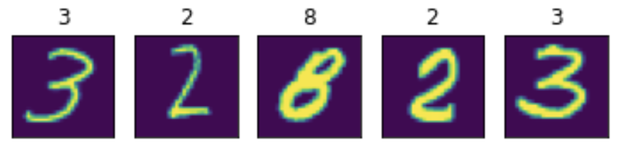

Google Colab is recommended for this tutorial. If you are running in colab, you should install the dependencies and download the dataset by running the following cell:

|  |
| --- |
| import subprocess  # Installation on Google Colab  try:  import google.colab  subprocess.run(['python', '-m', 'pip', 'install', 'skorch' , 'torch'])  except ImportError:  pass  from sklearn.datasets import fetch_openml  from sklearn.model_selection import train_test_split  import numpy as np  import matplotlib.pyplot as plt |

Using SciKit-Learns fetch_openml to load MNIST data.

|  |
| --- |
| mnist = fetch_openml('mnist_784', as_frame=False, cache=False) |

Each image of the MNIST dataset is encoded in a 784 dimensional vector, representing a 28 x 28 pixel image. Each pixel has a value between 0 and 255, corresponding to the grey-value of a pixel. The above featch_mldata method to load MNIST returns data and target as uint8 which we convert to float32 and int64 respectively.

|  |
| --- |
| X = mnist.data.astype('float32')  y = mnist.target.astype('int64') |

To avoid big weights that deal with the pixel values from between [0, 255], we scale X down. A commonly used range is [0, 1].

|  |
| --- |
| X /= 255.0 |

Split the data.

|  |
| --- |
| X_train, X_test, y_train, y_test = train_test_split(X, y, test_size=0.25, random_state=42) |

Plot data samples with labels to better understand the data.

|  |
| --- |
| def plot_example(X, y):  """Plot the first 5 images and their labels in a row."""  for i, (img, y) in enumerate(zip(X[:5].reshape(5, 28, 28), y[:5])):  plt.subplot(151 + i)  plt.imshow(img)  plt.xticks([])  plt.yticks([])  plt.title(y)  plot_example(X_train, y_train) |

The output demonstrates how the images and labels are aligned.



This next step builds a simple, fully connected neural network with one hidden layer. The input layer has 784 dimensions (28x28) hidden layer has 98 (= 784 / 8) and output layer 10 neurons, representing digits 0 - 9.

|  |
| --- |
| import torch  from torch import nn  import torch.nn.functional as F  device = 'cuda' if torch.cuda.is_available() else 'cpu'  mnist_dim = X.shape[1]  hidden_dim = int(mnist_dim/8)  output_dim = len(np.unique(mnist.target))  mnist_dim, hidden_dim, output_dim  # outputs: (784, 98, 10)  class ClassifierModule(nn.Module):  def __init__(  self,  input_dim=mnist_dim,  hidden_dim=hidden_dim,  output_dim=output_dim,  dropout=0.5,  ):  super(ClassifierModule, self).__init__()  self.dropout = nn.Dropout(dropout)  self.hidden = nn.Linear(input_dim, hidden_dim)  self.output = nn.Linear(hidden_dim, output_dim)  def forward(self, X, **kwargs):  X = F.relu(self.hidden(X))  X = self.dropout(X)  X = F.softmax(self.output(X), dim=-1)  return X |

skorch allows to use PyTorch's networks in the SciKit-Learn setting:

|  |
| --- |
| from skorch import NeuralNetClassifier  torch.manual_seed(0)  net = NeuralNetClassifier(  ClassifierModule,  max_epochs=20,  lr=0.1,  device=device,  )  net.fit(X_train, y_train); |

Running the code will give the ouput:

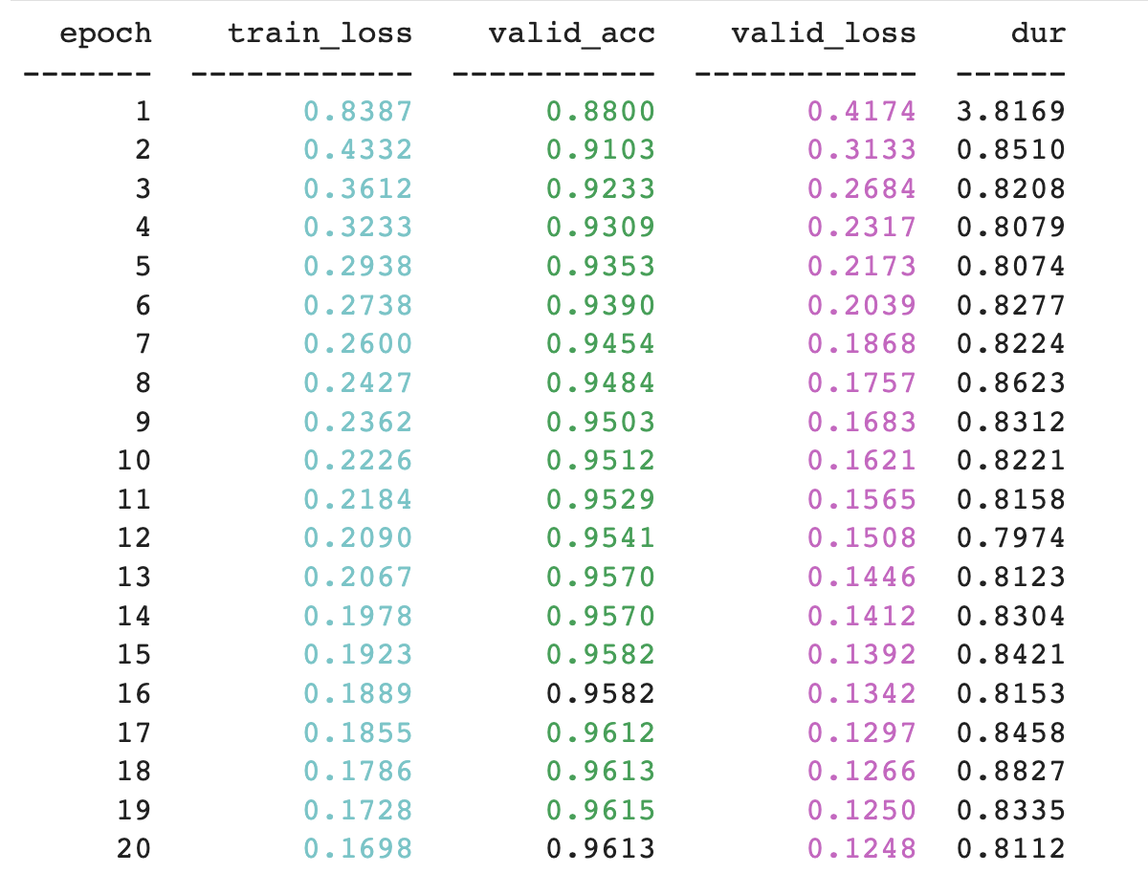

|  |
| --- |
| from sklearn.metrics import accuracy_score  y_pred = net.predict(X_test)  accuracy_score(y_test, y_pred) |

Exercise (3 marks)

There is not much to do here except to verify the code example is working. Run the code and add the code below with your name in it to get the mark. The sample output should look like the following but with your name:



Show your screenshot here:

|  |
| --- |
|  |

Table of Contents

References 1

Introduction 1

Classification Averaging Ensemble Preparation 1

numpy.sum() 1

np.argmax() 2

Eliminating Variance with Ensembles 3

Stacking to Improve Accuracy 7

## References

“Better Deep Learning’ by Dr. Jason Brownlee <https://machinelearningmastery.com/better-deep-learning/>

Chapter 19: Reducing Model Variance with Ensemble Learning

Chapter 20: Combine Models from Multiple Runs with Averaging Ensemble

Chapter 25: Learn to Combine Predictions with Stacked Generalization Ensemble

.

## Introduction

Averaging ensembles calculate the prediction by averaging the predictions of multiple models. Averaging ensembles attempt to reduce variance.

Stacking ensembles calculate the prediction by using the outputs of multiple models as inputs. Stacking ensembles attempt to help to improve accuracy

## Classification Averaging Ensemble Preparation

The classification averaging algorithms in this document will use numpy.sum() and numpy.argmax() to help find the average classification for each averaging ensemble. This section will explain how each function works.

### numpy.sum()

**numpy.sum()** adds element values across arrays for each index.

Example : numpy.sum()

|  |
| --- |
| import numpy as np  # Pred1 # Pred2  testArray = np.asarray( [[[0.6, 0.4],[0.2, 0.8]], # Predictions model 1  [[0.1, 0.9],[0.8, 0.2]], # Predictions model 2  [[0.9, 0.1],[0.3, 0.7]], # Predictions model 3  [[0.7, 0.3],[0.6, 0.4]]]) # Predictions model 4  summed = np.sum(testArray, axis=0)  print("\nsummed: ")  print(summed) |

The summed output is shown below. For better readability, I have added commas and re-arranged the output so it falls on a single line.

|  |
| --- |
| [[2.3, 1.7], [1.9, 2.1]] |

Here is the math that generates summed elements for prediction 1:

0.6 0.4

0.1 0.9

0.9 0.1

+ 0.7 0.3

[2.3] [1.7]

Exercise (2 marks)

Show the calculations needed to sum elements by index for all models for prediction 2:

|  |  |  |  |  |  |  |  |  |  |  |
| --- | --- | --- | --- | --- | --- | --- | --- | --- | --- | --- |
| |  |  | | --- | --- | | 0.2 | 0.8 | | 0.8 | 0.2 | | 0.3 | 0.7 | | 0.6 | 0.4 | | Sum: 1.9 | Sum: 2.1 | |

### np.argmax()

**np.argmax()** obtains the maximum element value for each of the sub-arrays.

Example : numpy.argmax()

This example shows how numpy.argmax() works. Here the output from Example 1 again. This time though, the largest numbers for each prediction are selected.

# Pred1 # Pred2

[[2.3, 1.7], [1.9, 2.1]]

If you at the following output to the end of the code in Example 1 and run the program again;

|  |
| --- |
| result = np.argmax(summed, axis=1)  print("Max element in array: ")  print(result) |

The output becomes:

[0 1]

Exercise (1 mark)

What is the result of the numpy.argmax() function for the following?

# Pred1 # Pred2

[[8.3, 5.7], [8.9, 8.1]]

|  |
| --- |
| [0 0] |

Exercise (1 mark)

What is the result of the numpy.argmax() function for the following?

[[2.3, 1.7, 2.2], [1.9, 2.1, 2.4]]

|  |
| --- |
| [0 2] |

We will revisit these functions later.

## Eliminating Variance with Ensembles

You will have noticed during the course that many of your networks exhibit significant variance in accuracy from run-to-run. This section demonstrates how model network ensembles can help to reduce the variance of the output.

Example : Model Variance (See Chapter 20 Better Deep Learning)

This example shows the average accuracy and accuracy standard deviation for 11 separate sequential neural network classifier models.

|  |
| --- |
| Average model accuracy: 0.8111688311688312  Accuracy standard deviation: 0.017505029034279744 |

The following code is set up to build multiple sequential networks for classification. The predictions of each network are then averaged using the numpy.sum() and numpy.argmax() functions. For the initial case in Example 3, only 1 sequential network is used to make the prediction. However, results are generated over 11 separate runs to observe the standard deviation between results.

Note: The output of the sequential network uses **categorical cross entropy** which causes the classification predictions to be presented in a one-hot-encoded manner.

# Two sample one-hot-encoded outputs. Each output must have only 1 of 3

# possible outcomes:

# [[1, 0, 0],

# [0, 1, 0],

Here is the code to build the network.

|  |
| --- |
| from keras.layers import Dense  from sklearn.metrics import accuracy_score  from numpy import argmax  from sklearn.datasets import make_blobs  from keras.models import Sequential  from sklearn.model_selection import train_test_split  import numpy as np  import tensorflow as tf  # fit model on dataset  def fitModel(trainX, trainy):  # define model  model = Sequential()  model.add(Dense(15, input_dim=2, activation='relu'))  model.add(Dense(3, activation='softmax'))  model.compile(loss='categorical_crossentropy',  optimizer='adam',  metrics=['accuracy'])  # fit model  model.fit(trainX, trainy, epochs=200, verbose=0)  return model  def getData():  # generate 2d classification dataset  X, y = make_blobs(n_samples=500, centers=3, n_features=2,  cluster_std=2, random_state=2)  # split into train and test  trainX, testX, trainy, testy = train_test_split(X, y, test_size=0.7)  # Converts array to matrix of categories.  # [0, 1, 2]  # Becomes:  # [[1, 0, 0],  # [0, 1, 0],  # [0, 0, 1]]  trainy = tf.keras.utils.to_categorical(trainy)  return trainX, testX, trainy, testy  def buildAndEvaluateIndividualModels():  trainX, testX, trainy, testy = getData()  NUM_MODELS = 11  yhats = []  scores = []  models = []  print("\n**** Single model results:")  for i in range(0, NUM_MODELS):  model = fitModel(trainX, trainy)  models.append(model)  predictions = model.predict(testX)  yhats.append(predictions)  # Converts multi-column prediction set back to single column  # so accuracy score can be calculated.  singleColumnPredictions = argmax(predictions, axis=1)  accuracy = accuracy_score(singleColumnPredictions, testy)  scores.append(accuracy)  print("Single model " + str(i) + " accuracy: " + str(accuracy))  print("Average model accuracy: " + str(np.mean(scores)))  print("Accuracy standard deviation: " + str(np.std(scores)))  return models  models = buildAndEvaluateIndividualModels() |

Now that you have seen varying results, next we will observe how an ensemble helps to stabilize the results.

Example : Ensemble Predictions (See Chapter 20 Better Deep Learning)

This example shows how results from multiple models are combined to make a more stable prediction by vote. Effectively, the code snippet below (which has already been included in Example 3) adds up votes for each prediction across all models.

Notice how the standard deviation of the ensemble voting model over 11 trials is lowered significantly compared with the ensemble model.

|  |
| --- |
| Average model accuracy: 0.8135064935064935  Accuracy standard deviation: 0.006901470262642296 |

Adding this code to the end of Example 3 will enable the building and evaluating of the ensemble.

|  |
| --- |
| # Evaluate ensemble  def buildAndEvaluateEnsemble(models):  scores = []  print("\n**** Ensemble model results: ")  for trial in range(0, 11):  # Generate new test data.  _, testX, _, testy = getData()  yhats = []  # Get predictions with pre-built models.  for model in models:  predictions = model.predict(testX)  yhats.append(predictions)  # Sum predictions for all models.  # [[0.2, 0.3, 0.5], [0.3, 0.3, 0.4]...], # Model 1 results  # [0.3, 0.3, 0.4], [0.1, 0.1, 0.8]...], # Model 2 results  # [0.2, 0.2, 0.6], [0.3, 0.3, 0.4]...], # Model 3 results  # Becomes  # [[0.7, 0.8, 1.5],[0.7, 0.7, 1.6]...] # Summed results  summed = np.sum(yhats, axis=0)  # Converts multi-column prediction set back to single column  # so accuracy score can be calculated. For example;  # [[0.7, 0.8, 1.5],[0.7, 0.7, 1.6]...]  # Becomes  # [2, 2,....]  singleColumnPredictions = argmax(summed, axis=1)  accuracy = accuracy_score(singleColumnPredictions, testy)  scores.append(accuracy)  print("Ensemble model accuracy during trial " + str(trial) +\  ": " + str(accuracy))  print("Average model accuracy: " + str(np.mean(scores)))  print("Accuracy standard deviation: " + str(np.std(scores)))  buildAndEvaluateEnsemble(models) |

Exercise (6 marks)

Replace the getData() function in Example 4 with the following code to load and prepare data from the Iris data set.

|  |
| --- |
| from sklearn.preprocessing import LabelEncoder  import pandas as pd  from keras.utils import to_categorical  def getData():  PATH = "/Users/pm/Desktop/DayDocs/data/"  df = pd.read_csv(PATH + 'iris_old.csv')  df.columns = ['Sepal L', 'Sepal W', 'Petal L', 'Petal W', 'Iris Type']  # Convert text to numeric category.  # 0 is setosa, 1 is versacolor and 2 is virginica  df['y'] = LabelEncoder().fit_transform(df['Iris Type'])  # Prepare the data.  X = df[['Sepal L', 'Sepal W', 'Petal L', 'Petal W']]  y = df['y']  ROW_DIM = 0  COL_DIM = 1  x_array = X.values  x_arrayReshaped = x_array.reshape(x_array.shape[ROW_DIM],  x_array.shape[COL_DIM])  y_array = y.values  y_arrayReshaped = y_array.reshape(y_array.shape[ROW_DIM], 1)  trainX, testX, trainy, testy = train_test_split(x_arrayReshaped,  y_arrayReshaped,  test_size=0.33)  trainy = to_categorical(trainy)  return trainX, testX, trainy, testy |

Also, adjust the fit_model() function to enable inputs with 4 features and an output value with 3 possible classifications.

|  |
| --- |
| # fit model on dataset  def fitModel(trainX, trainy):  # define model  model = Sequential()  model.add(Dense(15, input_dim=4, activation='relu'))  model.add(Dense(3, activation='softmax'))  model.compile(loss='categorical_crossentropy',  optimizer='adam',  metrics=['accuracy'])  # fit model  model.fit(trainX, trainy, epochs=200, verbose=0)  return model |

Explain how the standard deviation is affected by the ensemble of 11 models.

|  |
| --- |
| The standard deviation is lowered after the ensemble of 11 models. |

Show your average prediction accuracy and standard deviation for the stand-alone model and for the ensemble.

|  |
| --- |
|  |

## Stacking to Improve Accuracy

Stacking takes the outputs of existing models and uses them as inputs to build a new model. In this way, it is possible to dynamically generate a weighted set of inputs (see Figure 1).

Figure : Stacking Model Built with Inputs from Other Models

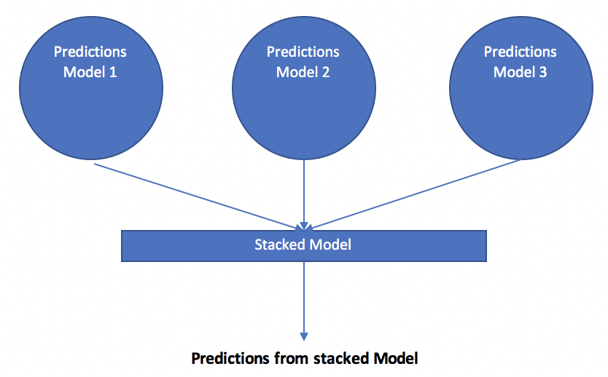

The next two examples show how to implement stacking for a neural network. These examples are discussed at:

<https://machinelearningmastery.com/stacking-ensemble-for-deep-learning-neural-networks/>

Example : Creating Model for Later Use in Stacking Ensemble (See Chapter 25 Better Deep Learning)

This first example creates 5 separate models and saves them as h5 binary files. If you run the code you will notice that it outputs the models in your project directory.

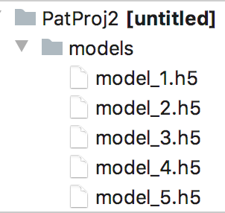

These models will be used in Example 6 for stacking.

|  |
| --- |
| from keras.models import Sequential  from keras.layers import Dense  from os import makedirs  from os import path  from sklearn.model_selection import train_test_split  from sklearn.datasets import make_blobs  from sklearn.metrics import accuracy_score  from sklearn.linear_model import LogisticRegression  from keras.models import load_model  from keras.utils import to_categorical  import pandas as pd  import numpy as np  PATH = './models/'  # fit model on dataset  def fit_model(trainX, trainy):  # define model  model = Sequential()  model.add(Dense(25, input_dim=2, activation='relu'))  model.add(Dense(3, activation='softmax'))  model.compile(loss='categorical_crossentropy',  optimizer='adam', metrics=['accuracy'])  # fit model  model.fit(trainX, trainy, epochs=500, verbose=0)  return model  def generateData():  # generate 2d classification dataset  X, y = make_blobs(n_samples=800, centers=3,  n_features=2,  cluster_std=2, random_state=2)  # split into train and test  trainX, tempX, trainy, tempy = train_test_split(X, y, test_size=0.6)  testX, valX, testy, valy = train_test_split(tempX, tempy, test_size=0.5)  return trainX, testX, valX, trainy, testy, valy  def generateModels(trainX, trainy):  # create directory for models  if(not path.exists(PATH)):  makedirs('./models')  # fit and save models  numModels = 5  print("\nFitting models with training data.")  for i in range(numModels):  # fit model  model = fit_model(trainX, trainy)  # save model  filename = PATH + 'model_' + str(i + 1) + '.h5'  model.save(filename)  print('>Saved %s' % filename)  trainX, testX, valX, trainy, testy, valy = generateData()  # one hot encode output variable  trainy = to_categorical(trainy)  generateModels(trainX, trainy)  # load models from file  def load_all_models(n_models):  all_models = list()  for i in range(n_models):  # define filename for this ensemble  filename = PATH + 'model_' + str(i + 1) + '.h5'  # load model from file  model = load_model(filename)  # add to list of models  all_models.append(model)  print('>loaded %s' % filename)  return all_models  #trainX, testX, trainy, testy = generateData()  # load all models  numModels = 5  models = load_all_models(numModels)  print('Loaded %d models' % len(models))  print("\nEvaluating single models with validation data.")  # evaluate standalone models on test dataset  # individual ANN models are built with one-hot encoded data.  for model in models:  oneHotEncodedY = to_categorical(valy)  _, acc = model.evaluate(valX, oneHotEncodedY, verbose=0)  print('Model Accuracy: %.3f' % acc) |

Example : Stacking

This example builds a meta-learner from the models that were created in Example 5. Each of the models that were built in Example 5 show the following accuracy ratings on their own.

|  |
| --- |
| Model Accuracy: 0.818  Model Accuracy: 0.773  Model Accuracy: 0.786  Model Accuracy: 0.777  Model Accuracy: 0.799 |

When predictions from the 5 models are fed as inputs to the stacking model, the stacked model shows a more favourable increase in performance:

|  |
| --- |
| Stacked Test Accuracy: 0.820 |

Here is the full program.

|  |
| --- |
| from keras.models import Sequential  from keras.layers import Dense  from os import makedirs  from os import path  from sklearn.model_selection import train_test_split  from sklearn.datasets import make_blobs  from sklearn.metrics import accuracy_score  from sklearn.linear_model import LogisticRegression  from keras.models import load_model  from keras.utils import to_categorical  import pandas as pd  import numpy as np  PATH = './models/'  # fit model on dataset  def fit_model(trainX, trainy):  # define model  model = Sequential()  model.add(Dense(25, input_dim=2, activation='relu'))  model.add(Dense(3, activation='softmax'))  model.compile(loss='categorical_crossentropy',  optimizer='adam', metrics=['accuracy'])  # fit model  model.fit(trainX, trainy, epochs=500, verbose=0)  return model  def generateData():  # generate 2d classification dataset  X, y = make_blobs(n_samples=800, centers=3,  n_features=2,  cluster_std=2, random_state=2)  # split into train and test  trainX, tempX, trainy, tempy = train_test_split(X, y, test_size=0.6)  valX, testX, valY, testY = train_test_split(tempX, tempy, test_size=0.5)  return trainX, valX, testX, trainy, valY, testY  def generateModels(trainX, trainy):  # create directory for models  if(not path.exists(PATH)):  makedirs('./models')  # fit and save models  numModels = 5  print("\nFitting models with training data.")  for i in range(numModels):  # fit model  model = fit_model(trainX, trainy)  # save model  filename = PATH + 'model_' + str(i + 1) + '.h5'  model.save(filename)  print('>Saved %s' % filename)  trainX, valX, testX, trainy, valY, testY = generateData()  # one hot encode output variable  trainy = to_categorical(trainy)  generateModels(trainX, trainy)  # load models from file  def load_all_models(n_models):  all_models = list()  for i in range(n_models):  # define filename for this ensemble  filename = PATH + 'model_' + str(i + 1) + '.h5'  # load model from file  model = load_model(filename)  # add to list of models  all_models.append(model)  print('>loaded %s' % filename)  return all_models  #trainX, valX, trainy, valY = generateData()  # load all models  numModels = 5  models = load_all_models(numModels)  print('Loaded %d models' % len(models))  print("\nEvaluating single models with test data.")  # evaluate standalone models o821  # Model Accuracy: 0.821n test dataset  # individual ANN models are built with one-hot encoded data.  for model in models:  oneHotEncodedY = to_categorical(testY)  _, acc = model.evaluate(testX, oneHotEncodedY, verbose=0)  print('Model Accuracy: %.3f' % acc)  # create stacked model input dataset as outputs from the ensemble  def getStackedData(models, inputX):  stackXdf = None  for model in models:  # make prediction  yhat = model.predict(inputX, verbose=0)  singleModelPredDf = pd.DataFrame(np.row_stack(yhat))  # Store predictions of all models for 1 sample in each df row.  # Here is 1st row for 5 models with predictions for 3 classes each.  # 5 models x 3 classes = 15 columns.  # 0 1 2 ... 12 13 14  # 0 0.993102 1.106366e-04 0.006788 ... 0.993102 1.106366e-04 0.006788  if stackXdf is None:  stackXdf = singleModelPredDf  else:  numClasses = len(singleModelPredDf.keys())  numStackXCols = len(stackXdf.keys())  # Add new classification columns.  for i in range(0, numClasses):  stackXdf[numStackXCols + i] = singleModelPredDf[i]  return stackXdf  # Make predictions with the stacked model  def stacked_prediction(models, stackedModel, inputX):  # create dataset using ensemble  stackedX = getStackedData(models, inputX)  # make a prediction  yhat = stackedModel.predict(stackedX)  return yhat  # fit a model based on the outputs from the ensemble models  def fit_stacked_model(models, inputX, inputy):  # create dataset using ensemble  stackedX = getStackedData(models, inputX)  # fit standalone model  model = LogisticRegression()  model.fit(stackedX, inputy)  return model  # fit stacked model using the ensemble  # Stacked model build with LogisticRegression.  # y for LogisticRegression is not one-hot encoded.  print("\nFitting stacked model with test data.")  stackedModel = fit_stacked_model(models, valX, valY)  # evaluate model on test set  print("\nEvaluating stacked model with test data.")  yhat = stacked_prediction(models, stackedModel, testX)  acc = accuracy_score(testY, yhat)  print('Stacked Test Accuracy: %.3f' % acc) |

Exercise (6 marks)

Use the following code to generate five models with the Iris data set.

|  |
| --- |
| from sklearn.preprocessing import LabelEncoder  def generateData():  PATH = "/Users/pm/Desktop/DayDocs/data/"  df = pd.read_csv(PATH + 'iris_old.csv')  df.columns = ['Sepal L', 'Sepal W', 'Petal L', 'Petal W', 'Iris Type']  # Convert text to numeric category.  # 0 is setosa, 1 is versacolor and 2 is virginica  df['y'] = LabelEncoder().fit_transform(df['Iris Type'])  # Prepare the data.  X = df[['Sepal L', 'Sepal W', 'Petal L', 'Petal W']]  y = df['y']  # split into train and test  trainX, tempX, trainy, tempy = train_test_split(X, y, test_size=0.6)  testX, valX, testy, valy = train_test_split(tempX, tempy, test_size=0.5)  return trainX, testX, valX, trainy, testy, valy |

Run the code. What adjustment is needed in fit_model()?

|  |
| --- |
| Needed to change the input_dim to 4 features. |

Explain the difference in performance between the stacked model and the individual models.

|  |
| --- |
| The stacked model shows an increased accuracy score compared to the individual models. |

Exercise (5 marks)

Show a screenshot of the debugger while it shows the dataframe contents. Be sure to show the rows and columns of the stackXdf dataframe at the end of getStackedData() to get this mark.



Show your screenshot here:

|  |
| --- |
|  |

Exercise (4 marks)

Use the terms *ensemble*, *stacked model* to fill in the blanks.

1. A ______ensemble_____________ attempts to reduce variance.
2. A _______stacked model____________ attempts to improve accuracy.
3. A ________stacked model___ builds a model by using the outputs of other models.
4. A _______ensemble____ builds a model by averaging the outputs of multiple models.

Table of Contents

References 1

Hyperparameter Tuning 1

Regular Logistic Regression 2

Configuring the Optimizer 3

Stochastic Gradient Descent (SGD) 3

Tuning the Number of Nodes 4

Configuring the Number of Layers 6

Configuring Batch Size 9

Summary 11

Other Tips 12

# References

“Better Deep Learning’ by Dr. Jason Brownlee <https://machinelearningmastery.com/better-deep-learning/>

# Hyperparameter Tuning

Hyperparameter tuning is the most challenging task in machine learning. Even for experts, hyperparameter tuning is difficult due to many reasons including:

* A complicated solution hyperplane that has many potential optima which are not necessarily the best optima in the solution space.
* Many settings to choose from that can lead to millions of tuning combinations that are not linearly related.
* Large amounts of training time needed.

This discussion presents a somewhat sequential approach to hyperparameter tuning. However, in practice you will likely find that you will need to iterate over different steps to fine tune the network. As you tune your models, sometimes you will have to settle on good-enough solutions at each step. Ideally you are able to iterate over and fine tune these configurations later to find a better solution. The use of loss and accuracy graphs should also be used where possible to visualize the success of the tuning effort. Accuracy graphs are not available for linear regression problems.

A generally recommended tuning order is:

* Performing a basic regression or classification to better understand the targets.
* Use stochastic gradient descent so you can adjust the learning rate and momentum. Pay attention to the validation loss and accuracy ratings.
* Tune the number of nodes in a single layer network. Tweak the learning rate, momentum and number of epochs if needed. Pay attention to the validation loss and accuracy ratings.
* Tune the number of layers. Tweak the learning rate, momentum and number of epochs if needed. Pay attention to the validation loss and accuracy ratings.
* Determine the optimal batch size. Tweak the learning rate, momentum and number of epochs if needed. Pay attention to the validation loss and accuracy ratings.

## Regular Logistic Regression

To better understand the tuning targets before configuring a network, a basic regression to identify reasonable targets is recommended.

Example : Basic Logistic Regression

In this example we will start the series by first perform basic logistic regression with the diabetes data set. Simple logistic regression can detect diabetes with accuracy score of 80%.

|  |
| --- |
| Accuracy: 0.8070866141732284  Confusion Matrix  Predicted 0 1  Actual  0 156 16  1 33 49 |

Here is the code:

|  |
| --- |
| import pandas as pd  from sklearn.model_selection import train_test_split  PATH = "/Users/pm/Desktop/DayDocs/data/"  from sklearn.linear_model import LogisticRegression  from sklearn import metrics  import numpy as np  # load the dataset  df = pd.read_csv(PATH + 'diabetes.csv', sep=',')  # split into input (X) and output (y) variables  X = df[['Pregnancies','Glucose','BloodPressure','SkinThickness','Insulin','BMI',  'DiabetesPedigreeFunction', 'Age']]  y = df[['Outcome']]  # Split into train and test data sets.  X_train, X_test, y_train, y_test = train_test_split( X, y, test_size=0.33)  # Perform logistic regression.  logisticModel = LogisticRegression(fit_intercept=True, random_state = 0,  solver='liblinear')  logisticModel.fit(X_train,y_train)  y_pred=logisticModel.predict(X_test)  # Show model coefficients and intercept.  print("\nModel Coefficients: ")  print("\nIntercept: ")  print(logisticModel.intercept_)  print(logisticModel.coef_)  # Show confusion matrix and accuracy scores.  confusion_matrix = pd.crosstab(np.array(y_test['Outcome']), y_pred,  rownames=['Actual'],  colnames=['Predicted'])  print('\nAccuracy: ',metrics.accuracy_score(y_test, y_pred))  print("\nConfusion Matrix")  print(confusion_matrix) |

## Configuring the Optimizer

Configuring the optimizer is usually done simultaneously while choosing the number of nodes in a single layer network.

### Stochastic Gradient Descent (SGD)

When faced with a large set of unknown parameters, use of the stochastic gradient descent optimizer is recommended for simplicity. With SGD you can tune the learning rate for speed of learning and the momentum for smoothing. The *learning_rate* and *momentum* parameters can range between 0 and 1. You can grid search these values or you can experiment with different settings to find reasonably adequate settings.

optimizer = tf.keras.optimizers.SGD(

learning_rate=0.1, momentum=0.9, name="SGD")

High **learning rates** can lead to volatile but quick learning at the risk of overshooting the optimum. Low learning rates lead to longer training times but they offer a smoother trend for losses and accuracy. Learning rates that are too low though may never converge on a solution. It is up to you to find a decent learning rate and there is no perfect solution. You may need to adjust this setting several times as you adjust other settings.

**Momentum** is a decaying weighted average of past gradients which helps to smooth weight adjustments. Momentum can help to overcome barriers to current weight adjustments such as steep curves or flat regions. A momentum that is too high though can lead to weight changes that are not sensitive enough to current changes in the solution plane.

## Tuning the Number of Nodes

In his book, “Better Deep Learning’, Dr. Jason Brownlee suggests starting the tuning session by determining the optimal number of nodes in a single layer network. A single layer network is capable of solving most learning problems if it is made wide enough. In this case, **width** refers to the number of nodes in the layer.

Example : Determining the Total Nodes

This example compares the losses and accuracy when of a single layer network that has different numbers of nodes. I actually started by testing a set of node counts totalling 3, 6 and 9. 9 nodes showed the most promise so I tried a set of larger nodes. However, the highest number of nodes in all of my trials kept offering the best results. I ended up drastically increasing the numbers of nodes until the single layer network performance plateaued at 230 nodes (see Figure 1). Note also that at this time I had to keep tweaking the learning rate and momentum of the stochastic gradient descent optimizer to find a balance between volatility and validation accuracy.

Figure : Comparing Performance of a Single Layer Network with Different Numbers of Nodes

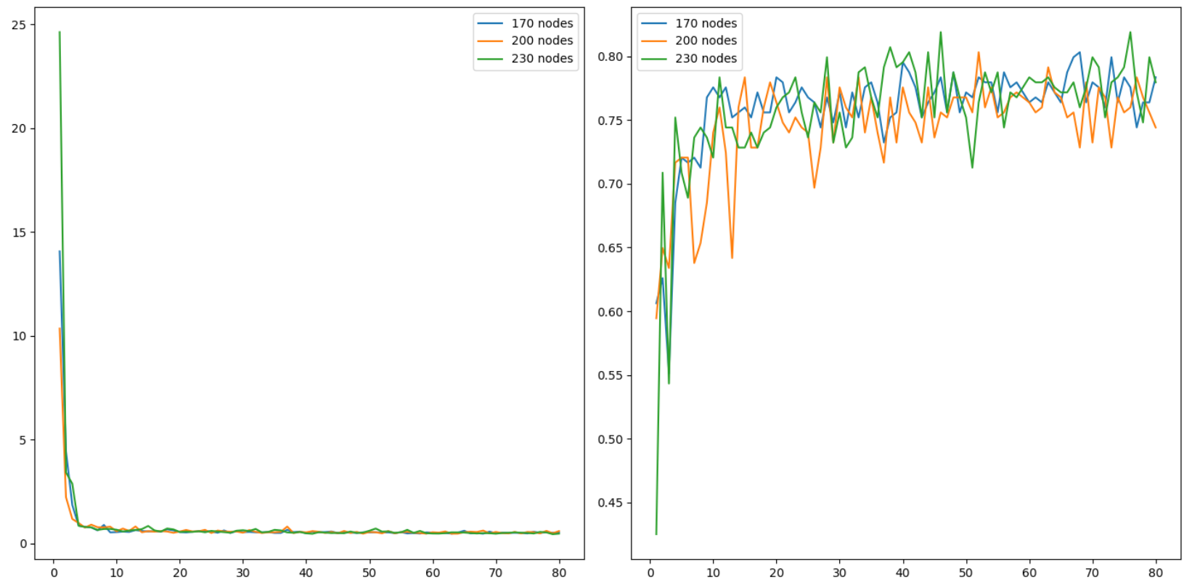

Here is the winning code so far at this point.

|  |
| --- |
| # first neural network with keras tutorial  from keras.models import Sequential  from keras.layers import Dense  import pandas as pd  from sklearn.model_selection import train_test_split  import matplotlib.pyplot as plt  PATH = "/Users/pm/Desktop/DayDocs/data/"  import tensorflow as tf  # load the dataset  df = pd.read_csv(PATH + 'diabetes.csv', sep=',')  # split into input (X) and output (y) variables  X = df[['Pregnancies','Glucose','BloodPressure','SkinThickness','Insulin','BMI',  'DiabetesPedigreeFunction', 'Age']]  y = df[['Outcome']]  # Split into train and test data sets.  X_train, X_test, y_train, y_test = train_test_split( X, y, test_size=0.33)  def buildModel(num_nodes):  # define the keras model  model = Sequential()  model.add(Dense(num_nodes, input_dim=8, activation='relu',  kernel_initializer='he_normal'))  model.add(Dense(1, activation='sigmoid'))  opitimizer = tf.keras.optimizers.SGD(  learning_rate=0.0005, momentum=0.9, name="SGD",  )  # compile the keras model  model.compile(loss='binary_crossentropy', optimizer=opitimizer,  metrics=['accuracy'])  # fit the keras model on the dataset  history = model.fit(X, y, epochs=80, batch_size=10, validation_data=(X_test,  y_test))  # evaluate the keras model  # Evaluate the model.  loss, acc = model.evaluate(X_test, y_test, verbose=0)  print('Test Accuracy: ' + str(acc) + ' Num nodes: ' + str(num_nodes))  return history  def showLoss(history, numNodes):  # Get training and test loss histories  training_loss = history.history['loss']  validation_loss = history.history['val_loss']  # Create count of the number of epochs  epoch_count = range(1, len(training_loss) + 1)  # Visualize loss history for training data.  actualLabel = str(numNodes) + " nodes"  plt.subplot(1, 2, 1)  # View loss on unseen data.  plt.plot(epoch_count, validation_loss, label=actualLabel)  plt.legend()  def showAccuracy(history, numNodes):  # Get training and test loss histories  training_loss = history.history['accuracy']  validation_loss = history.history['val_accuracy']  # Create count of the number of epochs  epoch_count = range(1, len(training_loss) + 1)  plt.subplot(1, 2, 2)  actualLabel = str(numNodes) + " nodes"  # View loss on unseen data.  plt.plot(epoch_count, validation_loss, label=actualLabel)  plt.legend()  nodeCounts = [170,200,230]  plt.subplots(nrows=1, ncols=2, figsize=(14,7))  for i in range(0, len(nodeCounts)):  history = buildModel(nodeCounts[i])  showLoss(history, nodeCounts[i])  showAccuracy(history, nodeCounts[i])  plt.show() |

## Configuring the Number of Layers

Deeper networks are typically more efficient than single layer networks. An optimal number of layers should be chosen with the same number of nodes that was optimized for a single layer in Example 2. Later in Example 3, we will use this code snippet to grid search the optimal number of layers.

|  |
| --- |
| numLayers = [5,6,7,8]  plt.subplots(nrows=1, ncols=2, figsize=(14,7))  for i in range(0, len(numLayers)):  history = buildModel(numLayers[i])  showLoss(history, numLayers[i])  showAccuracy(history, numLayers[i]) |

When we refer to numbers of layers we are really referring to network **depth**. Until recently, deeper networks were often not possible due to vanishing gradients. The **relu** activation function helps to overcome the vanishing gradient problem so use it when configuring the number of layers.

Example : Number Layers

When searching for the optimal number of layers, I started with network layers of 1, 3 and 4. I kept shifting the number of layers up and eventually found that 7 layers was optimal as shown in Figure 2. As you can see in Figure 2, the losses are still declining and the accuracy is still rising. It appears that additional gains can be obtained by increasing the number of epochs so I did later.

Figure : Comparing Network Depth

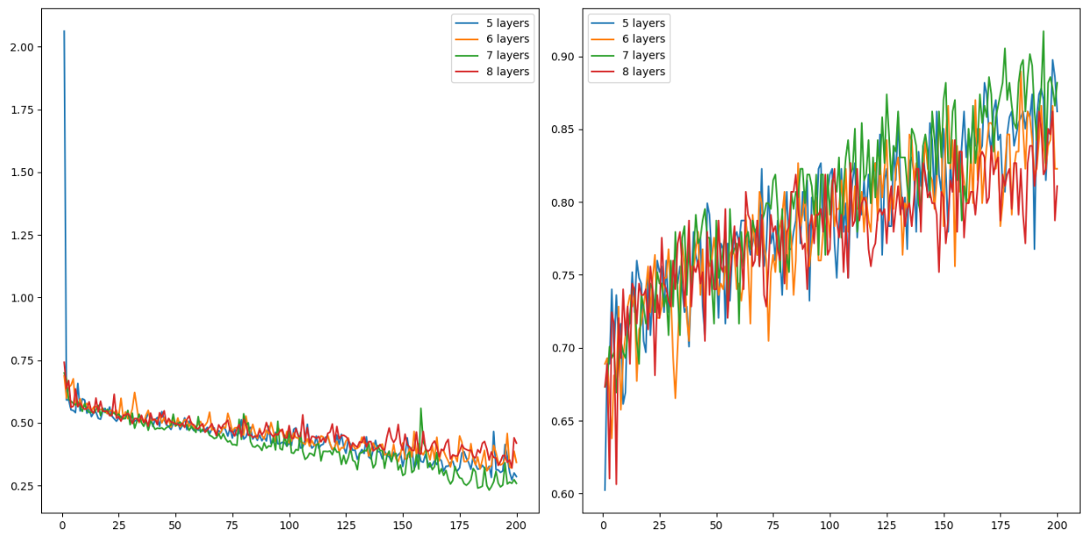

Here is the code:

|  |
| --- |
| # first neural network with keras tutorial  from keras.models import Sequential  from keras.layers import Dense  import pandas as pd  from sklearn.model_selection import train_test_split  import matplotlib.pyplot as plt  PATH = "/Users/pm/Desktop/DayDocs/data/"  import tensorflow as tf  # load the dataset  df = pd.read_csv(PATH + 'diabetes.csv', sep=',')  # split into input (X) and output (y) variables  X = df[['Pregnancies','Glucose','BloodPressure','SkinThickness','Insulin','BMI',  'DiabetesPedigreeFunction', 'Age']]  y = df[['Outcome']]  # Split into train and test data sets.  X_train, X_test, y_train, y_test = train_test_split( X, y, test_size=0.33)  def buildModel(numLayers):  # define the keras model  model = Sequential()  model.add(Dense(230, input_dim=8, activation='relu',  kernel_initializer='he_normal'))  for i in range(0, numLayers-1):  model.add(Dense(230, activation='relu',  kernel_initializer='he_normal'))  model.add(Dense(1, activation='sigmoid'))  opitimizer = tf.keras.optimizers.SGD(  learning_rate=0.0005, momentum=0.9, name="SGD",  )  # Compile the keras model.  model.compile(loss='binary_crossentropy', optimizer=opitimizer,  metrics=['accuracy'])  # Fit the keras model on the dataset.  history = model.fit(X, y, epochs=200, batch_size=10,  validation_data=(X_test, y_test))  # Evaluate the model.  loss, acc = model.evaluate(X_test, y_test, verbose=0)  print('Test Accuracy: %.3f' % acc)  return history  def showLoss(history, numNodes):  # Get training and test loss histories  training_loss = history.history['loss']  validation_loss = history.history['val_loss']  # Create count of the number of epochs  epoch_count = range(1, len(training_loss) + 1)  # Visualize loss history for training data.  actualLabel = str(numNodes) + " layers"  plt.subplot(1, 2, 1)  # View loss on unseen data.  plt.plot(epoch_count, validation_loss, label=actualLabel)  plt.legend()  def showAccuracy(history, numNodes):  # Get training and test loss histories  training_loss = history.history['accuracy']  validation_loss = history.history['val_accuracy']  # Create count of the number of epochs  epoch_count = range(1, len(training_loss) + 1)  plt.subplot(1, 2, 2)  actualLabel = str(numNodes) + " layers"  # View loss on unseen data.  plt.plot(epoch_count, validation_loss, label=actualLabel)  plt.legend()  numLayers = [5,6,7,8]  plt.subplots(nrows=1, ncols=2, figsize=(14,7))  for i in range(0, len(numLayers)):  history = buildModel(numLayers[i])  showLoss(history, numLayers[i])  showAccuracy(history, numLayers[i])  plt.show() |

## Configuring Batch Size

Once a reasonable number of nodes and layers have been chosen, the next step involves configuring the batch size. Batch sizes can range between 1 and the size of the training set. You can actually set the batch size to larger than the training set but there is usually no gain from doing that.

Small batches will provide better generalization to help prevent overfitting but they will take longer to train and the results will be more volatile. A large batch size is faster but can lead to overfitting.

Example : Configuring Batch Size

This example builds on the observations that were found in Example 3. The smaller batch size of 32 did really well.

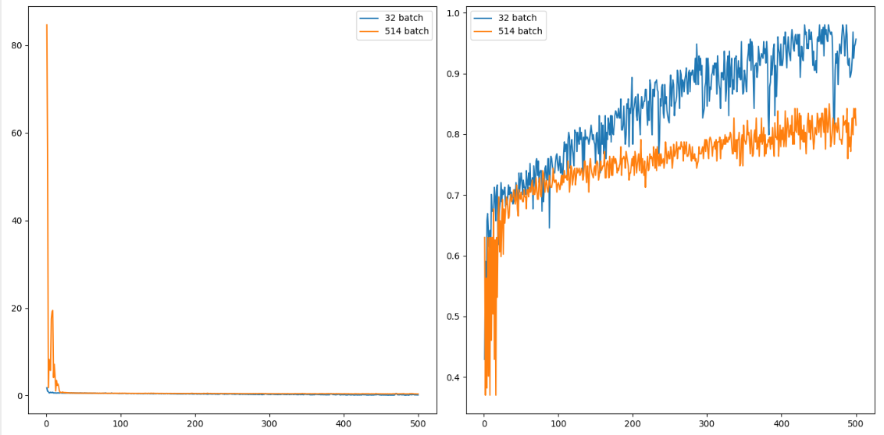

The validation accuracy reading is 0.957 for a batch size of 32 versus 0.815 for a batch size of 514. This is much better than logistic regression which had an accuracy rating of 80.7%.

Could this result be improved? Possibly more epochs and maybe even a smaller batch size would lead to an even better solution. I am happy with the 15% increase in accuracy that I received by tuning though so I will leave it there for now.

|  |
| --- |
| # first neural network with keras tutorial  from keras.models import Sequential  from keras.layers import Dense  import pandas as pd  from sklearn.model_selection import train_test_split  import matplotlib.pyplot as plt  PATH = "/Users/pm/Desktop/DayDocs/data/"  import tensorflow as tf  # load the dataset  df = pd.read_csv(PATH + 'diabetes.csv', sep=',')  # split into input (X) and output (y) variables  X = df[['Pregnancies','Glucose','BloodPressure','SkinThickness','Insulin','BMI',  'DiabetesPedigreeFunction', 'Age']]  y = df[['Outcome']]  # Split into train and test data sets.  X_train, X_test, y_train, y_test = train_test_split( X, y, test_size=0.33)  accuracy = []  def buildModel(batchSize):  NUM_LAYERS = 7  # define the keras model  model = Sequential()  model.add(Dense(230, input_dim=8, activation='relu', kernel_initializer='he_normal'))  for i in range(0, NUM_LAYERS-1):  model.add(Dense(230, activation='relu', kernel_initializer='he_normal'))  model.add(Dense(1, activation='sigmoid'))  opitimizer = tf.keras.optimizers.SGD(  learning_rate=0.0005, momentum=0.9, name="SGD",  )  # compile the keras model  model.compile(loss='binary_crossentropy', optimizer=opitimizer, metrics=['accuracy'])  # fit the keras model on the dataset  history = model.fit(X, y, epochs=500, batch_size=batchSize,  validation_data=(X_test, y_test))  # evaluate the keras model  # Evaluate the model.  loss, acc = model.evaluate(X_test, y_test, verbose=0)  print('Test Accuracy: %.3f' % acc)  accuracy.append(acc)  print(accuracy)  return history  def showLoss(history, batchSize):  # Get training and test loss histories  training_loss = history.history['loss']  validation_loss = history.history['val_loss']  # Create count of the number of epochs  epoch_count = range(1, len(training_loss) + 1)  # Visualize loss history for training data.  actualLabel = str(batchSize) + " batch"  plt.subplot(1, 2, 1)  # View loss on unseen data.  plt.plot(epoch_count, validation_loss, label=actualLabel)  plt.legend()  def showAccuracy(history, batchSize):  # Get training and test loss histories  training_loss = history.history['accuracy']  validation_loss = history.history['val_accuracy']  # Create count of the number of epochs  epoch_count = range(1, len(training_loss) + 1)  plt.subplot(1, 2, 2)  actualLabel = str(batchSize) + " batch"  # View loss on unseen data.  plt.plot(epoch_count, validation_loss, label=actualLabel)  plt.legend()  plt.subplots(nrows=1, ncols=2, figsize=(14,7))  batchSizes = [32, len(y_train)]  for i in range(0, len(batchSizes)):  history = buildModel(batchSizes[i])  showLoss(history, batchSizes[i])  showAccuracy(history, batchSizes[i])  plt.show() |

## Summary

To tune your parameters:

* Perform regular linear regression or logistic regression to figure out what will happen.
* Configure the optimizer. To keep it simple, use SGD and set the learning rate and momentum. Slower learning rate can help to make it easier to identify the loss trend but takes more time. More momentum can make the learning smoother but too much momentum can make the algorithm insensitive to changes in the solution plane.
* Determine the optimal number of nodes (width) for a single layer network.
* Configure the number of layers using a **relu** activation function.
* Configure the batch size.
* Tweak the learning rate, momentum and number of epochs as needed during the entire process.
* Remember to use loss visualizations and where possible accuracy visualizations to help understand the impact of the tuning parameter values.
* Pay attention to the validation loss and accuracy ratings.

## Other Tips

* Reduce the size of your data set to help speed up training until your model is more finely tuned.
* Emulate existing networks that solve similar problems.
* Use MLPRegressor or MLPClassifer to automate the process of generating a network quickly with a decent set of hyperparameters.

Exercise (2 marks)

Starting with the fluDiagnosis.csv file from the data sets folder, use the following code to perform logistic regression:

|  |
| --- |
| import pandas as pd  from sklearn.model_selection import train_test_split  PATH = "/Users/pm/Desktop/DayDocs/data/"  from sklearn.linear_model import LogisticRegression  from sklearn import metrics  import numpy as np  # load the dataset  df = pd.read_csv(PATH + 'fluDiagnosis.csv')  # split into input (X) and output (y) variables  print(df)  X = df[['A','B']]  y = df[['Diagnosed']]  # Split into train and test data sets.  X_train, X_test, y_train, y_test = train_test_split( X, y, test_size=0.33)  # Perform logistic regression.  logisticModel = LogisticRegression(fit_intercept=True, random_state = 0,  solver='liblinear')  logisticModel.fit(X_train,y_train)  y_pred=logisticModel.predict(X_test)  # Show model coefficients and intercept.  print("\nModel Coefficients: ")  print("\nIntercept: ")  print(logisticModel.intercept_)  print(logisticModel.coef_)  # Show confusion matrix and accuracy scores.  confusion_matrix = pd.crosstab(np.array(y_test['Diagnosed']), y_pred,  rownames=['Actual'],  colnames=['Predicted'])  print('\nAccuracy: ',metrics.accuracy_score(y_test, y_pred))  print("\nConfusion Matrix")  print(confusion_matrix) |

Show the accuracy rating and confusion matrix here:

|  |
| --- |
|  |

Exercise (6 marks)

Next, use the following code to configure the optimal learning rate, momentum value and total number of nodes in a single layer network:

|  |
| --- |
| import pandas as pd  from sklearn.model_selection import train_test_split  PATH = "/Users/pm/Desktop/DayDocs/data/"  from keras.models import Sequential  from keras.layers import Dense  import matplotlib.pyplot as plt  import tensorflow as tf  # load the dataset  df = pd.read_csv(PATH + 'fluDiagnosis.csv')  # split into input (X) and output (y) variables  print(df)  X = df[['A','B']]  y = df[['Diagnosed']]  # Split into train and test data sets.  X_train, X_test, y_train, y_test = train_test_split( X, y, test_size=0.33)  def buildModel(num_nodes):  # define the keras model  model = Sequential()  model.add(Dense(num_nodes, input_dim=2, activation='relu',  kernel_initializer='he_normal'))  model.add(Dense(1, activation='sigmoid'))  opitimizer = tf.keras.optimizers.SGD(  learning_rate=0.1, momentum=0.9, name="SGD",  )  # compile the keras model  model.compile(loss='binary_crossentropy', optimizer=opitimizer,  metrics=['accuracy'])  # fit the keras model on the dataset  history = model.fit(X, y, epochs=80, batch_size=10, validation_data=(X_test,  y_test))  # evaluate the keras model  # Evaluate the model.  loss, acc = model.evaluate(X_test, y_test, verbose=0)  print('Test Accuracy: ' + str(acc) + ' Num nodes: ' + str(num_nodes))  return history  def showLoss(history, numNodes):  # Get training and test loss histories  training_loss = history.history['loss']  validation_loss = history.history['val_loss']  # Create count of the number of epochs  epoch_count = range(1, len(training_loss) + 1)  # Visualize loss history for training data.  actualLabel = str(numNodes) + " nodes"  plt.subplot(1, 2, 1)  # View loss on unseen data.  plt.plot(epoch_count, validation_loss, label=actualLabel)  plt.legend()  def showAccuracy(history, numNodes):  # Get training and test loss histories  training_loss = history.history['accuracy']  validation_loss = history.history['val_accuracy']  # Create count of the number of epochs  epoch_count = range(1, len(training_loss) + 1)  plt.subplot(1, 2, 2)  actualLabel = str(numNodes) + " nodes"  # View loss on unseen data.  plt.plot(epoch_count, validation_loss, label=actualLabel)  plt.legend()  nodeCounts = [170,200,230]  plt.subplots(nrows=1, ncols=2, figsize=(14,7))  for i in range(0, len(nodeCounts)):  history = buildModel(nodeCounts[i])  showLoss(history, nodeCounts[i])  showAccuracy(history, nodeCounts[i])  plt.show() |

After finding decent values for your learning rate, momentum and number of nodes, show a screenshot of the graphs for the loss and accuracy functions here:

|  |
| --- |
|  |

Show the optimal learning rate so far here:

|  |
| --- |
| 0.03 |

Show the optimal momentum value so far here:

|  |
| --- |
| 0.9 |

Show the optimal number of nodes in a single layer here:

|  |
| --- |
| 230 |

Exercise (4 marks)

Starting with the code from Exercise 2, configure the optimal number of layers. Examine Example 3 for code hints. Show your full program which implements code to search for the optimal number of layers here. You may or may not need to adjust the learning rate, momentum and number of epochs:

|  |
| --- |
| import pandas as pd from sklearn.model_selection import train_test_split from sklearn.linear_model import LogisticRegression import numpy as np from sklearn import metrics   # load the dataset # PATH = "C:\\datasets\\" df = pd.read_csv("C:\\datasets\\fluDiagnosis.csv") # split into input (X) and output (y) variables print(df)  X = df[['A','B']] y = df[['Diagnosed']] # Split into train and test data sets. X_train, X_test, y_train, y_test = train_test_split( X, y, test_size=0.33)  # Perform logistic regression. logisticModel = LogisticRegression(fit_intercept=True, random_state = 0,  solver='liblinear') logisticModel.fit(X_train,y_train) y_pred=logisticModel.predict(X_test)  # Show model coefficients and intercept. print("\nModel Coefficients: ") print("\nIntercept: ") print(logisticModel.intercept_)  print(logisticModel.coef_)  # Show confusion matrix and accuracy scores. confusion_matrix = pd.crosstab(np.array(y_test['Diagnosed']), y_pred,  rownames=['Actual'],  colnames=['Predicted'])  print('\nAccuracy: ',metrics.accuracy_score(y_test, y_pred)) print("\nConfusion Matrix") print(confusion_matrix)   import pandas as pd from sklearn.model_selection import train_test_split from keras.models import Sequential from keras.layers import Dense import matplotlib.pyplot as plt import tensorflow as tf # load the dataset df = pd.read_csv("C:\\datasets\\fluDiagnosis.csv") # split into input (X) and output (y) variables print(df)  X = df[['A','B']] y = df[['Diagnosed']] # Split into train and test data sets. X_train, X_test, y_train, y_test = train_test_split( X, y, test_size=0.33)    def buildModel(numLayers):  # define the keras model  model = Sequential()  model.add(Dense(230, input_dim=2,activation='relu',  kernel_initializer='he_normal'))   for i in range(0, numLayers-1):  model.add(Dense(230, activation='relu',  kernel_initializer='he_normal'))  model.add(Dense(1, activation='sigmoid'))  opitimizer = tf.keras.optimizers.SGD(  learning_rate=0.00005, momentum=0.9, name="SGD",  #learning_rate=0.03, momentum=0.9  )   # Compile the keras model.  model.compile(loss='binary_crossentropy', optimizer=opitimizer,  metrics=['accuracy'])   # Fit the keras model on the dataset.  history = model.fit(X_train, y_train, epochs=200, batch_size=10,  validation_data=(X_test, y_test))   # Evaluate the model.  loss, acc = model.evaluate(X_test, y_test, verbose=0)  print('Test Accuracy: %.3f' % acc)  return history   def showLoss(history, numNodes):  # Get training and test loss histories  training_loss = history.history['loss']  validation_loss = history.history['val_loss']   # Create count of the number of epochs  epoch_count = range(1, len(training_loss) + 1)   # Visualize loss history for training data.  actualLabel = str(numNodes) + "layers"  plt.subplot(1, 2, 1)  # View loss on unseen data.  plt.plot(epoch_count, validation_loss, label=actualLabel)  plt.legend()  def showAccuracy(history, numNodes):  # Get training and test loss histories  training_loss = history.history['accuracy']  validation_loss = history.history['val_accuracy']   # Create count of the number of epochs  epoch_count = range(1, len(training_loss) + 1)  plt.subplot(1, 2, 2)   actualLabel = str(numNodes) + " layers"  # View loss on unseen data.  plt.plot(epoch_count, validation_loss, label=actualLabel)  plt.legend()   numLayers = [5, 10] plt.subplots(nrows=1, ncols=2, figsize=(14,7))  for i in range(0, len(numLayers)):  history = buildModel(numLayers[i])  showLoss(history, numLayers[i])  showAccuracy(history, numLayers[i])   plt.show() |

Exercise (1 mark)

Show the optimal number of layers here:

|  |
| --- |
| 5 |

Exercise (4 marks)

Show screenshots of the accuracy and loss plots after adjusting the number of layers here:

|  |
| --- |
|  |

Exercise (4 marks)

Starting with the code from Exercise 3, configure the optimal batch size. Examine Example 4 for code hints. Show your full program which implements code to search for the optimal batch size here. You may or may not need to adjust the learning rate, momentum and number of epochs:

|  |
| --- |
| import pandas as pd from sklearn.model_selection import train_test_split from keras.models import Sequential from keras.layers import Dense import matplotlib.pyplot as plt import tensorflow as tf  # load the dataset df = pd.read_csv("C:\\datasets\\fluDiagnosis.csv") # split into input (X) and output (y) variables print(df)  X = df[['A', 'B']] y = df[['Diagnosed']] # Split into train and test data sets. X_train, X_test, y_train, y_test = train_test_split(X, y, test_size=0.33)  accuracy = []   def buildModel(batchSize):  NUM_LAYERS = 7  # define the keras model  model = Sequential()  model.add(Dense(230, input_dim=2, activation='relu', kernel_initializer='he_normal'))  for i in range(0, NUM_LAYERS - 1):  model.add(Dense(230, activation='relu', kernel_initializer='he_normal'))   model.add(Dense(1, activation='sigmoid'))   opitimizer = tf.keras.optimizers.SGD(  learning_rate=0.0005, momentum=0.9, name="SGD",  )   # compile the keras model  model.compile(loss='binary_crossentropy', optimizer=opitimizer, metrics=['accuracy'])   # fit the keras model on the dataset  history = model.fit(X_train, y_train, epochs=500, batch_size=batchSize,  validation_data=(X_test, y_test))  # evaluate the keras model   # Evaluate the model.  loss, acc = model.evaluate(X_test, y_test, verbose=0)  print('Test Accuracy: %.3f' % acc)  accuracy.append(acc)  print(accuracy)  return history   def showLoss(history, batchSize):  # Get training and test loss histories  training_loss = history.history['loss']  validation_loss = history.history['val_loss']   # Create count of the number of epochs  epoch_count = range(1, len(training_loss) + 1)   # Visualize loss history for training data.  actualLabel = str(batchSize) + " batch"  plt.subplot(1, 2, 1)  # View loss on unseen data.  plt.plot(epoch_count, validation_loss, label=actualLabel)  plt.legend()   def showAccuracy(history, batchSize):  # Get training and test loss histories  training_loss = history.history['accuracy']  validation_loss = history.history['val_accuracy']   # Create count of the number of epochs  epoch_count = range(1, len(training_loss) + 1)  plt.subplot(1, 2, 2)   actualLabel = str(batchSize) + " batch"  # View loss on unseen data.  plt.plot(epoch_count, validation_loss, label=actualLabel)  plt.legend()   plt.subplots(nrows=1, ncols=2, figsize=(14, 7)) batchSizes = [32, len(y_train)] for i in range(0, len(batchSizes)):  history = buildModel(batchSizes[i])  showLoss(history, batchSizes[i])  showAccuracy(history, batchSizes[i])  plt.show() |

Exercise (1 mark)

Show the optimal batch size here:

|  |
| --- |
| 32 |

Exercise (4 marks)

Show screenshots of the accuracy and loss plots after adjusting the batch size here:

|  |
| --- |
|  |

Exercise (1 mark)

What type of activation function is used and why?

|  |
| --- |
| The relu activation function is sued to help overcome the vanishing gradient problem. |

Exercise (2 marks)

Compare accuracy ratings for the original logistic regression model and your MLP network model here:

|  |
| --- |
| Original: 0.75  MLP: 0.775 |

Exercise (2 marks)

While a multiparameter grid search is a good idea when configuring a network, summarize in your own words an alternate order for configuring hyperparameters as outlined in these notes based on Dr. Brownlee’s recommendations.

|  |
| --- |
| 1. Run logistic regression to get the variables 2. Build a model and play with the number of nodes for width, layers for depth, and the batch size. 3. Experiment with different values for learning rate, momentum, and epoch as well. |

Table of Contents

Artificial Neural Networks (ANN) Introduction 1

Forward Pass 4

Applying Weights and Bias of the Neurons in the Hidden Layer 4

Applying the Activation Function for the Hidden Layer 4

Applying Weights and Bias of the Neurons in the Output Layer 5

Applying the Activation Function for the Output Layer 6

Back Propagation 7

Calculate the losses 7

TensorFlow and Keras 9

PyTorch 13

# Artificial Neural Networks (ANN) Introduction

This document introduces the topic of artificial neural networks. The steps for ANN learning are summarized in Figure 1.

Some important items to note about the network are:

* Each sample is fed to each neuron of the hidden and output layers.
* Each neuron stores its own weights and bias.
* The activation function for this network is a simple sigmoid function.
* A gradient descent algorithm is used to calculate losses.

Figure : Neural Network Summary of Learning

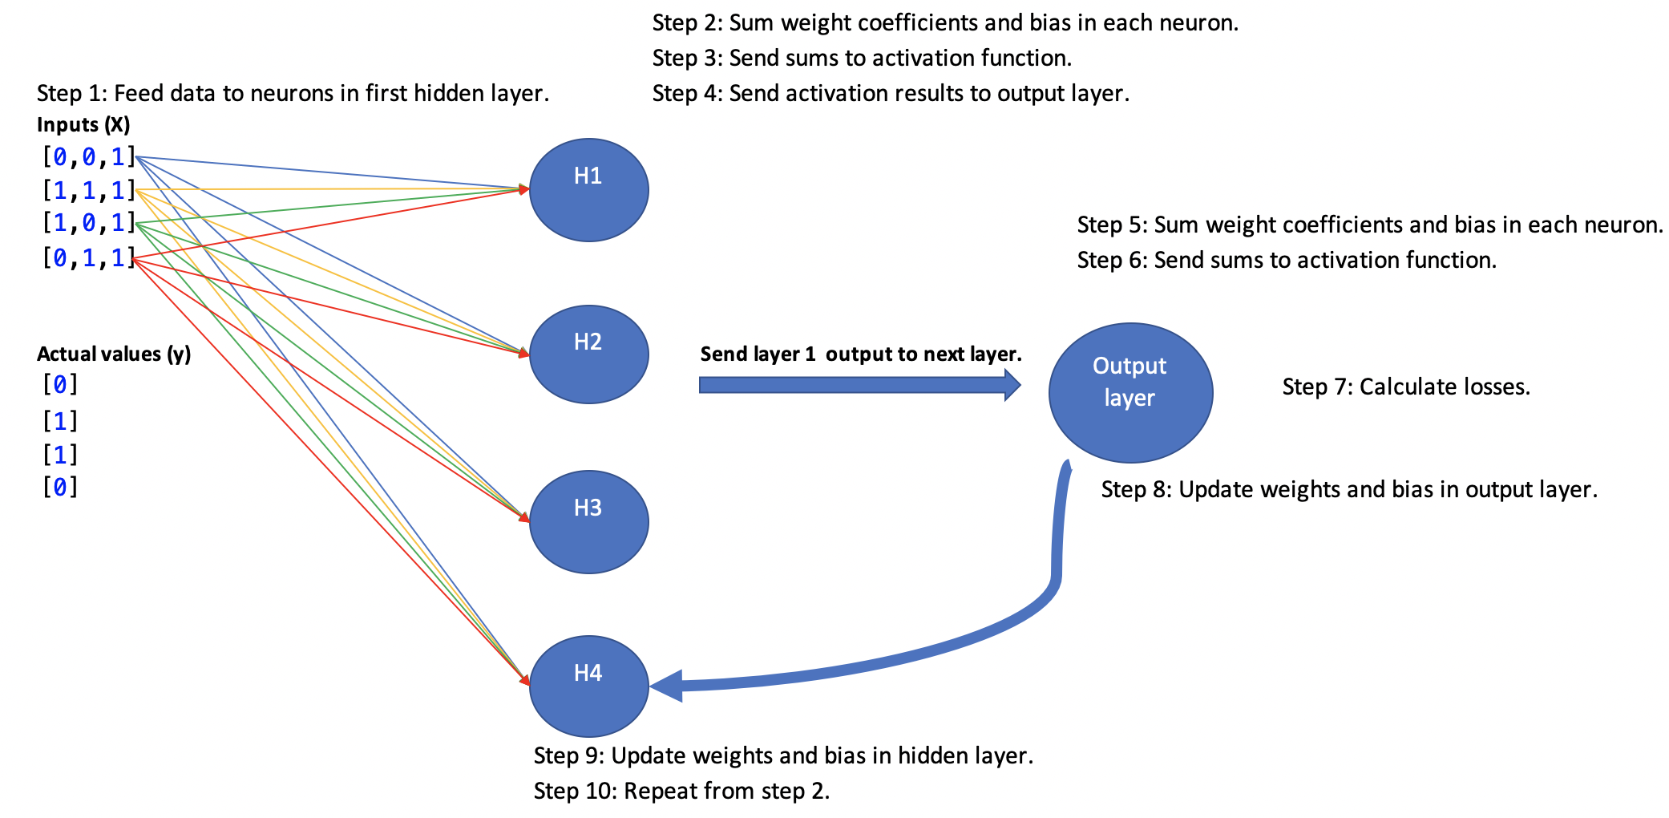

Example : ANN from Scratch

This example shows the code needed to implement the network that is summarized in Figure 1. The network learns with the X and y values in the table and is able to accurately predict y when finished training.

|  |  |  |
| --- | --- | --- |
| y | X |  |
| Actual data:  [[0]  [1]  [1]  [0]] | [[0, 0, 1],  [1, 1, 1],  [1, 0, 1],  [0, 1, 1]] | ANN predictions:  [[0.02123225]  [0.98112875]  [0.98349298]  [0.01860364]] |

Here is the code:

|  |
| --- |
| # importing libraries  import numpy as np  import pandas as pd  ### DATA #######################################  # input data  # (no scaling required in this case for simplicity)  X_train_scaled = np.array([[0, 0, 1],  [1, 1, 1],  [1, 0, 1],  [0, 1, 1]])  # output data  y_train = np.array([ [0],  [1],  [1],  [0]])  ### DATA #######################################  # defining sigmoid activation function  def sigmoid(x):  return 1 / (1 + np.exp(-x))  # defining derivative of sigmoid activation function  def sigmoid_derivative(x):  return x * (1 - x)  # Pass data through layers.  # Each layer sums applied weights and bias, passes to  # an activation function.  def feedForward(X_scaled):  sum1 = np.dot(X_scaled, weights_0_1) + bias_0_1  sum1 = np.array(sum1)  layer_1 = sigmoid(sum1) # Activation function.  sum2 = np.dot(layer_1, weights_1_2) + bias_1_2  layer_2 = sigmoid(sum2) # Activation function.  return layer_1, layer_2  # Update weights and bias from front to back.  def backPropogate(weights_0_1, bias_0_1, weights_1_2, bias_1_2):  yDf = pd.DataFrame(data=y_train, columns=['admitted'])  # Calculate prediction error.  layer_2_error = layer_2 - np.array(yDf['admitted']).reshape(-1, 1)  # Get rate of change of cost function.  layer_2_delta = layer_2_error * sigmoid_derivative(layer_2)    # Determine layer 1 error as cost rate of change * layer 2 weights.  layer_1_error = layer_2_delta.dot(weights_1_2.T)  # Get rate of change for layer 1.  layer_1_delta = layer_1_error * sigmoid_derivative(layer_1)  # Update weights and bias.  weights_1_2 -= layer_1.T.dot(layer_2_delta) * learning_rate  weights_0_1 -= layer_0.T.dot(layer_1_delta) * learning_rate  bias_1_2 -= np.sum(layer_2_delta, axis=0, keepdims=True) * learning_rate  bias_0_1 -= np.sum(layer_1_delta, axis=0, keepdims=True) * learning_rate  return weights_0_1, bias_0_1, weights_1_2, bias_1_2  # defining learning rate  learning_rate = 0.1  # These weights would normally be generated randomly  # or with kernel initializers.  weights_0_1 = np.array([[0.10473281, 0.23991864, 0.51106061, 0.97739018],  [0.46591006, 0.54318817, 0.58782883, 0.68117129],  [0.0502301, 0.22142866, 0.86126238, 0.72482657]])  bias_0_1 = np.array([[0.15025418, 0.73481849, 0.90219478, 0.30605943]])  weights_1_2 = np.array([[0.62996657], [0.25984049], [0.72180012], [0.81730325]])  bias_1_2 = np.array([[0.09842751]])  # training loop  EPOCHS = 10000  for i in range(EPOCHS):  layer_0 = X_train_scaled  # Feed data forward.  layer_1, layer_2 = feedForward(X_train_scaled)  # Back propagate to update weights and bias.  weights_0_1, bias_0_1, weights_1_2, bias_1_2 = \  backPropogate(weights_0_1, bias_0_1, weights_1_2, bias_1_2)  # printing output  print('Actual data:')  print(y_train)  print('ANN predictions:')  print(layer_2) |

## Forward Pass

### Applying Weights and Bias of the Neurons in the Hidden Layer

Figure 2 shows how the weights and bias of a single neuron are applied to the first sample during a forward pass through the network.

Figure : Weights and Bias of each Neuron are Applied to First Sample Where X=[0,0,1]

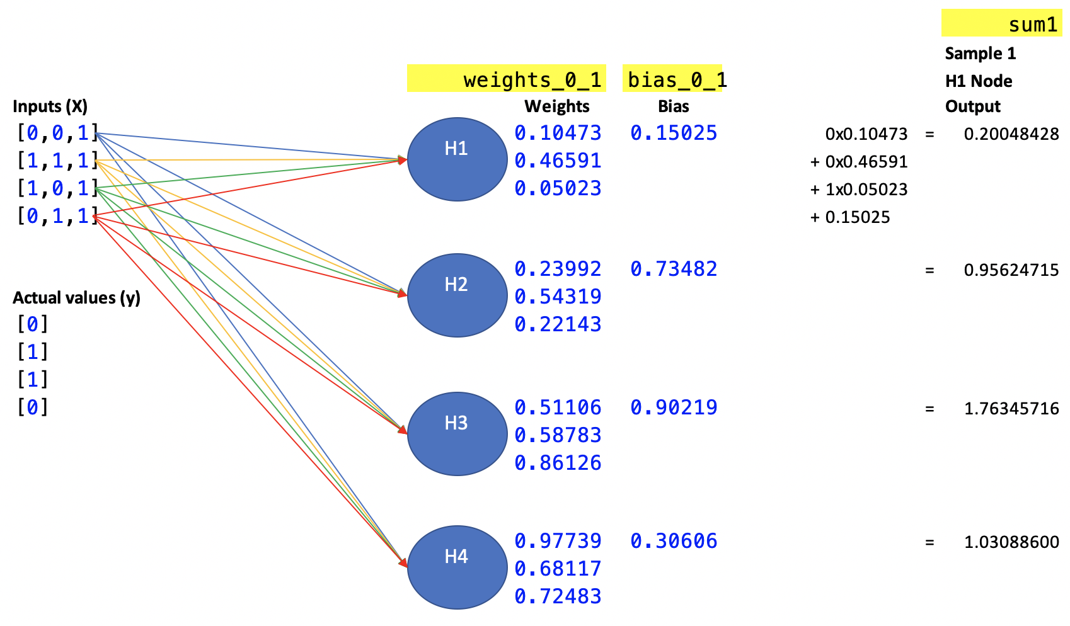

Exercise (5 marks)

Show calculations that are applied by the second neuron, H2, to sum the respective weights*features plus bias for the second sample where X = [1,1,1]. Show the final sum as well.   
Note that it is possible to step through the code to check your work.

|  |
| --- |
| Weights and bias for the second sample where X = [1, 1, 1]  Neuron H1:  1 * 0.10473 + 1 * 0.46591 + 1 * 0.05023 + 0.15025 = 0.77112  Neuron H2:  1 * 0.23992 + 1 * 0.54319 + 1 * 0.22143 + 0.73482 = 1.73936  Neuron H3:  1 * 0.51106 + 1 * 0.58783 + 1 * 0.86126 + 0.90219 = 2.86234  Neuron H4:  1 * 0.97739 + 1 * 0.68117 + 1 * 0.72483 + 0.30606 = 2.68945 |

### Applying the Activation Function for the Hidden Layer

After weights and biases are applied to each of the samples, their sums are passed to the activation function. The activation function used in this example happens to be a sigmoid function. After the sums are passed through the sigmoid function the data is then passed to the next layer. (See Figure 3).

Figure : Weight and bias sums of each neuron are passed to the activation function. Activation results are sent to next layer.

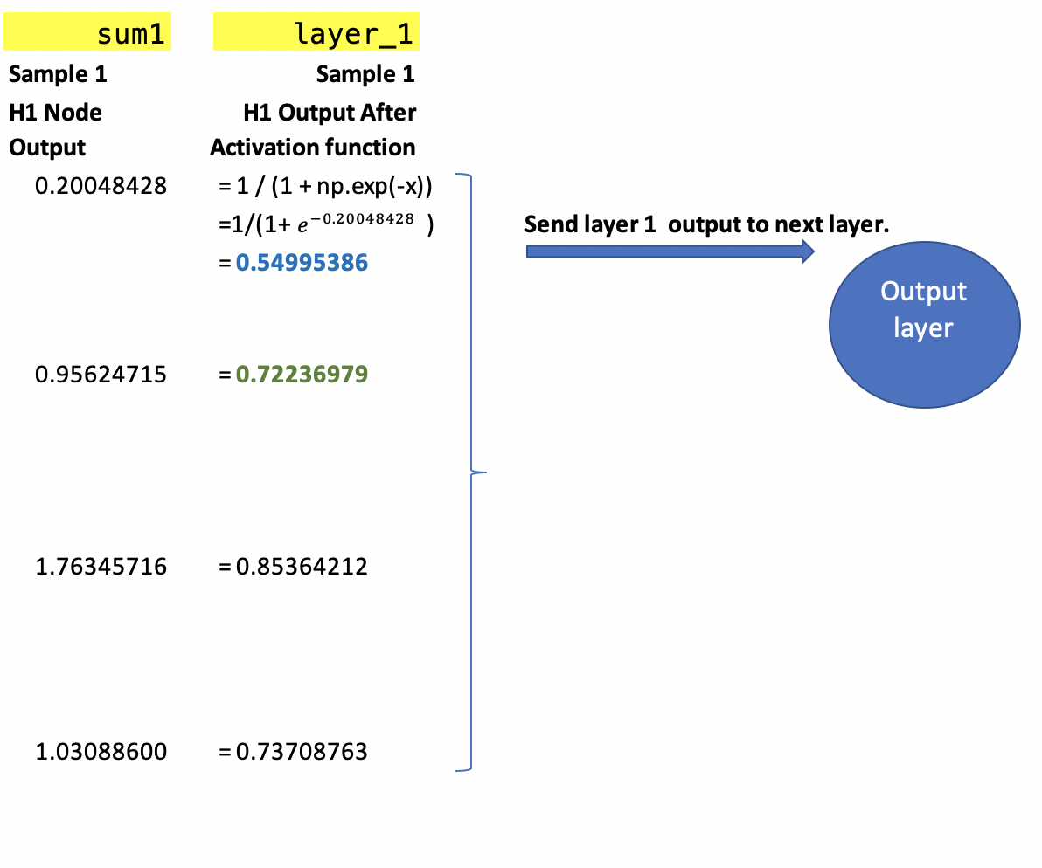

Exercise (3 marks)

Show the array of outputs from the activation function for the second sample where X=[1,1,1]. It is possible to check your work by stepping through the code. There should be four elements in this output for the second sample.

|  |
| --- |
| [0.6837631 $, 0.8506058, 0.9508435, 0.9327330$] $$H1= \frac{1}{1+ e^{-0.77112}}= 0.6837631$$ $$H2= \frac{1}{1+ e^{-1.73936}}= 0.8506058$$ $$H3= \frac{1}{1+ e^{-2.96234}}= 0.9508435$$ $$H4= \frac{1}{1+ e^{-2.62945}}= 0.9327330$$ |

Exercise (2 marks)

Show the activation function equation with any necessary value(s) plugged in to calculate the first value in the array for Exercise 2.

|  |
| --- |
| $$H1= \frac{1}{1+ e^{-0.77112}}= 0.6837631$$ |

Exercise 4 (1 mark)

Show a picture of the graph for a sigmoid function here:

|  |
| --- |
|  |

### Applying Weights and Bias of the Neurons in the Output Layer

This step shows how the output layer weights and bias are applied to the data that is sent from the previous layer.

Figure : Weights and bias are applied to sample outputs from the previous layer.

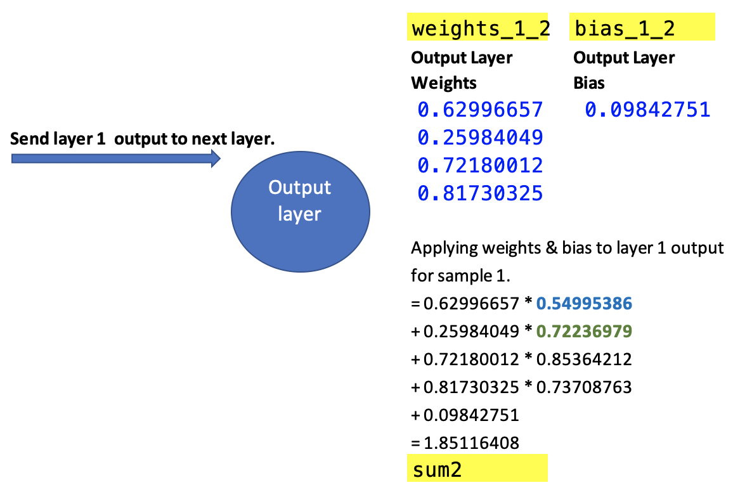

Exercise (5 marks)

Using the sample 2 output from the activation function of the hidden layer where the input X = [1, 1, 1]. Apply the weights and bias of the output layer and show the calculations and resulting sum. Show the calculation. (You can check your work by stepping through the code and examining sum2).

|  |
| --- |
| Sum2 =  0.62996657 * 0.6837631  + 0.25984049 * 0.8506058  + 0.72180012 * 0.9508435  + 0.81730325 * 0.9327330  + 0.09842751  = 2.198841897351879 |

### Applying the Activation Function for the Output Layer

In the last step of the forward pass, the sums from the output neuron are fed to the activation function. The resulting value is the prediction.

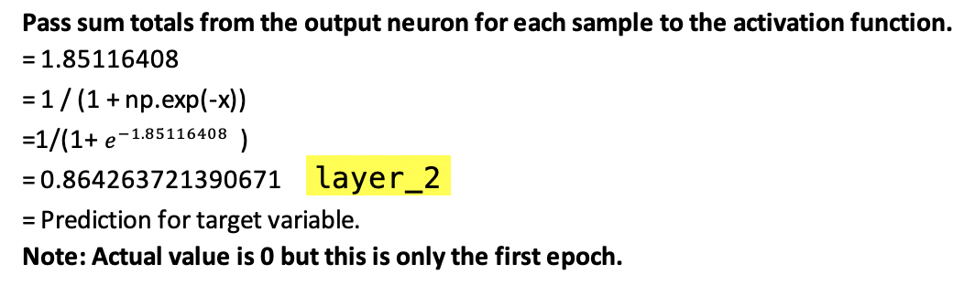

Exercise (2 marks)

After the first epoch, what is the prediction for the second sample where input X is [1,1,1]?

|  |
| --- |
| $$\frac{1}{1+ e^{-2.114545881630208}}= 2.114545881630208$$ |

What is the actual target value for the second sample?

|  |
| --- |
| 1 |

Exercise (2 marks)

Add an instruction to print out the sample predictions after each weight and bias update at each epoch.

print(layer_2)

Show the predictions after the first epoch here. Hint, the prediction for the first sample is 0.86426372.

|  |
| --- |
|  |

## Back Propagation

After each forward pass, back propagation updates the weights and bias of each neuron using a gradient descent approach to move towards the optimum.

### Calculate the losses

First losses are calculated. The losses are measured in this case by the distance between actual and predicted values.

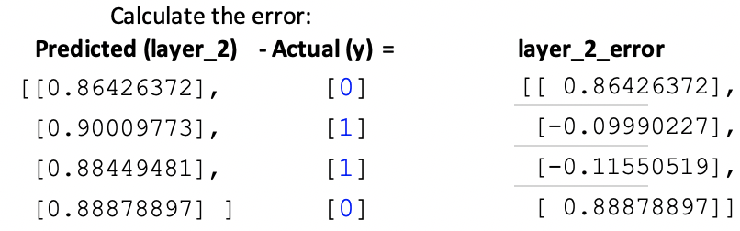

Exercise (3 marks)

Show the layer_2_error calculations at the last epoch here:

|  |  |  |  |  |  |  |  |  |  |  |  |  |  |  |  |
| --- | --- | --- | --- | --- | --- | --- | --- | --- | --- | --- | --- | --- | --- | --- | --- |
| Error calculation:   |  |  |  | | --- | --- | --- | | Predicted (layer 2) | Actual (y) | Layer 2 error | | 0.02123225 | 0 | 0.02123225 | | 0.98112875 | 1 | -0.01887125 | | 0.98349298 | 1 | -0.01650702 | | 0.01860364 | 0 | 0.01860364 | |

Is there a noticeable reduction in layer_2_error at the last epoch compared to the first?

|  |
| --- |
| There is a noticeable reduction in layer 2 at the last epoch compared to the first epoch. |

Exercise (5 marks)

Complete the table to help explain how accuracy improves during iterative learning in Example 1.

|  |  |  |  |
| --- | --- | --- | --- |
| Actual y | Predictions after 100 epochs | Predictions after 1000 epochs | Predictions after 10000 epochs |
| [[0]  [1]  [1]  [0]] | [[0.49028624]  [0.53441769]  [0.52092656]  [0.51271655]] | [[0.12917534]  [0.88207576]  [0.89723503]  [0.11738308]] | [[0.02123225]  [0.98112875]  [0.98349298]  [0.01860364]] |

What conclusion can be made about accuracy and learning for this network?

|  |
| --- |
| Accuracy and learning for this network improves over each epoch iteration. |

Example : Neural Network Applied

This example shows how to use the network from Example 1 to build a model which predicts whether a student will be accepted to a college or University where they apply. To build this example, replace the section that is surrounded by the open and close ## Data ## comment with the following.

|  |
| --- |
| ### DATA #######################################  # Setup data.  candidates = {'gmat': [780,750,690,710,680,730,690,720,  740,690,610,690,710,680,770,610,580,650,540,590,620,  600,550,550,570,670,660,580,650,660,640,620,660,660,  680,650,670,580,590,690],  'gpa': [4,3.9,3.3,3.7,3.9,3.7,2.3,3.3,  3.3,1.7,2.7,3.7,3.7,3.3,3.3,3,2.7,3.7,2.7,2.3,  3.3,2,2.3,2.7,3,3.3,3.7,2.3,3.7,3.3,3,2.7,4,  3.3,3.3,2.3,2.7,3.3,1.7,3.7],  'work_experience': [3,4,3,5,4,6,1,4,5,  1,3,5,6,4,3,1,4,6,2,3,2,1,4,1,2,6,4,2,6,5,1,2,4,6,  5,1,2,1,4,5],  'admitted': [1,1,1,1,1,1,0,1,1,0,0,1,  1,1,1,0,0,1,0,0,0,0,0,0,0,1,1,0,1,1,0,0,1,1,1,0,0,  0,0,1]}  df = pd.DataFrame(candidates,columns= ['gmat', 'gpa',  'work_experience','admitted'])  y = np.array(df['admitted'])  X = df.copy()  del X['admitted']  from sklearn.model_selection import train_test_split  from sklearn.preprocessing import StandardScaler  # Split data.  X_train,X_test,y_train,y_test = train_test_split(X, y, test_size=0.25,  random_state=0)  # define standard scaler  scaler = StandardScaler()  # transform data  X_train_scaled = scaler.fit_transform(X_train)  X_test_scaled = scaler.transform(X_test)  ### DATA ####################################### |

Exercise (5 marks)

ANN’s are sensitive to scaling. Most of the time inputs should be scaled. Modify Example 2 by removing the scaling. What predictions are made with the training data when all epochs have been completed?

|  |
| --- |
|  |

Step through the code in Example 2and identify the point where the algorithm fails with unscaled data. Explain what went wrong. Please use your best judgement here – there is no single perfect way to answer this question but you should be able to observe some point early on when the algorithm is unable to learn.

|  |
| --- |
|  |

Example : Making Predictions

This example shows that the network is trained up perfectly to make accurate predictions with the test data from Example 2.

|  |
| --- |
| [0 0 1 1 0 0 1 1 0 1]  precision recall f1-score support  0 1.00 1.00 1.00 5  1 1.00 1.00 1.00 5  accuracy 1.00 10  macro avg 1.00 1.00 1.00 10  weighted avg 1.00 1.00 1.00 10 |

To build this example add this code to the end of Example 2. The neural network has trained up properly.

|  |
| --- |
| from sklearn.metrics import classification_report  # Make predictions.  layer_1, layer_2 = feedForward(X_test_scaled)  print(layer_2)  print(y_test)  predictions = []  for i in range(0, len(layer_2)):  if(layer_2[i]>0.5):  predictions.append(1)  else:  predictions.append(0)  print(classification_report(y_test, predictions)) |

## TensorFlow and Keras

I have been using Tensorflow and Keras. The book by Dr. Brownlee also uses Keras. I like Keras because it provides structures that are easy to learn.

Example : Building a Sequential ANN with Keras

This example shows how to build an ANN to predict college admission acceptance like in the earlier examples in this document. To run this code likely you will need to install tensorflow and keras with pip.

When running the code, the performance appears to be acceptable.

|  |
| --- |
| Actual:  [0 0 1 1 0 0 1 1 0 1]  Predicted:  [[0.0219794 ]  [0.02577448]  [0.98109984]  [0.98109984]  [0.02254776]  [0.02202809]  [0.98113185]  [0.981141 ]  [0.0219158 ]  [0.980833 ]]  precision recall f1-score support  0 1.00 1.00 1.00 5  1 1.00 1.00 1.00 5  accuracy 1.00 10  macro avg 1.00 1.00 1.00 10  weighted avg 1.00 1.00 1.00 10 |

The network built is a 10 neuron x 3 neuron x 1 neuron or 10x3x1 ANN.

Here is the code:

|  |
| --- |
| # importing libraries  import numpy as np  import pandas as pd  ### DATA #######################################  # Setup data.  candidates = {'gmat': [780,750,690,710,680,730,690,720,  740,690,610,690,710,680,770,610,580,650,540,590,620,  600,550,550,570,670,660,580,650,660,640,620,660,660,  680,650,670,580,590,690],  'gpa': [4,3.9,3.3,3.7,3.9,3.7,2.3,3.3,  3.3,1.7,2.7,3.7,3.7,3.3,3.3,3,2.7,3.7,2.7,2.3,  3.3,2,2.3,2.7,3,3.3,3.7,2.3,3.7,3.3,3,2.7,4,  3.3,3.3,2.3,2.7,3.3,1.7,3.7],  'work_experience': [3,4,3,5,4,6,1,4,5,  1,3,5,6,4,3,1,4,6,2,3,2,1,4,1,2,6,4,2,6,5,1,2,4,6,  5,1,2,1,4,5],  'admitted': [1,1,1,1,1,1,0,1,1,0,0,1,  1,1,1,0,0,1,0,0,0,0,0,0,0,1,1,0,1,1,0,0,1,1,1,0,0,  0,0,1]}  df = pd.DataFrame(candidates,columns= ['gmat', 'gpa',  'work_experience','admitted'])  y = np.array(df['admitted'])  X = df.copy()  del X['admitted']  from sklearn.model_selection import train_test_split  from sklearn.preprocessing import StandardScaler  # Split data.  X_train,X_test,y_train,y_test = train_test_split(X, y, test_size=0.25,  random_state=0)  # define standard scaler  scaler = StandardScaler()  # transform data  X_train_scaled = scaler.fit_transform(X_train)  X_test_scaled = scaler.transform(X_test)  ##########################################################  from tensorflow.keras import Sequential  from tensorflow.keras.layers import Dense  # Build a network model of sequential layers.  model = Sequential()  NUM_COLS = 3  # Add 1st hidden layer. Note 1st hidden layer also receives data.  # The input array must contain two feature columns and any number of rows.  model.add(Dense(10, activation='sigmoid',  input_shape=(NUM_COLS,)))  # Add 2nd hidden layer.  model.add(Dense(3, activation='sigmoid'))  # Add output layer.  model.add(Dense(1, activation='sigmoid'))  # Compile the model.  # Binary cross entropy is used to measure error cost for binary predictions.  model.compile(loss='binary_crossentropy', metrics=['accuracy'])  # Fit the model.  # An epoch is one iteration for all samples through the network.  # verbose can be set to 1 to show detailed output during training.  model.fit(X_train_scaled, y_train, epochs=2000, verbose=1)  # Evaluate the model.  loss, acc = model.evaluate(X_test_scaled, y_test, verbose=0)  print('Test Accuracy: %.3f' % acc)  # Make predictions.  yhats = model.predict(X_test_scaled)  print("Actual:")  print(y_test)  print("Predicted: ")  print(yhats)  predictions = []  from sklearn.metrics import classification_report  def showClassificationReport(y_test, yhats):  # Convert continous predictions to  # 0 or 1.  for i in range(0, len(yhats)):  if(yhats[i]>0.5):  predictions.append(1)  else:  predictions.append(0)  print(classification_report(y_test, predictions))  showClassificationReport(y_test, yhats) |

Exercise (1 mark)

How many epochs are used in the network above?

|  |
| --- |
| 2000 |

Exercise (1 mark)

What important loss trend can you identify when observing the output while the network is learning?

|  |
| --- |
| Loss decreases as the network learns |

Exercise (3 marks)

Modify Example 4 so it can predict if a flower is red or white. Here is the data:

|  |
| --- |
| # Load the flower feature data into a DataFrame.  df = pd.DataFrame(columns=['Length', 'Width', 'IsRed'])  data = [  {'Length':3, 'Width':1.5, 'IsRed': 1},  {'Length':2, 'Width':1, 'IsRed': 0},  {'Length':4, 'Width':1.5, 'IsRed': 1},  {'Length':3, 'Width':1, 'IsRed': 0},  {'Length':3.5, 'Width':.5, 'IsRed': 1},  {'Length':2, 'Width':.5, 'IsRed': 0},  {'Length':5.5, 'Width':1, 'IsRed': 1},  {'Length':1, 'Width':1, 'IsRed': 0},  {'Length':4.5, 'Width':1, 'IsRed':1}]  df = pd.DataFrame.from_records(data) |

Show a screenshot of the output from your edited network here:

|  |
| --- |
|  |

## PyTorch

I am not a PyTorch expert but it has become very popular. I will try to use it in the course where possible but we will still use lots of Keras.

Example : College Admissions Using PyTorch

This example shows how to implement a model for classifying if applicants will be accepted to College by using PyTorch.

This model has two fully connected layers, with 3 input nodes and 8 hidden nodes, and an output node that gives the probability of the input belonging to class 1. The model is trained using stochastic gradient descent and the binary cross-entropy loss function. The accuracy of the model is computed on the sample data and is printed out at the end. Note that the sample data is random, so the accuracy may be different each time the model is run.

|  |
| --- |
| import torch  import torch.optim as optim  from sklearn.model_selection import train_test_split  ### DATA #######################################  # Setup data.  import pandas as pd  import numpy as np  candidates = {'gmat': [780,750,690,710,680,730,690,720,  740,690,610,690,710,680,770,610,580,650,540,590,620,  600,550,550,570,670,660,580,650,660,640,620,660,660,  680,650,670,580,590,690],  'gpa': [4,3.9,3.3,3.7,3.9,3.7,2.3,3.3,  3.3,1.7,2.7,3.7,3.7,3.3,3.3,3,2.7,3.7,2.7,2.3,  3.3,2,2.3,2.7,3,3.3,3.7,2.3,3.7,3.3,3,2.7,4,  3.3,3.3,2.3,2.7,3.3,1.7,3.7],  'work_experience': [3,4,3,5,4,6,1,4,5,  1,3,5,6,4,3,1,4,6,2,3,2,1,4,1,2,6,4,2,6,5,1,2,4,6,  5,1,2,1,4,5],  'admitted': [1,1,1,1,1,1,0,1,1,0,0,1,  1,1,1,0,0,1,0,0,0,0,0,0,0,1,1,0,1,1,0,0,1,1,1,0,0,  0,0,1]}  df = pd.DataFrame(candidates,columns= ['gmat', 'gpa',  'work_experience','admitted'])  y = np.array(df['admitted'])  X = df.copy()  del X['admitted']  X = X  ##########################################################  # Split the data into training and test sets  X_train, X_test, y_train, y_test = train_test_split(X, y, test_size=0.2)  # define standard scaler  from sklearn.preprocessing import StandardScaler  scaler = StandardScaler()  # transform data  X_train_scaled = scaler.fit_transform(X_train)  X_test_scaled = scaler.transform(X_test)  # Convert the data to PyTorch tensors  X_train = torch.tensor(X_train_scaled, dtype=torch.float32)  X_test = torch.tensor(X_test_scaled, dtype=torch.float32)  # Reshapes array.  # unsqueeze() creates array of single dimensional arrays.  y_train = torch.tensor(y_train, dtype=torch.float32).unsqueeze(1)  y_test = torch.tensor(y_test, dtype=torch.float32).unsqueeze(1)  import torch  import torch.nn as nn  # Define the neural network architecture  class BinaryClassificationNet(nn.Module):  def __init__(self):  super(BinaryClassificationNet, self).__init__()  self.fc1 = nn.Linear(3, 8)  self.fc2 = nn.Linear(8, 1)  self.sigmoid = nn.Sigmoid()  def forward(self, x):  x = self.fc1(x) # Hidden layer.  x = self.sigmoid(x) # Activation function.  x = self.fc2(x) # Output layer.  x = self.sigmoid(x) # Activation function.  return x  # Instantiate the model  model = BinaryClassificationNet()  # Define the loss function and optimizer  criterion = nn.BCELoss() # Binary cross entropy.  # Use stochastic gradient descent to update weights & bias.  optimizer = optim.SGD(model.parameters(), lr=0.01)  # Train the model  for epoch in range(2000):  print("Epoch: " + str(epoch))  # Forward pass  output = model(X_train)  loss = criterion(output, y_train)  # Backward pass and optimization  optimizer.zero_grad()  loss.backward()  optimizer.step()  # Evaluate the model  with torch.no_grad():  outputs = model(X_test)  predictions = outputs.round()  accuracy = (predictions == y_test).float().mean()  print(f'Accuracy: {accuracy}') |

Exercise (6 marks)

Using the data from Exercise 13, modify Example 5 to use PyTorch with this data set. Also, add the classification report to show the precision, recall and accuracy scores with the test data. Show your complete program after making the changes here.

|  |
| --- |
| import torch.optim as optim from sklearn.model_selection import train_test_split from sklearn.metrics import classification_report import pandas as pd import numpy as np from sklearn.preprocessing import StandardScaler import torch import torch.nn as nn  # ------------------------ DATA --------------------------------------  # Load the flower feature data into a DataFrame. df = pd.DataFrame(columns=['Length', 'Width', 'IsRed'])  data = [  {'Length': 3, 'Width': 1.5, 'IsRed': 1},  {'Length': 2, 'Width': 1, 'IsRed': 0},  {'Length': 4, 'Width': 1.5, 'IsRed': 1},  {'Length': 3, 'Width': 1, 'IsRed': 0},  {'Length': 3.5, 'Width': .5, 'IsRed': 1},  {'Length': 2, 'Width': .5, 'IsRed': 0},  {'Length': 5.5, 'Width': 1, 'IsRed': 1},  {'Length': 1, 'Width': 1, 'IsRed': 0},  {'Length': 4.5, 'Width': 1, 'IsRed': 1}]  df = pd.DataFrame.from_records(data)  y = np.array(df['IsRed']) X = df.copy() del X['IsRed']  # --------------------------------------------------------------   # Split the data into training and test sets X_train, X_test, y_train, y_test = train_test_split(X, y, test_size=0.2)  # define standard scaler scaler = StandardScaler()  # transform data X_train_scaled = scaler.fit_transform(X_train) X_test_scaled = scaler.transform(X_test)  # Convert the data to PyTorch tensors X_train = torch.tensor(X_train_scaled, dtype=torch.float32) X_test = torch.tensor(X_test_scaled, dtype=torch.float32)  # Reshapes array. # unsqueeze() creates array of single dimensional arrays. y_train = torch.tensor(y_train, dtype=torch.float32).unsqueeze(1) y_test = torch.tensor(y_test, dtype=torch.float32).unsqueeze(1)   # Define the neural network architecture class BinaryClassificationNet(nn.Module):  def __init__(self):  super(BinaryClassificationNet, self).__init__()  self.fc1 = nn.Linear(2, 8)  self.fc2 = nn.Linear(8, 1)  self.sigmoid = nn.Sigmoid()   def forward(self, x):  x = self.fc1(x) # Hidden layer.  x = self.sigmoid(x) # Activation function.  x = self.fc2(x) # Output layer.  x = self.sigmoid(x) # Activation function.  return x   # Instantiate the model model = BinaryClassificationNet()  # Define the loss function and optimizer criterion = nn.BCELoss() # Binary cross entropy. # Use stochastic gradient descent to update weights & bias. optimizer = optim.SGD(model.parameters(), lr=0.01)  # Train the model for epoch in range(2000):  print("Epoch: " + str(epoch))  # Forward pass  output = model(X_train)  loss = criterion(output, y_train)   # Backward pass and optimization  optimizer.zero_grad()  loss.backward()  optimizer.step()  # Evaluate the model with torch.no_grad():  outputs = model(X_test)  predictions = outputs.round()  accuracy = (predictions == y_test).float().mean()  print(f'\nAccuracy: {accuracy}')   # Make predictions.  print("Actual:")  print(y_test)  print("Predicted: ")  print(predictions)  predictions_list = []    def showClassificationReport(y_test, yhats):  # Convert continous predictions to  # 0 or 1.  for i in range(0, len(yhats)):  if yhats[i] > 0.5:  predictions_list.append(1)  else:  predictions_list.append(0)  print(classification_report(y_test, predictions_list, zero_division=False))    showClassificationReport(y_test, predictions) |

Table of Contents

Other Machine Learning Algorithms for Regression and Classification 1

Reshaping Data 1

Linear Regression with Scaling 3

Gradient Descent 5

Ridge Regression 6

Lasso Regression 8

Elastic Net Regression 9

Equation Comparison 11

Support Vector Machines 12

Summary 15

# Other Machine Learning Algorithms for Regression and Classification

<https://www.analyticsvidhya.com/blog/2017/06/a-comprehensive-guide-for-linear-ridge-and-lasso-regression/>

Since the start of the course, we have discussed several machine learning algorithm alternatives which perform linear regression and classification. During this section we will extend the stochastic gradient descent algorithm and also will briefly cover support vector machines.

## Reshaping Data

Many algorithms will require a transformation to adjust how X and y values are arranged. The need to transform, scale and then revert back to original formats is magnified when working with machine learning algorithms. The need to switch data formats can be frustrating but the problem will become less troubling with practice and experience. A common error to watch for is:

**Reshape your data either using array.reshape(-1, 1)**

Example 1: Resolving the Reshape Error

This example demonstrates the reshape error. Initially the data is presented as:

642 5

679 5

473 5

390 8

1096 6

When trying to scale the data, the following error displays:

**Reshape your data either using array.reshape(-1, 1)**

The code needs to be transformed into a set of vertical arrays.

[[5]

[5]

[5]

...

[6]

[6]

[5]]

Here is the code which leads to the error while scaling:

|  |
| --- |
| import pandas as pd  import numpy as np  from sklearn.metrics import mean_squared_error  from sklearn.model_selection import train_test_split  import statsmodels.api as sm  PATH = "/Users/pm/Desktop/DayDocs/data/"  CSV_DATA = "winequality.csv"  dataset = pd.read_csv(PATH + CSV_DATA)  # Show all columns.  pd.set_option('display.max_columns', None)  # Include only statistically significant columns.  X = dataset[['volatile acidity', 'chlorides', 'total sulfur dioxide',  'pH', 'sulphates','alcohol']]  y = dataset['quality']  X_train, X_test, y_train, y_test = train_test_split(X, y, test_size=0.2, random_state=0)  # Stochastic gradient descent models are sensitive to differences  # in scale so a MinMax is usually used.  from sklearn.preprocessing import MinMaxScaler  scalerX = MinMaxScaler()  scalerX.fit(X_train)  print(y_train)  # Build scaler for y.  scalerY = MinMaxScaler()  scalerY.fit(y_train) |

To fix the error we use:

y_train = np.array(y_train).reshape(-1, 1)

To transform the y values to the following format of vertical arrays:

Modified y_train

[[5]

[5]

[5]

...

[6]

[6]

[5]]

To build this example, replace the code that performs the scaling in Example 1 with the following:

|  |
| --- |
| import numpy as np  # Create array of y-values and reshape.  y_train = np.array(y_train).reshape(-1, 1)  print("\nModified y_train")  print(y_train)  # Build scaler for y.  scalerY = MinMaxScaler()  scalerY.fit(y_train)  y_scaled = scalerY.transform(y_train)  print("\nScaled y")  print(y_scaled) |

## Linear Regression with Scaling

Example 2: Linear Regression with Scaling

Here is linear regression with scaling. The RMSE is 0.620698340123314.

|  |
| --- |
| import pandas as pd  from sklearn.model_selection import train_test_split  from sklearn                 import metrics  import statsmodels.api       as sm  import numpy as np  PATH     = "/Users/pm/Desktop/DayDocs/data/"  CSV_DATA = "winequality.csv"  dataset  = pd.read_csv(PATH + CSV_DATA)  X = dataset[['volatile acidity', 'chlorides', 'total sulfur dioxide', 'sulphates',               'alcohol']]  # Adding an intercept *** This is requried ***. Don't forget this step.  # The intercept centers the error residuals around zero  # which helps to avoid over-fitting.  X_withConst = sm.add_constant(X)  y = dataset['quality'].values  import pandas as pd  import numpy as np  from sklearn.model_selection import train_test_split  import statsmodels.api       as sm  # Show all columns.  pd.set_option('display.max_columns', None)  # Include only statistically significant columns.  X = dataset[['volatile acidity', 'chlorides', 'total sulfur dioxide',               'pH', 'sulphates','alcohol']]  X = sm.add_constant(X)  y = dataset['quality']  X_train, X_test, y_train, y_test = train_test_split(X, y, test_size=0.2, random_state=0)  # Stochastic gradient descent models are sensitive to scaling.  # Fit X scaler and transform X_train.  from sklearn.preprocessing import StandardScaler  scalerX = StandardScaler()  X_train_scaled = scalerX.fit_transform(X_train)  # Build y scaler and transform y_train.  scalerY = StandardScaler()  y_train_scaled = scalerY.fit_transform(np.array(y_train).reshape(-1,1))  # Scale test data.  X_test_scaled = scalerX.transform(X_test)  def performLinearRegression(X_train, X_test, y_train, y_test, scalerY):      model = sm.OLS(y_train, X_train).fit()      scaledPredictions = model.predict(X_test) # make the predictions by the model      predictions = scalerY.inverse_transform(np.array(scaledPredictions).reshape(-1,1))      print(model.summary())      print('Root Mean Squared Error:',            np.sqrt(metrics.mean_squared_error(y_test, predictions)))      return predictions  predictions = performLinearRegression(X_train_scaled, X_test_scaled,                                        y_train_scaled, y_test, scalerY) |

## Gradient Descent

On the first day of COMP3948 we also discussed stochastic gradient descent. In case you need a review, you may want to watch Josh Stormer’s video where he explains how gradient descent works at <https://youtu.be/sDv4f4s2SB8>.

Gradient descent finds the minimum of the loss function which in turn identifies the best fit line. The example in the video uses an ordinary least squares regression. The loss function uses the equation ${(actual-predicted)}^{2}$ to quantify the deviation between expected and actual values.

Gradient descent involves taking the derivative of the loss function to find the lowest point of the function’s curve. Derivatives with respect to different predictor variables are called gradients.

Given that we are only making adjustments for different intercepts, Figure 1 shows how the gradient descent algorithm could calculate the slope of the loss function when the intercept is 0. The slope of -5.7 is not optimal but it is a start. Ideally, we want to find a slope that is as close to zero as possible somewhere around where the intercept equals 1.

Figure : Following Gradients to the Minimum



Example : Stochastic Gradient Descent

This example shows how to build a predictive model using stochastic gradient descent.

To build this example, add this code to the end of Example 2.

The root mean squared error from SGD is 0.68442053944026. The RMSE in this case is higher than the RMSE value of 0.6259157889490549 that was generated with the ordinary least-squares regression.

|  |
| --- |
| from sklearn.linear_model import SGDRegressor  def performSGD(X_train, X_test, y_train, y_test, scalerY):  sgd = SGDRegressor()  sgd.fit(X_train, y_train)  print("\n***SGD=")  predictionsUnscaled = sgd.predict(X_test)  predictions = scalerY.inverse_transform(  np.array(predictionsUnscaled).reshape(-1,1))  print('Root Mean Squared Error:',  np.sqrt(metrics.mean_squared_error(y_test,  predictions)))  predictions = performSGD(X_train_scaled, X_test_scaled,  y_train_scaled, y_test, scalerY) |

## Ridge Regression

On the first day of COMP4948 we also discussed ridge regression. Josh Stormer’s video explains ridge regression nicely in detail in case you would like to review it

<https://www.youtube.com/watch?v=Q81RR3yKn30>

**Note:** Josh Stormer’s videos refers to $λ$ as the parameter which sets the strength of L1 and L2 penalties. (We will talk about the L1 and L2 penalties shortly). However, sklearn uses $∝$ since sklearn already refers to $λ$ as the learning rate. These notes will also use $∝$ to refer to the strength of the L1 and L2 penalties. The conflicting references to the penalty strength are confusing so I will try my best to make it as clear as I can.

As Josh explains, the original ordinary least squares best-fit line in Figure 2 is a perfect fit for the training data. The model equation in this case is:

intercept + slope $∙x_{i}$

Figure : Fitting a best-fit line to training data without a penalty

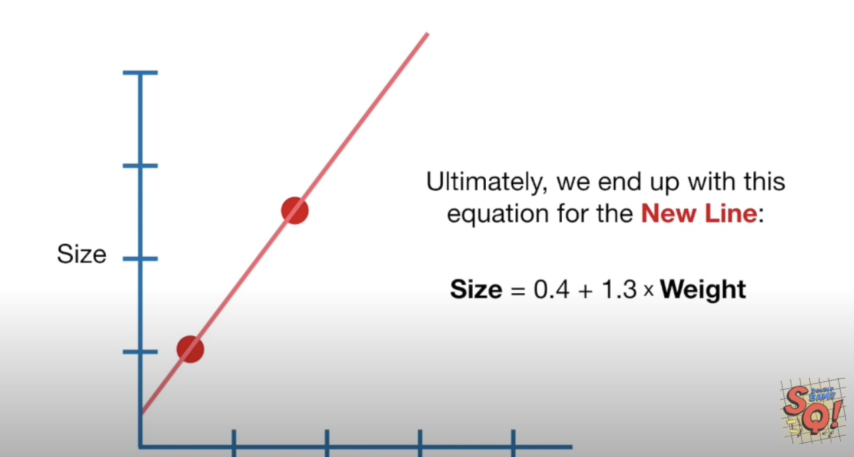

However, if we were given new data which is represented by the green dots in Figure 3, it is obvious that the original model does not fit the new data well.

Figure : Poor fit with new data

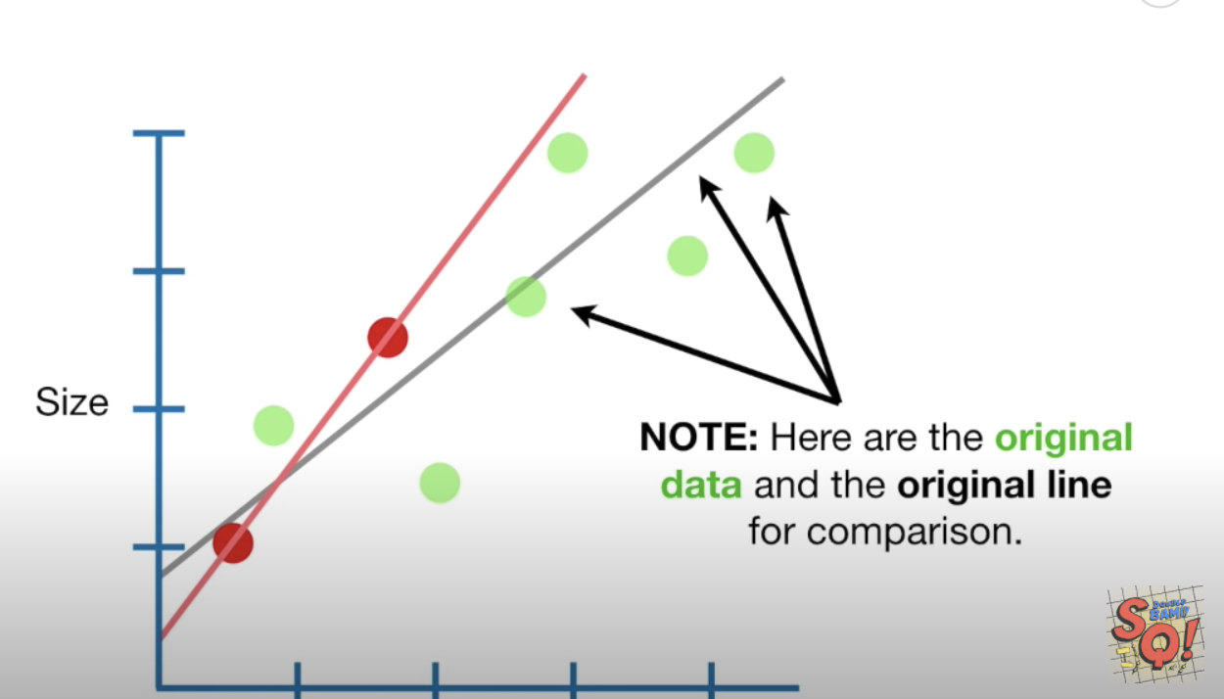

Ridge regression adds an **L2** penalty which equals $∝∙{slope}^{2}$ to the best fit line equation. $∝$

determines how strong the penalty is. The new model equation becomes;

intercept + slope $∙x_{i}$ + $∝∙{slope}^{2}$

Ridge regression then includes the penalty when calculating gradients to minimize the loss function. The loss function in this case is;

$Loss= {(Actual-predicted)}^{2}$ = ${(Actual-( intercept+slope∙x_{i}+ ∝∙{slope}^{2} ))}^{2}$

When the minimum point of the loss function is found, it is used to identify the best fit line.

Example : Ridge Regression

This example uses ridge regression to model the best fit line. To build this example add this code to the end of Example 3. When alpha=0.17, the RMSE of 0 0.623445 for ridge regression is slightly better than 0.6259157889490531 for ordinary least squares regression.

The coefficients in this case become:

Intercept: 3.349750965754926

'volatile acidity', 'chlorides', 'total sulfur dioxide', 'sulphates', 'alcohol'

[-1.09042919 -1.5465499 -0.00208941 0.79016659 0.24841788]

To build this program, add this code to the end of Example 3.

|  |
| --- |
| from sklearn.linear_model import Ridge  def ridge_regression(X_train, X_test, y_train, y_test, alpha, scalerY):  # Fit the model  ridgereg = Ridge(alpha=alpha)  ridgereg.fit(X_train, y_train)  y_pred_scaled = ridgereg.predict(X_test)  # predictions = scalerY.inverse_transform(y_pred.reshape(-1,1))  print("\n***Ridge Regression Coefficients ** alpha=" + str(alpha))  print(ridgereg.intercept_)  print(ridgereg.coef_)  y_pred = scalerY.inverse_transform(np.array(y_pred_scaled).reshape(-1,1))  print('Root Mean Squared Error:',  np.sqrt(metrics.mean_squared_error(y_test, y_pred)))  X_train, X_test, y_train, y_test = train_test_split(X, y,  test_size=0.2, random_state=0)  alphaValues = [0, 0.16, 0.17, 0.18]  for i in range(0, len(alphaValues)):  ridge_regression(X_train_scaled, X_test_scaled, y_train_scaled,  y_test, alphaValues[i], scalerY) |

Exercise (1 mark)

What is the RMSE value of ridge regression when alpha = 0?

|  |
| --- |
| When alpha = 0: 0.620698340123314 |

Exercise (1 mark)

How does the RMSE from OLS compare with the RMSE of ridge regression when alpha = 0?

|  |
| --- |
| OLS = 0.620698340123314, very similar |

Exercise (1 mark)

In addition to giving the same result as OLS, when alpha equals 0 ridge regression also provides a result that is identical to which other algorithm?

|  |
| --- |
| S gradient descent |

## Lasso Regression

A problem with ridge regression is that it cannot fully eliminate any of insignificant predictor variables unless we remove them manually. Lasso regression addresses this problem by adding an **L1 penalty** of $∝∙\left|slope\right|$ so insignificant predictor variables vanish.

intercept + slope $∙x_{i}$ + $∝∙|slope|$

To understand lasso regression in detail, see Josh Stormer’s videos at

<https://www.youtube.com/watch?v=NGf0voTMlcs> (Lasso regression)

<https://www.youtube.com/watch?v=Xm2C_gTAl8c> (Comparing lasso and ridge regression)

Example : Lasso

To implement lasso regression, add the code below Example 4. Lasso does very poorly. For this case, lasso set all predictor coefficients to zero so the intercept of 5.6466 is the only predictive feature in the entire model. It turns out that 5.6465 is approximately the average wine quality rating.

|  |
| --- |
| ***Lasso Regression Coefficients ** alpha=0.1  3.0833025347842193  [ 0. -0. -0. -0.00268159 0. 0.25827142]  Root Mean Squared Error: 0.6606896871528144  ***Lasso Regression Coefficients ** alpha=0.5  5.836986684298963  [ 0. -0. -0. -0.00404099 0. 0. ]  Root Mean Squared Error: 0.7450216331718217  ***Lasso Regression Coefficients ** alpha=1  5.8160845378755255  [ 0. -0. -0. -0.00359734 0. 0. ]  Root Mean Squared Error: 0.7455442007369433 |

Here is the code:

|  |
| --- |
| from sklearn.linear_model import Lasso  def performLassorRegression(X_train, X_test, y_train, y_test, alpha,  scalerY):  lassoreg = Lasso(alpha=alpha)  lassoreg.fit(X_train, y_train)  y_pred_scaled = lassoreg.predict(X_test)  y_pred = scalerY.inverse_transform(np.array(y_pred_scaled).reshape(-1,1))  print("\n***Lasso Regression Coefficients ** alpha=" + str(alpha))  print(lassoreg.intercept_)  print(lassoreg.coef_)  print('Root Mean Squared Error:',  np.sqrt(metrics.mean_squared_error(y_test, y_pred)))  alphaValues = [0, 0.1, 0.5, 1]  for i in range(0, len(alphaValues)):  performLassorRegression(X_train_scaled, X_test_scaled, y_train_scaled,  y_test, alphaValues[i], scalerY) |

Lasso did poorly in this case but we will see shortly how it can make a difference as part of the elastic net algorithm.

## Elastic Net Regression

Elastic Net is useful when there are many predictor variables and we do not know which ones are actually significant for making a prediction. Elastic Net regression combines the L1 penalty from lasso regression and the L2 penalty from ridge regression.

For a reference consider reading:

<https://machinelearningmastery.com/elastic-net-regression-in-python/>

You might watch Josh Stormer’s video on elastic net for a better understanding at;

<https://www.youtube.com/watch?v=1dKRdX9bfIo>

The equation for generating the best fit line with elastic net regression is;

intercept + slope $∙x_{i}$ + $∝∙\left|slope\right| +(1-∝)∙{slope}^{2}$

As mentioned at the start of this document, the conflicting variable references for the strength of L1 and L2 penalties is confusing. The sklearn package also provides an additional l1_ratio parameter for their ElasticNet regressor to set the strength level of the L1 penalty. This extra parameter makes the terminology even more confusing so rather than overthinking it – I recommend just grid searching for the *alpha* and *l1_ratio* parameters to find the best results.

Example : ElasticNet Regression

This example demonstrates how to implement elastic net regression. When running the code, given all potential predictor variables, elastic net chose to only implement the L2 penalty. We know this because the l1ratio is set to 0 where the RMSE is at its lowest value of 0.61973. It is possible though that the model is overfit. A way to test this further would involve cross fold validation.

***ElasticNet Regression Coefficients ** alpha=0.01 l1ratio=0

2.9628181790919284

[ 0.0248009 -0.90311047 -0.00991496 0.00671778 -0.26896603 0.00376948

-0.00286842 -0.00340709 -0.18190618 0.55111427 0.31511091]

Root Mean Squared Error: 0.619732479961025

If we are concerned about overfitting, we can assign more strength to the L1 penalty for lasso regression. When an L1 penalty is used you will notice that some of the insignificant predictor variables are eliminated. The RMSE values from the elastic net regression with the L1 and L2 penalties still out-perform all OLS, SGD, ridge and lasso models.

***ElasticNet Regression Coefficients ** alpha=0.01 l1ratio=0.25

2.5743182663196325

[ 0.03011923 -0.9144444 -0. 0.00502741 -0.05385138 0.00359964

-0.00275648 -0. -0.06977843 0.50768012 0.31363392]

Root Mean Squared Error: 0.6214618411645152

***ElasticNet Regression Coefficients ** alpha=0.01 l1ratio=0.5

2.357912146791541

[ 0.03387944 -0.92442306 0. 0.00376742 -0. 0.00348747

-0.00267609 -0. -0. 0.47166676 0.31168149]

Root Mean Squared Error: 0.6225075422100831

Here is the code that implements elastic net regression. Add this code to the end of Example 6.

|  |
| --- |
| from sklearn.linear_model import ElasticNet  bestRMSE = 100000.03  def performElasticNetRegression(X_train, X_test, y_train, y_test, alpha, l1ratio, bestRMSE,  bestAlpha, bestL1Ratio, scalerY):  model = ElasticNet(alpha=alpha, l1_ratio=l1ratio)  # fit model  model.fit(X_train, y_train)  y_pred_scaled = model.predict(X_test)  y_pred = scalerY.inverse_transform(np.array(y_pred_scaled).reshape(-1,1))  print("\n***ElasticNet Regression Coefficients ** alpha=" + str(alpha)  + " l1ratio=" + str(l1ratio))  rmse = np.sqrt(metrics.mean_squared_error(y_test, y_pred))  print(model.intercept_)  print(model.coef_)  try:  if(rmse < bestRMSE):  bestRMSE = rmse  bestAlpha = alpha  bestL1Ratio = l1ratio  print('Root Mean Squared Error:', rmse)  except:  print("rmse =" + str(rmse))  return bestRMSE, bestAlpha, bestL1Ratio  alphaValues = [0, 0.00001, 0.0001, 0.001, 0.01, 0.18]  l1ratioValues = [0, 0.25, 0.5, 0.75, 1]  bestAlpha = 0  bestL1Ratio = 0  for i in range(0, len(alphaValues)):  for j in range(0, len(l1ratioValues)):  bestRMSE, bestAlpha, bestL1Ratio = performElasticNetRegression(  X_train_scaled, X_test_scaled, y_train_scaled,  y_test,  alphaValues[i], l1ratioValues[j], bestRMSE,  bestAlpha, bestL1Ratio, scalerY)  print("Best RMSE " + str(bestRMSE) + " Best alpha: " + str(bestAlpha)  + " " + "Best l1 ratio: " + str(bestL1Ratio)) |

## Equation Comparison

With all of the methods discussed we are using gradients to find the minimum loss with the minimum least squared error equation. To implement each of the machine learning algorithms, we search for the minimum loss by calculating the gradient of the loss function.

$\frac{d(least squares)}{dx}$ = $\frac{d {(actual-prediction)}^{2}}{dx}$

The prediction equation changes with the algorithm. The prediction equation includes an L2 penalty with ridge regression. The prediction equation includes an L1 penalty for lasso regression. The prediction equation includes both L1 and L2 penalties for elastic net regression.

Table : Regression Comparison

|  |  |  |
| --- | --- | --- |
|  | Prediction equation as |  |
| Gradient Descent | intercept+slope $∙x_{i}$ | Simple |
| Stochastic Gradient Descent | intercept+slope $∙x_{i}$ (Training set is randomly selected) | Simple |
| Ridge Regression | intercept+slope $∙x_{i}$ + $∝∙{slope}^{2}$ | Tends to do better when most variables are relevant. |
| Lasso Regression | intercept+slope + | Gets rid of useless variables. |
| Elastic Net Regression  (Is a hybrid of ridge and lasso) | intercept+slope++ | Good for many variables when don’t know which ones are relevant. |

## Support Vector Machines

Support vector machines offer another way to apply machine learning for conducting linear regression and classification. Once again Josh Stormer has an excellent video to explain how support vector machines work.

<https://www.youtube.com/watch?v=efR1C6CvhmE>

Support vector machines (SVMs) are supervised algorithms for both classification and regression. Generally, an SVM algorithm tries to find the widest margin between classes to distinguish one from the other.

Josh Stormer presents an example of an SVM for classifying mice as either not obese or obese. Figure 4 illustrates how we can set a threshold to separate non-obese mice from obese mice.

Figure : Classifying Non-Obese Mice (Left) with Obese Mice (Right)

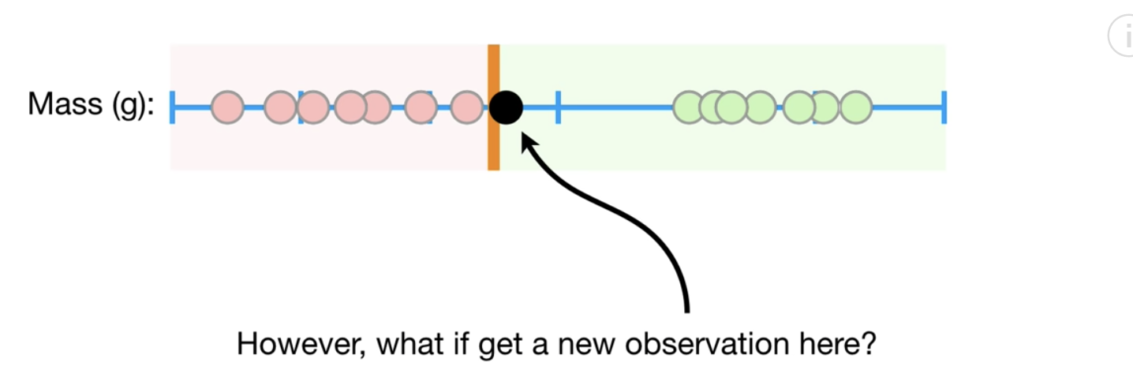

In order to optimize most predictions, we may place set threshold that allows some samples to be misclassified. Obviously, there is a trade-off but the benefit of high accuracy may be worth the occasional misclassification.

Figure : Allowing for Mis-classification

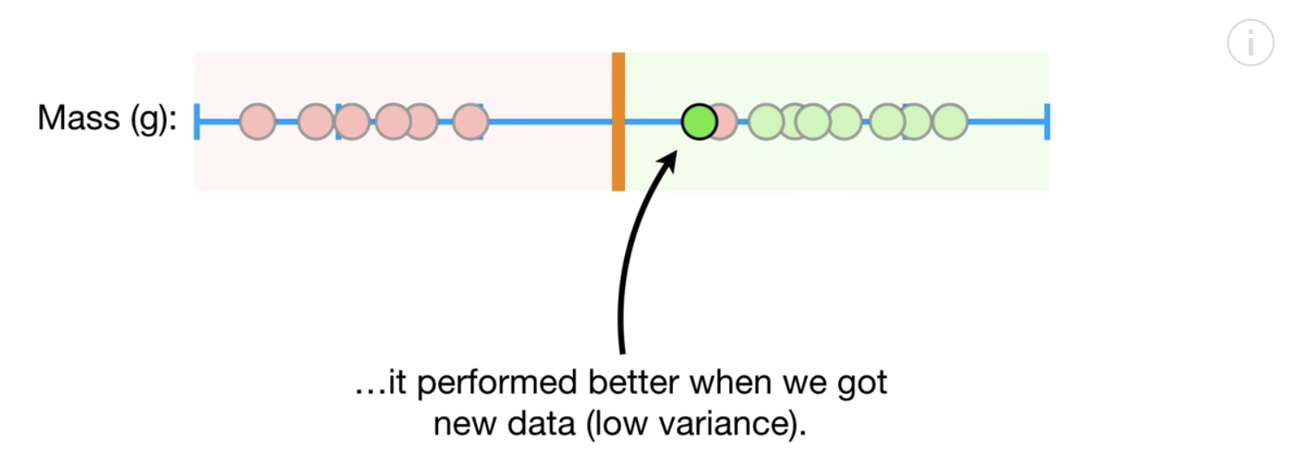

Josh presents another scenario in Figure 6 for vaccine dosage. The samples on the left do not receive enough of the vaccine to be cured. The samples on the right receive too much of the dosage to be cured. The samples in the middle receive the right amount of the dosage. A threshold in the same dimension does not help with classification.

Figure : Vaccine Dosage



Support vector classifiers allow us to create lines or planes in higher dimensions to enable better separation between classes (refer to Figure 7).

Figure : Enabling Classification with Higher Dimensions

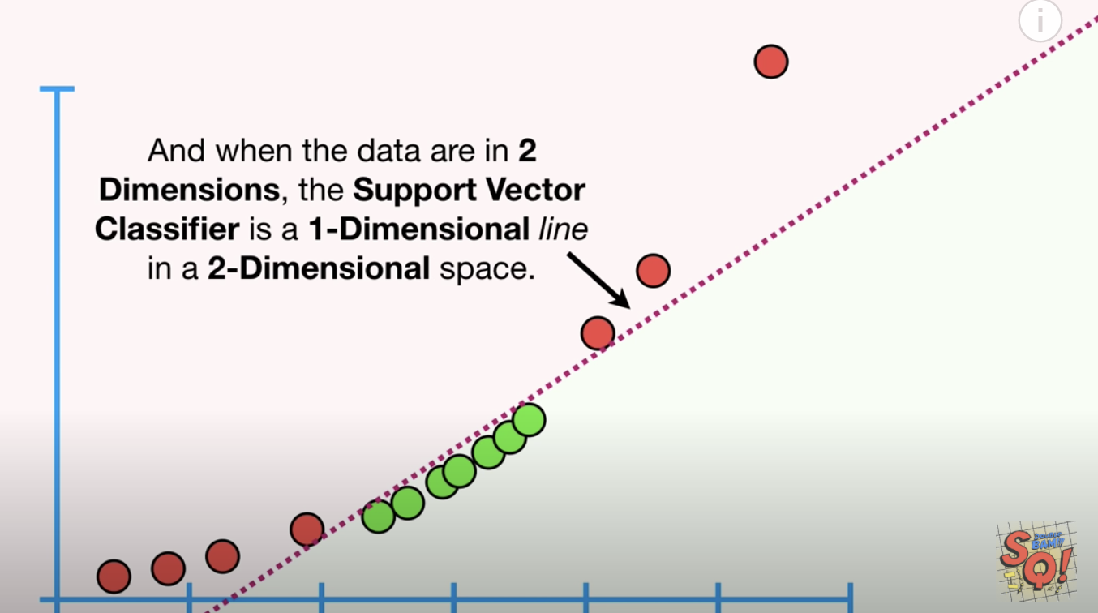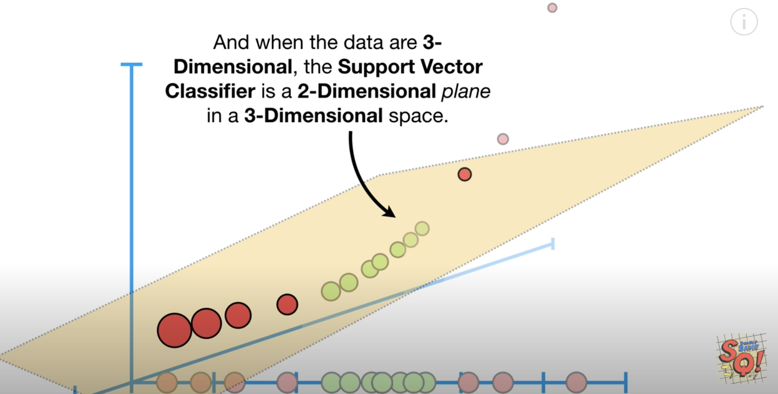

We could Kernel could be sigmoid, linear, rbf (gaussian), poly with degree.

clf = svm.SVC(kernel='linear')

clf = svm.SVC(kernel='rbf')

clf = svm.SVC(kernel='sigmoid')

svclassifier = SVC(kernel='poly', degree=8)

Example : Basic Logistic Regression

In this example we will start the series by first perform basic logistic regression with the diabetes data set. Simple logistic regression can detect diabetes with accuracy score of 80%.

|  |
| --- |
| Accuracy: 0.8070866141732284  Confusion Matrix  Predicted 0 1  Actual  0 156 16  1 33 49 |

Here is the code:

|  |
| --- |
| import pandas as pd  from sklearn.model_selection import train_test_split  PATH = "/Users/pm/Desktop/DayDocs/data/"  from sklearn.linear_model import LogisticRegression  from sklearn import metrics  import numpy as np  # load the dataset  df = pd.read_csv(PATH + 'diabetes.csv', sep=',')  # split into input (X) and output (y) variables  X = df[['Pregnancies','Glucose','BloodPressure','SkinThickness','Insulin','BMI',  'DiabetesPedigreeFunction', 'Age']]  y = df[['Outcome']]  # Split into train and test data sets.  X_train, X_test, y_train, y_test = train_test_split( X, y, test_size=0.33)  # Perform logistic regression.  logisticModel = LogisticRegression(fit_intercept=True, random_state = 0,  solver='liblinear')  logisticModel.fit(X_train,y_train)  y_pred=logisticModel.predict(X_test)  # Show model coefficients and intercept.  print("\nModel Coefficients: ")  print("\nIntercept: ")  print(logisticModel.intercept_)  print(logisticModel.coef_)  # Show confusion matrix and accuracy scores.  confusion_matrix = pd.crosstab(np.array(y_test['Outcome']), y_pred,  rownames=['Actual'],  colnames=['Predicted'])  print('\nAccuracy: ',metrics.accuracy_score(y_test, y_pred))  print("\nConfusion Matrix")  print(confusion_matrix) |

Example : Support Vector Machines with a Linear Kernel

This example implements an SVM model with a linear kernel setting. The original logistic regression equation generates reasonable accuracy.

Accuracy: 0.7716535433070866

Confusion Matrix

Predicted 0 1

Actual

0 145 26

1 32 51

The linear kernel appears to be slightly better in this case. Running the code multiple times though obtains varying results.

Accuracy: 0.7755905511811023

To build this example, add this code to the end of Example 6.

|  |
| --- |
| # Import svm package  from sklearn import svm  # Create a svm Classifier using one of the following options:  # linear, polynomial, and radial  clf = svm.SVC(kernel='linear')  # Train the model using the training set.  clf.fit(X_train, y_train)  # Evaluate the model.  y_pred = clf.predict(X_test)  from sklearn import metrics  print("Accuracy:",metrics.accuracy_score(y_test, y_pred)) |

Exercise (1 mark)

Try running the code in Example 7 with the ‘rbf’ option. How do the results compare with logistic regression?

|  |
| --- |
| Accuracy is slightly lower |

Exercise (1 mark)

Try running the code in Example 7 with the ‘sigmoid’ option. How do the results compare with logistic regression?

|  |
| --- |
| Accuracy is a lot lower |

## Summary

The content that has been covered in this document shows several other ways to perform linear regression and classification. In addition to OLS and logistic regression, we have added gradient descent, ridge regression, lasso regression, elastic net regression and support vector machines to our tool kit. To know which algorithm performs best always cross validate and compare.

Exercise (2 marks)

Run the following code and show the model summary and RMSE. Indicate if any of the predictor variables are insignificant in a 5% confidence interval. It is fine if the intercept is not significant.

|  |
| --- |
| import pandas as pd  from sklearn.model_selection import train_test_split  from sklearn import metrics  import statsmodels.api as sm  import numpy as np  PATH = "/Users/pm/Desktop/DayDocs/data/"  CSV_DATA = "petrol_consumption.csv"  dataset = pd.read_csv(PATH + CSV_DATA)  # Petrol_Consumption  X = dataset[['Petrol_tax','Average_income', 'Population_Driver_licence(%)']]  # Adding an intercept *** This is requried ***. Don't forget this step.  # The intercept centers the error residuals around zero  # which helps to avoid over-fitting.  X_withConst = sm.add_constant(X)  y = dataset['Petrol_Consumption'].values  X_train, X_test, y_train, y_test = train_test_split(X_withConst, y,  test_size=0.2, random_state=0)  def performLinearRegression(X_train, X_test, y_train, y_test):  model = sm.OLS(y_train, X_train).fit()  predictions = model.predict(X_test) # make the predictions by the model  print(model.summary())  print('Root Mean Squared Error:',  np.sqrt(metrics.mean_squared_error(y_test, predictions)))  return predictions  predictions = performLinearRegression(X_train, X_test, y_train, y_test) |

Show the model summary here:

|  |
| --- |
|  |

Show the RMSE here:

|  |
| --- |
| Root Mean Squared Error: 62.88023441228479 |

Are any predictor variables insignificant? If so which ones are insignificant?

|  |
| --- |
| No, all the predictor variables have a p-value less than 0.05. |

Exercise (2 marks)

Build a linear regression model for petrol consumption using stochastic gradient descent. Big hint: add in the code from Example 2. How does the RMSE from SGD compare with the RMSE when using OLS? Explain why this may have happened.

|  |
| --- |
| SGD has a better RMSE. This is likely due to the scaling. |

Exercise (3 marks)

Using petrol consumption data from the previous exercise, add in the code to perform **ridge** regression. This is easy. Please see the example code for ridge regression. Make sure none of the SGD or scaling code exists in this file so you can get a clear view of how ridge regression compares with OLS. Also, remove the parameter random_state=0 to prevent seeding so you can have truly random data. Grid search optimal values for alpha. Compare RMSE’s for your OLS and ridge regression models here:

|  |
| --- |
| The RMSE gets better as the alpha increases. |

Exercise (3 marks)

Start with the code for OLS again from the previous exercise. Add in the code to perform **lasso** regression. This is easy. Please see the example code for lasso regression. Make sure none of the SGD or scaling code exists in this file so you can get a clear view of how ridge regression compares with OLS. Also, remove the parameter random_state=0 to prevent seeding so you can have truly random data. Grid search optimal values for alpha. Compare RMSE’s for your OLS and your best performing lasso regression models here:

|  |
| --- |
| The RMSE gets better as the alpha increases. |

Exercise (6 marks)

Start with the code from the previous exercise. Add in the following code to perform **elastic net** regression:

|  |
| --- |
| from sklearn.linear_model import ElasticNet  bestRMSE = 100000.03  def performElasticNetRegression(X_train, X_test, y_train, y_test, alpha, l1ratio, bestRMSE,  bestAlpha, bestL1Ratio):  model = ElasticNet(alpha=alpha, l1_ratio=l1ratio)  # fit model  model.fit(X_train, y_train)  y_pred = model.predict(X_test)  print("\n***ElasticNet Regression Coefficients ** alpha=" + str(alpha)  + " l1ratio=" + str(l1ratio))  rmse = np.sqrt(metrics.mean_squared_error(y_test, y_pred))  print(model.intercept_)  print(model.coef_)  try:  if(rmse < bestRMSE):  bestRMSE = rmse  bestAlpha = alpha  bestL1Ratio = l1ratio  print('Root Mean Squared Error:', rmse)  except:  print("rmse =" + str(rmse))  return bestRMSE, bestAlpha, bestL1Ratio  alphaValues = [0, 0.00001, 0.0001, 0.001, 0.01, 0.18]  l1ratioValues = [0, 0.25, 0.5, 0.75, 1]  bestAlpha = 0  bestL1Ratio = 0  for i in range(0, len(alphaValues)):  for j in range(0, len(l1ratioValues)):  bestRMSE, bestAlpha, bestL1Ratio = performElasticNetRegression(  X_train, X_test, y_train, y_test,  alphaValues[i], l1ratioValues[j], bestRMSE,  bestAlpha, bestL1Ratio)  print("Best RMSE " + str(bestRMSE) + " Best alpha: " + str(bestAlpha)  + " " + "Best l1 ratio: " + str(bestL1Ratio)) |

Compare RMSE’s for your OLS and your best performing elastic net regression model here:

|  |
| --- |
|  |

Show a screenshot of your best elastic net model settings here:

|  |
| --- |
|  |

What are the model coefficients of your best model? What does this imply?

|  |
| --- |
| Alpha 0.18, l1ratio 1 |

Exercise (5 marks)

Create a table. Show RMSE values, alpha values and where applicable l1_ratio values for your best OLS, ridge, lasso and elastic net models. Show your table here:

|  |  |  |  |  |  |  |  |  |  |  |  |  |  |  |  |  |  |  |  |  |
| --- | --- | --- | --- | --- | --- | --- | --- | --- | --- | --- | --- | --- | --- | --- | --- | --- | --- | --- | --- | --- |
| |  |  |  |  | | --- | --- | --- | --- | | Model/Values | RMSE | Alpha | l1_ratio | | OLS | 62.88023441228479 |  |  | | ridge | 62.784017284563184 | 0.18 |  | | lasso | 60.971605112056984 | 0.1 |  | | elastic net | 60.47209624414529 | 0.18 | 1 | |

Exercise (2 marks)

Match the following terms with a definition. Use each term only once to generate the optimal matches.

Gradient descent, Elastic net regression, Lasso regression, Ridge Regression, Support Vector Machines

1. _____Elastic Net____________

Is good for data sets with many attributes and significant predictor variables are unknown.

1. ____Lasso_____________

Is good for eliminating insignificant predictor variables.

1. _______Ridge__________

Adds a penalty to eliminate bias.

1. ___SVM______________

Uses higher dimensions for better separation between classes.

Exercise (3 marks)

Indicate if each of the following statements is either true or false.

___T___ Lasso regression adds an L1 penalty so insignificant variable coefficients effectively

vanish.

_T_____ Ridge regression uses an L2 penalty to help minimize the loss function.

__F____ Support vector machines combine L1 and L2 penalties.

_T_____ Elastic net regression combines L1 and L2 penalties.

__T____ The L1 penalty is $∝∙|slope|$

____F__ The L1 penalty is $∝∙{slope}^{2}$

Table of Contents

Trees Are Not Strong on their Own 1

Random Forests 1

Advantage of Random Forests 2

Disadvantage of Random Forests 2

Building a Simple Random Forest Model 2

Displaying Feature Importance 5

Random Forest Hyperparameter Tuning 8

Random forests have several hyperparameters: 8

## Trees Are Not Strong on their Own

Last week we looked at decision trees for regression. On their own they are not great. They may work well with training data but they are not good with new samples.

## Random Forests

Random forests combine hundreds of trees. These trees are built and initialized slightly differently. Once the random forest is built, the test data is given to each tree in the forest. Each tree makes a prediction. Each prediction counts as a vote for the collective outcome. Random forests can be used for classification and linear regressions.



Once again Josh Stormer provides a great video on now to build a random forest. I recommend watching it:

<https://www.youtube.com/watch?v=J4Wdy0Wc_xQ>

To create a forest:

* Each tree is created with a bootstrapped data set. “Bootstrapped” means the tree is built using sampling with replacement.
* Each decision tree is built with a random subset of variables at each step.
* Hundreds of trees are built.

To evaluate the forest, test data is given to the forest and the trees vote on the prediction.

### Advantage of Random Forests

Random forests include the following:

* They are often highly accurate.
* They help to avoid overfitting.
* They enable helpful scoring of important features so the least important features can be dropped during training.

### Disadvantage of Random Forests

The downside of random forests includes:

* Slowness.
* Difficult interpretability.

## Building a Simple Random Forest Model

The code that builds a random forest is similar to many other models that we have used. In the snippet below, a random forest with 1000 trees is created. We will fine tune these parameters later.

|  |
| --- |
| # Import the model we are using  from sklearn.ensemble import RandomForestRegressor  # Instantiate model with 1000 decision trees  rf = RandomForestRegressor(n_estimators = 1000, random_state = 42)  # Train the model on training data  rf.fit(train_features, train_labels)  # Use the forest's predict method on the test data  predictions = rf.predict(test_features) |

Example : Random Forests

This example implements a random forest to predict the weather. It is based on the code that is presented at <https://towardsdatascience.com/random-forest-in-python-24d0893d51c0>

Here is a quick view of the data set:

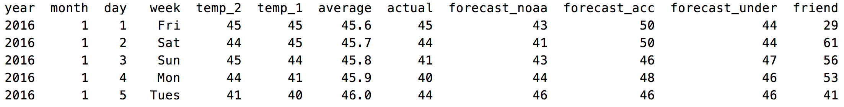

When preparing the data, one-hot encoding is used to create dummy variables for the days of the week:

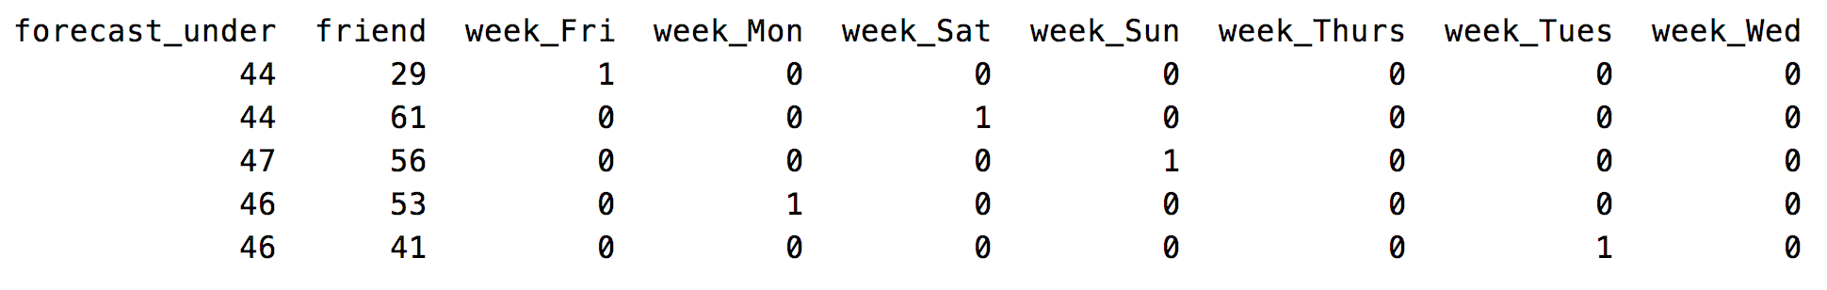

The random forest produces a reasonably accurate model. The example provided implements the mean absolute error which is used to calculate an accuracy rating.

Mean Absolute Error = $\frac{1}{n}\sum{|y-\hat{y}|}$

# Calculate the absolute errors

errors = abs(predictions - test_labels)

# Calculate mean absolute percentage error (MAPE)

mape = 100 * (errors / test_labels)

# Calculate and display accuracy

accuracy = 100 - np.mean(mape)

The root mean square error has also been included with the results as another valid measure of model success.

|  |
| --- |
| Mean Absolute Error: 3.87 degrees.  Accuracy: 93.93 %.  RMSE: 5.101657512937373 |

Here is the full program:

|  |
| --- |
| # Pandas is used for data manipulation  import pandas as pd  from sklearn.metrics import mean_squared_error  # Read in data and display first 5 rows  features = pd.read_csv('/Users/pm/Desktop/DayDocs/data/temperatures.csv')  # Show all columns.  pd.set_option('display.max_columns', None)  pd.set_option('display.width', 1000)  print(features)  # One-hot encode the data using pandas get_dummies  features = pd.get_dummies(features)  # Display the first 5 rows of the last 12 columns.  print(features.head(5))  # Use numpy to convert to arrays  import numpy as np  # Labels are the values we want to predict  labels = np.array(features['actual'])  # Remove the labels from the features  # axis 1 refers to the columns  features= features.drop('actual', axis = 1)  # Saving feature names for later use  feature_list = list(features.columns)  # Convert to numpy array  features = np.array(features)  # Using Skicit-learn to split data into training and testing sets  from sklearn.model_selection import train_test_split  # Split the data into training and testing sets  train_features, test_features, train_labels, test_labels =\  train_test_split(features, labels, test_size = 0.25, random_state = 42)  # Import the model we are using  from sklearn.ensemble import RandomForestRegressor  # Instantiate model with 1000 decision trees  rf = RandomForestRegressor(n_estimators = 1000, random_state = 42)  # Train the model on training data  rf.fit(train_features, train_labels)  # Use the forest's predict method on the test data  predictions = rf.predict(test_features)  # Calculate the absolute errors  errors = abs(predictions - test_labels)  # Print out the mean absolute error (mae)  print('Mean Absolute Error:', round(np.mean(errors), 2), 'degrees.')  # Calculate mean absolute percentage error (MAPE)  mape = 100 * (errors / test_labels)  # Calculate and display accuracy  accuracy = 100 - np.mean(mape)  print('Accuracy:', round(accuracy, 2), '%.')  # Print out the mean square error.  mse = mean_squared_error(test_labels, predictions)  print('RMSE:', np.sqrt(mse)) |

## Displaying Feature Importance

A neat feature of random forests is its ability to provide a ranking of feature importance for making predictions.

Example : Show the Importance’s

This example demonstrates how to rank feature importance for the random forest. The output is:

|  |
| --- |
| Variable: temp_1 Importance: 0.66  Variable: average Importance: 0.15  Variable: forecast_noaa Importance: 0.05  Variable: forecast_acc Importance: 0.03  Variable: day Importance: 0.02  Variable: temp_2 Importance: 0.02  Variable: forecast_under Importance: 0.02  Variable: friend Importance: 0.02  Variable: month Importance: 0.01  Variable: year Importance: 0.0  Variable: week_Fri Importance: 0.0  Variable: week_Mon Importance: 0.0  Variable: week_Sat Importance: 0.0  Variable: week_Sun Importance: 0.0  Variable: week_Thurs Importance: 0.0  Variable: week_Tues Importance: 0.0  Variable: week_Wed Importance: 0.0 |

To implement this solution, add the following code to the end of Example 1.

|  |
| --- |
| # Get numerical feature importances  importances = list(rf.feature_importances_)  # Present features and importance scores.  def showFeatureImportances(importances, feature_list):  dfImportance = pd.DataFrame()  for i in range(0, len(importances)):  dfImportance = dfImportance.append({"importance":importances[i],  "feature":feature_list[i] },  ignore_index = True)  dfImportance = dfImportance.sort_values(by=['importance'],  ascending=False)  print(dfImportance)  showFeatureImportances(importances, feature_list) |

Example : Building Forest with Important Features Only

This example builds a random forest with the important features which includes only the *temp1* variable and the *average* variable. The following scores are surprisingly competitive with the results from Example 2 which use many more features.

|  |
| --- |
| Mean Absolute Error: 3.92 degrees.  Accuracy: 93.76 %.  RMSE: 5.167988371104833 |

To build this solution, add this code to the end of Example 2:

|  |
| --- |
| # New random forest with only the two most important variables  rf_most_important = RandomForestRegressor(n_estimators= 1000, random_state=42)  # Extract the two most important features  important_indices = [feature_list.index('temp_1'), feature_list.index('average')]  train_important = train_features[:, important_indices]  test_important = test_features[:, important_indices]  # Train the random forest  rf_most_important.fit(train_important, train_labels)  # Make predictions and determine the error  predictions = rf_most_important.predict(test_important)  errors = abs(predictions - test_labels)  # Display the performance metrics  print('Mean Absolute Error:', round(np.mean(errors), 2), 'degrees.')  mape = np.mean(100 * (errors / test_labels))  accuracy = 100 - mape  print('Accuracy:', round(accuracy, 2), '%.') |

Exercise (4 marks)

Given the following code for the Iris data set, add the additional code needed to find the top three features for a random forest where. Hint: (See Example 3)

feature_list = ['sepal length', 'sepal width', 'petal length', 'petal width']

Here is code to help you get started:

|  |
| --- |
| #Import scikit-learn dataset library  from sklearn import datasets  #Load dataset  iris = datasets.load_iris()  # Creating a DataFrame of given iris dataset.  import pandas as pd  data=pd.DataFrame({  'sepal length':iris.data[:,0],  'sepal width':iris.data[:,1],  'petal length':iris.data[:,2],  'petal width':iris.data[:,3],  'species':iris.target  })  iris['target_names']  print(data.head())  # Import train_test_split function  from sklearn.model_selection import train_test_split  X=data[['sepal length', 'sepal width', 'petal length', 'petal width']] # Features  y=data['species'] # Labels  # Split dataset into training set and test set  X_train, X_test, y_train, y_test = train_test_split(X, y, test_size=0.3)  #Import Random Forest Model  from sklearn.ensemble import RandomForestClassifier  #Create a Gaussian Classifier  rf=RandomForestClassifier(n_estimators=100)  #Train the model using the training sets y_pred=rf.predict(X_test)  rf.fit(X_train,y_train)  y_pred=rf.predict(X_test)  #Import scikit-learn metrics module for accuracy calculation  from sklearn import metrics  # Model Accuracy, how often is the classifier correct?  print("Accuracy:", metrics.accuracy_score(y_test, y_pred))  # Predict species for a single flower.  # sepal length = 3, sepal width = 5  # petal length = 4, petal width = 2  prediction = rf.predict([[3, 5, 4, 2]])  # 'setosa', 'versicolor', 'virginica'  print(prediction) |

Add in code to generate the top performing feature list. Show the listing that is displayed when running your revised program here:

|  |
| --- |
|  |

Exercise (3 marks)

Rebuild the random forest with Iris data set using only the top performing features. Show the accuracy score. Compare the accuracy of the Iris data set before and after the removal of the lowest performing feature.

|  |
| --- |
|  |

## Random Forest Hyperparameter Tuning

## Random forests have several hyperparameters:

* n_estimators = number of trees in the forest.
* max_features = max number of features considered for splitting a node. Settings include:
  + int, then consider max_features features at each split.
  + float, then max_features is a fraction and int(max_features * n_features) features are considered at each split.
  + “auto”, then max_features=sqrt(n_features).
  + “sqrt”, then max_features=sqrt(n_features) (same as “auto”).
  + “log2”, then max_features=log2(n_features).
  + None, then max_features=n_features.
* max_depth = max number of levels in each decision tree.
* min_samples_split = min number of data points placed in a node before the node is split.
* min_samples_leaf = min number of data points allowed in a leaf node.
* bootstrap = method for sampling data points (with or without replacement).

It is possible to use both RandomizedSearchCV() and GridSearchCV() to help find optimal parameters.

Example : Searching for the Optimal RandomForest Hyperparmaters

This example shows how to search for an optimal set of parameters with RandomizedSearchCV() for the temperatures.csv data set. When running the program with the weather set the output is:

{'n_estimators': 1600, 'min_samples_split': 10, 'min_samples_leaf': 2, 'max_features': 'auto', 'max_depth': None, 'bootstrap': True}

To build this example, add this code to the end of Example 1.

|  |
| --- |
| #############################################################  # This revised example shows a more realistic range of hyperparameters.  #############################################################  # Pandas is used for data manipulation  import pandas as pd  from sklearn.metrics import mean_squared_error  # Read in data and display first 5 rows  features = pd.read_csv('C:\\datasets\\temperatures.csv')  # Show all columns.  pd.set_option('display.max_columns', None)  pd.set_option('display.width', 1000)  print(features)  # One-hot encode the data using pandas get_dummies  features = pd.get_dummies(features)  # Display the first 5 rows of the last 12 columns.  print(features.head(5))  # Use numpy to convert to arrays  import numpy as np  # Labels are the values we want to predict  labels = np.array(features['actual'])  # Remove the labels from the features  # axis 1 refers to the columns  features= features.drop('actual', axis = 1)  # Saving feature names for later use  feature_list = list(features.columns)  # Convert to numpy array  features = np.array(features)  # Using Skicit-learn to split data into training and testing sets  from sklearn.model_selection import train_test_split  # Split the data into training and testing sets  train_features, test_features, train_labels, test_labels =\  train_test_split(features, labels, test_size = 0.25, random_state = 42)  # Import the model we are using  from sklearn.ensemble import RandomForestRegressor  # Instantiate model with 1000 decision trees  rf = RandomForestRegressor(n_estimators = 1000, random_state = 42)  # Train the model on training data  rf.fit(train_features, train_labels)  # Use the forest's predict method on the test data  predictions = rf.predict(test_features)  # Calculate the absolute errors  errors = abs(predictions - test_labels)  # Print out the mean absolute error (mae)  print('Mean Absolute Error:', round(np.mean(errors), 2), 'degrees.')  # Calculate mean absolute percentage error (MAPE)  mape = 100 * (errors / test_labels)  # Calculate and display accuracy  accuracy = 100 - np.mean(mape)  print('Accuracy:', round(accuracy, 2), '%.')  # Print out the mean square error.  mse = mean_squared_error(test_labels, predictions)  print('RMSE:', np.sqrt(mse))  # Get numerical feature importances  importances = list(rf.feature_importances_)  # Present features and importance scores.  def showFeatureImportances(importances, feature_list):  dfImportance = pd.DataFrame()  for i in range(0, len(importances)):  dfImportance = dfImportance.append({"importance":importances[i],  "feature":feature_list[i] },  ignore_index = True)  dfImportance = dfImportance.sort_values(by=['importance'],  ascending=False)  print(dfImportance)  showFeatureImportances(importances, feature_list)  from sklearn.model_selection import RandomizedSearchCV  random_grid =\  {'bootstrap': [True],  'max_depth': [4,6, None],  'max_features': ['auto'],  'min_samples_leaf': [15],  'min_samples_split': [15],  'n_estimators': [ 400, 800, 1600]}  print(random_grid)  # Use the random grid to search for best hyperparameters  # First create the base model to tune  rf = RandomForestRegressor()  # Random search of parameters, using 3 fold cross validation,  # search across 100 different combinations, and use all available cores  rf_random = RandomizedSearchCV(estimator = rf, param_distributions = random_grid, n_iter = 100, cv = 3, verbose=2, n_jobs = -1)  # Fit the random search model  rf_random.fit(train_features, train_labels)  print("Best parrameters")  print(rf_random.best_params_) |

Exercise (4 marks)

Using the randomized search parameter values that are listed before the code in Example 4, take the code from Example 1 and assign these parameter values when declaring the RandomForestRegressor() object. Show the new RMSE measures here after making the changes:

|  |
| --- |
|  |

Compare these scores with the results that are obtained initially in Example 1:

|  |
| --- |
| Before RMSE: 5.101657512937373  With changed parameters: 5.091737186952902  Accuracy has improved from 93.93% to 93.99% |

Exercise (3 marks)

The following code performs logistic regression using Logistic Regression. Scaling is not required for decision trees and hence random forests since the split is not dependent on other features. However, scaling has been included in this example for logistic regression in case it makes a difference.

|  |
| --- |
| from sklearn import datasets  iris = datasets.load_iris()  # Creating a DataFrame of given iris dataset.  import pandas as pd  data=pd.DataFrame({  'sepal length':iris.data[:,0],  'sepal width':iris.data[:,1],  'petal length':iris.data[:,2],  'petal width':iris.data[:,3],  'species':iris.target  })  iris['target_names']  print(data.head())  # Import train_test_split function  from sklearn.model_selection import train_test_split  X=data[['sepal length', 'sepal width', 'petal length', 'petal width']] # Features  y=data['species'] # Labels  # Split dataset into training set and test set  X_train, X_test, y_train, y_test = train_test_split(X, y, test_size=0.3)  from sklearn.preprocessing import StandardScaler  sc_x = StandardScaler()  X_train_scaled = sc_x.fit_transform(X_train)  X_test_scaled = sc_x.transform(X_test)  from sklearn import metrics  from sklearn.ensemble import RandomForestClassifier  from sklearn.linear_model import LogisticRegression  def buildModelAndPredict(clf, X_train_scaled, X_test_scaled, y_train, y_test, title):  print("\n**** " + title)  #Train the model using the training sets y_pred=rf.predict(X_test)  clf_fit = clf.fit(X_train_scaled,y_train)  y_pred = clf_fit.predict(X_test_scaled)  print("Accuracy:", metrics.accuracy_score(y_test, y_pred))  # For explanation see:  # https://towardsdatascience.com/multi-class-metrics-made-simple-part-i-precision-and-recall-9250280bddc2  print(metrics.classification_report(y_test, y_pred, digits=3))  # Predict species for a single flower.  # sepal length = 3, sepal width = 5  # petal length = 4, petal width = 2  prediction = clf_fit.predict([[3, 5, 4, 2]])  # 'setosa', 'versicolor', 'virginica'  print(prediction)  lr = LogisticRegression(fit_intercept=True, solver='liblinear')  buildModelAndPredict(lr, X_train_scaled, X_test_scaled, y_train, y_test, "Logistic Regression") |

Modify the code to initialize a RandomForest classifier using 200 estimators and max_features of 3. Show a comparison of the precision, recall and F1 scores here for both logistic regression and random forests.

|  |
| --- |
|  |